**MINISTRY OF**

**EDUCATION AND TRAINING**

**FPT UNIVERSITY**

Capstone Project Document

**VEHICLES RENTAL SYSTEM**

|  |  |
| --- | --- |
| **Group 10** | |
| **Group members** | Vũ Đức Mạnh – ManhVDSE61952 (Leader)  Nguyễn Thanh Hải – HaiNTSE61825  Nguyễn Văn Khải – KhaiNVSE61960 |
| **Supervisor** | Ms. Nguyễn Thị Cẩm Hương |
| **Ext. Supervisor** | N/A |
| **Capstone Project Code** | VRS |

- Ho Chi Minh City, 14 May 2018 -

This page is intentionally left blank

Table of Contents

Table of Contents 3

List of Tables 6

List of Figures 10

Definitions, Acronyms, and Abbreviations 13

A. Introduction 14

1. Project Information 14

2. Introduction 14

3. Current Situation 14

4. Problem Definition 14

5. Proposed Solution 15

5.1. Feature functions 15

5.2. Advantages and disadvantages 15

6. Functional Requirements 15

7. Roles and Responsibility 16

B. Software Project Management Plan 17

1. Problem Definition 17

1.1. Name of this Capstone Project 17

1.2. Problem Abstract 17

1.3. Project Overview 17

2. Project organization 19

2.1. Software Process Model 19

2.2. Roles and responsibilities 20

2.3. Tools and Techniques 20

3. Project Management Plan 21

3.1. Software development life cycle 21

3.2. Phase Detail 24

3.3. Task sheet 25

3.4. All Meeting Minutes 25

4. Coding Convention 25

C. Software Requirement Specification 26

1. User Requirement Specification 26

1.1. Guest requirement 26

1.2. Customer requirement 26

1.3. Vehicle owner requirement 26

1.4. Staff requirement 27

2. System Requirement Specification 27

2.1. External Interface Requirement 27

2.2. System Overview Use Case 27

2.3. List of Use Case 30

3. Software System Attribute 63

3.1. Usability 63

3.2. Reliability 63

3.3. Availability 63

3.4. Security 63

3.5. Maintainability 63

3.6. Portability 63

3.7. Performance 63

4. Conceptual Diagram 63

D. Software Design Description 66

1. Design Overview 66

2. System Architecture Design 66

2.1. Web Application architecture description 67

2.2. Mobile Application architecture description 67

3. Component Diagram 68

4. Detailed Description 69

4.1. Class Diagram 69

4.2. Class Diagram Explanation 70

4.3. Interactive Diagram 77

5. Interface 89

5.1. Component Interface 89

5.2. Web application Design 91

5.1. Android application Design 100

6. Database Design 115

6.1. Entity relationship diagram 115

6.2. Data Dictionary 116

7. Algorithms 116

7.1. Find nearby vehicle 116

7.2. Contract State 118

7.3. Notification 119

E. System Implementation & Test 120

1. Introduction 120

1.1. Overview 120

1.2. Test Approach 120

2. Database Relationship Diagram 120

2.1. Physical Diagram 120

2.2. Data Dictionary 122

3. Performance Measures 127

3.1. Web application page load speed 127

3.2. Mobile application API load speed 130

4. Test Plan 132

4.1. Features to be tested 132

4.2. Features not to be tested 132

5. System Testing Test Case 132

5.1. Communication Diagrams 132

5.2. Test cases 136

F. Software User’s Manual 155

1. Installation Guide 155

1.1 Setting up environment at server side 155

1.2 Back-end Deployment Process 156

1.3 Web application deployment process 158

2. User Manual 160

2.1 Employee 160

2.2 Customer 163

2.3 Owner 166

List of Tables

Table 1: Definitions, Acronyms, and Abbreviations 13

Table 2 Roles and Responsibility 16

Table 3 Hardware requirement for continuous integrating server 18

Table 4 Hardware requirement for web development 18

Table 5 Hardware requirement for mobile development 19

Table 6 Software requirement 19

Table 7 Roles and responsibilities 20

Table 8 Tools and Techniques 21

Table 9 Software development life cycle 23

Table 10 Use case VRSG01 - <Unauthorized user> Sign up 32

Table 11 Use case VRSG01 - <Unauthorized user> Login 34

Table 12 Use case VRSC01 - <Customer> Rent vehicle 37

Table 13 Use case VRSC02 - <Customer> Cancel contract 38

Table 14 Use case VRSC04 - <Customer> View renting history 40

Table 15 Use case VRSC04 - <Customer> View profile information 41

Table 16 Use case VRSC06 - <Customer> Update profile 42

Table 17 Use case VRSO01 - <Owner> Insert vehicle 44

Table 18 Use case VRSO02 - <Owner> Update vehicle information 46

Table 19 Use case VRSO03 - <Owner> Delete vehicle 48

Table 20 Use case VRSO04 - <Owner> View revenue report 49

Table 22 Use case VRSO07 - <Owner> Update penalty fee 50

Table 23 Use case VRSO08 - <Owner> Create discount 51

Table 24 Use case VRSE01 - <Employee> Approve information 53

Table 25 Use case VRSE02 - <Employee> Update profile 55

Table 26 Use case VRSE03 - <Employee> View profile 56

Table 27 Use case VRSE04 - <Employee> Approve vehicle 58

Table 30 Use case VRSE07 - <Employee> View vehicle detail 59

Table 31 Use case VRSE08 - <Employee> View total profit 60

Table 34 Use case VRSP01 - <Payment> Pay 62

Table 35 Conceptual Diagram Data Dictionary 65

Table 36 Component Dictionary 68

Table 37 Class dictionary 70

Table 38 Account Attribute 71

Table 39 Account Method 71

Table 40 Contract Attribute 72

Table 41 Contract Method 72

Table 42 Vehicle Attribute 73

Table 43 Vehicle Method 73

Table 44 Image Attribute 73

Table 45 Image Method 73

Table 46 Driver Attribute 73

Table 47 Driver Method 74

Table 48 Penalty Attribute 74

Table 49 Penalty Method 74

Table 50 Discount Attribute 74

Table 51 Discount Method 74

Table 52 Vehicle Image Attribute 74

Table 53 Vehicle Image Method 75

Table 54 Vehicle Information Attribute 75

Table 55 Vehicle Information Method 75

Table 56 Rent type Attribute 75

Table 57 Rent type Method 75

Table 58 Rent fee Attribute 75

Table 59 Rent fee Method 76

Table 60 Role Attribute 76

Table 61 Role Method 76

Table 62 District Attribute 76

Table 63 District Method 76

Table 64 City Attribute 76

Table 65 City Method 76

Table 66 Contract Detail Attribute 77

Table 67 Contract Detail Method 77

Table 68 Web Services Interfaces 89

Table 69 Output format description 90

Table 70 Exception description 90

Table 71 Employee home page fields 91

Table 72 Employee home page buttons/hyperlinks 91

Table 73 < Employee> Manage approve account fields 92

Table 74 < Employee> Manage approve account buttons/hyperlinks 92

Table 75 < Employee> Approve account fields 93

Table 76 < Employee> Approve account buttons/hyperlinks 94

Table 79 <Employee> View account detail fields 94

Table 80 <Employee> View account detail buttons/hyperlinks 95

Table 81 <Employee> Manage approve vehicle fields 95

Table 82 <Employee> Manage approve vehicle buttons/hyperlinks 96

Table 83 <Employee> Approve vehicle fields 96

Table 84 <Employee> Approve vehicle buttons/hyperlinks 97

Table 87 <Employee> View vehicle detail fields 97

Table 88 <Employee> View vehicle detail buttons/hyperlinks 98

Table 89 <Employee> Manage report fields 99

Table 90 <Employee> Manage report buttons/hyperlinks 99

Table 91 <Customer> Register account fields 100

Table 92 <Customer> Register account buttons/hyperlinks 101

Table 93 <Customer> Customer home page fields 101

Table 94 <Customer> Customer home page buttons/hyperlinks 102

Table 95 <Customer> Advance vehicle filter 102

Table 96 <Customer> Search vehicle list button/hyperlinks 103

Table 97 <Customer> Vehicle detail fields 104

Table 98 <Customer> Vehicle detail button/hyperlinks 104

Table 99 <Customer> Select renting time field 105

Table 100 <Customer> Select renting time button/hyperlinks 105

Table 101 <Customer> Renting process method fields 106

Table 102 <Customer> Renting process method buttons/hyperlinks 106

Table 103 <Customer> View rental bill fields 107

Table 104 <Customer> View rental bill buttons/hyperlinks 107

Table 107 <Owner> Register vehicle fields 108

Table 108 <Owner> Register vehicle buttons/hyperlinks 108

Table 109 <Owner> Owner home page fields 109

Table 110 <Owner> Owner home page buttons/hyperlinks 110

Table 111 <Owner> Create rental bill fields 110

Table 112 <Owner> Create rental bill buttons/hyperlinks 111

Table 114 <Owner> View rental report fields 111

Table 115 <Owner> View rental report – Buttons 112

Table 116 <Owner> Manage vehicle fields 113

Table 117 <Owner> Manage vehicle – Buttons 113

Table 118 <Owner> Owner vehicle detail fields 114

Table 119 <Owner> Owner vehicle detail button/hyperlinks 114

Table 120 Entity data dictionary 116

Table 121 Contract State Dictionary 118

Table 122 Contract State Flow 119

Table 123 Notification use cases 119

Table 124 Data table dictionary 122

Table 125 Data attribute dictionary 127

Table 126 Web application page load speed test result 130

Table 127 Mobile app API load speed client specification 130

Table 128 Mobile app API load speed test cases 130

Table 129 Mobile application API load speed test result 132

Table 130 Test case - <Guest> Register new account 141

Table 131 Test case - <Employee> View account request 142

Table 132 Test case - <Employee> Approve account request 142

Table 133 Test case - <Employee> View vehicle request 143

Table 134 Test case - <Employee> Approve vehicle request 144

Table 135 Test case - <Employee> View account detail 145

Table 136 Test case - <Employee> View vehicle detail 145

Table 137 Test case - <Employee> View report chart 146

Table 138 Test case - <Customer> Manage profile 146

Table 139 Test case - <Customer> Create new rental request 147

Table 140 Test case - <Customer> Execute vehicle rental process 148

Table 141 Test case - <Customer> Cancel vehicle rental process 149

Table 142 Test case - <Customer> View renting history 150

Table 143 Test case - <Owner> Accept rental request 150

Table 144 Test case - <Owner> Update penalty bill 151

Table 145 Test case - <Owner> Manage vehicle 152

Table 146 Test case - <Owner> Manage rental report 153

Table 147 Test case - <Owner> Manage driver 154

Table 148 Test case - <Owner> Create discount 154

Table 149: Hardware requirement for server 155

Table 150: Hardware requirement for client 155

Table 151: Software requirement for server 155

Table 152: Software requirement for client 155

Table 152: Software requirement for mobile 155

Table 153: User manual – View contract detail 160

Table 154: User manual – Approve account 161

Table 155: User manual – Approve vehicle 162

Table 156: User manual - Create rental request 164

Table 157: User manual – View rental history 164

Table 158: User manual - Update profile 165

Table 159: User manual - Update vehicle 167

Table 160: User manual – Create discount 167

List of Figures

Figure 1: Waterfall model 20

Figure 2: Android Application Overview Use Case 29

Figure 3 Web Application Overview Use Case 30

Figure 4 < Unauthorized user> Overview Use Case 31

Figure 5 <Unauthorized user> Sign up 31

Figure 6 <Unauthorized user> Login 33

Figure 7 <Customer> Overview Use Case 36

Figure 8 <Customer> Rent vehicle 36

Figure 9 <Customer> Cancel reservation 38

Figure 10 <Customer> View renting history 39

Figure 11 <Customer> View profile information 40

Figure 12 <Customer> Update profile 41

Figure 13 <Owner> Overview Use Case 43

Figure 14 <Owner> Insert vehicle 43

Figure 15 <Owner> Update vehicle information 45

Figure 16 <Owner> Delete vehicle 47

Figure 17 <Owner> View revenue report 48

Figure 19 <Owner> Update penalty fee 49

Figure 20 <Owner> Create discount 51

Figure 21 <Employee> Overview Use Case 52

Figure 22 <Employee> Approve information 53

Figure 23 <Employee> Update profile 54

Figure 24 <Employee> View profile 56

Figure 25 <Employee> Approve vehicle 57

Figure 28 <Employee> View vehicle detail 58

Figure 29 <Employee> View total profit 60

Figure 33 <Payment> Overview payment 61

Figure 34 <Payment> Pay 61

Figure 35 Conceptual diagram 64

Figure 36 System architecture design 66

Figure 37 Component Diagram 68

Figure 38 Class diagram 69

Figure 39 Sequence diagram - <Customer>View vehicle list 78

Figure 40 Sequence diagram - <Customer> Create rental contract 79

Figure 41 Sequence diagram - <Customer> Cancel renting vehicle 80

Figure 41 Sequence diagram - <Customer> Complain rental contract 81

Figure 42 Sequence diagram - <Customer> PayPal payment 82

Figure 43 Sequence diagram - <Owner> Create vehicle 83

Figure 44 Sequence diagram - <Owner> Update penalty bill 84

Figure 45 Sequence diagram - <Guest> Register new account 85

Figure 46 Sequence diagram - <Employee> Approve account 86

Figure 47 Sequence diagram - <Employee> Approve vehicle 87

Figure 48 Sequence diagram - <Employee> Manage vehicle 88

Figure 50 Interface - <Employee> Home page 91

Figure 51 Interface - < Employee> Manage account 92

Figure 52 Interface - < Employee> Approve account 93

Figure 54 Interface - <Employee> View account detail 94

Figure 55 Interface - <Employee> Manage approve vehicle 95

Figure 56 Interface - <Employee> Approve vehicle 96

Figure 58 Interface - <Employee> View vehicle detail 97

Figure 59 Interface - <Employee> Manage report 99

Figure 60 Interface - <Customer> Register account 100

Figure 61 Interface - <Customer> Customer home page 101

Figure 62 Interface - <Customer> Advance vehicle filter 102

Figure 63 Interface - <Customer> Vehicle detail 103

Figure 65 Interface - <Customer> Select renting time 104

Figure 66 Interface - <Customer> Renting process 105

Figure 67 Interface - <Customer> View rental bill 106

Figure 68 Interface - <Owner> Register vehicle 107

Figure 70 Interface - <Owner> Owner home page 109

Figure 72 Interface - <Owner> Create rental bill 110

Figure 73 Interface - <Owner> View rental report 111

Figure 74 Interface - <Owner> Manage vehicle 112

Figure 75 Interface - <Owner> Owner vehicle detail 113

Figure 76 Entity relationship diagram 115

Figure 77: Find nearby vehicle flow chart 117

Figure 78 Contract State Chart 118

Figure 79 Physical diagram 121

Figure 80 Web application page load speed test result 129

Figure 81 Mobile application API load speed test result 131

Figure 82 Web Application Communication Diagram 133

Figure 83 Mobile Applications Communication Diagram - Customer 134

Figure 84 Mobile Applications Communication Diagram - Owner 135

Figure 85: Check Java Runtime Environment Version 156

Figure 86: Check MySQL57 status 156

Figure 87: Start MySQL57 157

Figure 88: Import Database 157

Figure 89: View contract detail (1) 160

Figure 90: View contract detail (2) 160

Figure 91: Approve account (1) 161

Figure 92: Approve account (2) 161

Figure 93: Approve vehicle (1) 162

Figure 94: Aprrove vehicle (2) 162

Figure 95: Create rental request (1) 163

Figure 96: Create rental request (2) 163

Figure 97: Create rental request (3) 163

Figure 98: View rental history (1) 164

Figure 99: View rental history (2) 164

Figure 100: Update profile (1) 165

Figure 101: Update profile (2) 165

Figure 102: Update vehicle (1) 166

Figure 103: Update vehicle (2) 166

Figure 104: Update vehicle (3) 166

Figure 105: Create discount (1) 167

Figure 106: Create discount (2) 167

Definitions, Acronyms, and Abbreviations

|  |  |
| --- | --- |
| Name | Definition |
| VRS | Vehicles Rental System |
| GPS | Global Positioning System |
| OS | Operating System |
| API | Application Programming Interface |
| HTTP | Hyper Text Transfer Protocol |

Table 1: Definitions, Acronyms, and Abbreviations

# Introduction

## Project Information

* Project name: **Vehicles Rental System**
* Project Code: **VRS**
* Product Type: **Website & Android Application**
* Start Date: 14 May, 2018
* End Date: 24 August, 2018

## Introduction

Nowadays, while the urbanization process is fast, housing and parking issues become an extremely difficult and costly issue. That is why so many people choose to rent a car or call a taxi instead of owning their own car to increase their convenience and at the same time minimize the cost of parking, maintenance, as well as many other expenses incurred in the process of car ownership. And that's why our application was developed.

In our project, we wanted to create an Android application that would allow users to rent a car on their own quickly and easily, able to see clearly and accurately the temporary expenses and surcharge, alert them when they rented time is out, .... At the same time, to ensure the accuracy of user and car information, we also built a Web Application to help manage and verify the accuracy of the data.

## Current Situation

Below are some comparison car rental applications and user behaviors. Android phone applications (OtoSharing, Aleka, Mioto, Enterprise Rent-A-Car…): they have functions such as view car information, show list of available cars, find route between two points… but cannot rent car for a short time, cannot alert users when renting time is out, and less helpful when users rent a car immediately- rely a lot on face-to-face interaction. And when people want to rent a car, they will have to spend a long time because the process of booking car depends a lot on the response and interaction of car owners.

## Problem Definition

Below are the advantages and disadvantages of current car rental application in Android Phone store and website in Viet Nam:

* Advantages:
* Easy to use.
* Provide users quick access to information about car information and price.
* Have variety of car to choose from.
* Disadvantages:
* Cannot alert users when their rent time is out.
* Unable to process car rental request automatically.
* Users unable to filter specific car information.
* Rely a lot on car owner reply and interaction.
* Application payment rely on cash, not support many types of online payment.

## Proposed Solution

The application allows users to view information of rental car and use their GPS or address to find nearest rental car. Users can also search car with specific car information. Users can keep track with rental time on application. By taking advantages of GPS device on car, they can also find the shortest route to the rental car or monitor exact location of vehicle. Users can send feedback to server, update user data and modify payment method.

### Feature functions

* Users can determine which car they want to rent and where they want to receive vehicle.
* Users can view rent cost and deposits of each car.
* Users can hire a car quickly without having to wait for the car owner's response.
* Users can send their feedback.
* Users can update data and payment method in application.
* Owner can use GPS to keep tracking with their vehicle.
* Owner can view financial report of their vehicle.
* Owner can view recommended rent price of each specific vehicle.

### Advantages and disadvantages

* Advantages:
  + Provide users as many supports as possible from renting a vehicle, to alert their rental time and price.
  + Most of functions will run and return result on real time.
* Disadvantages:
  + Users must have suitable Android device and GPS enable on device.
  + Internet connection may not response stable enough which lead to application low performance, so it is essential to maximum internet usage and performance.

## Functional Requirements

Function requirements of the system are listed as below:

* **Create Account and Verified Account Information:**
  + User can choose to create account as normal users or car owner. Each type of account will require different type of information and image.
  + User can add more than one car information and car detail with require paper and picture.
  + User information will be review and verify by employees.
* **View Rental Car List:**
  + User can find rental car by using GPS or input location (s)he wants to rent a car.
  + User can choose pick up time and car pick up method.
  + User also can find specific type of car want to rent by using advanced find.
  + User can view detail rent cost, information, deposit and surcharges of each vehicle
* **Car rental**
  + User can choose different ways to pick up and drop off vehicle.
  + User can monitor rental time and surcharge during car rental.
  + Renting car process can be execute automatic without need car owner interact during
* **Feedback and Manage Saved Data**
  + User can send feedback to server.
  + User can manage and update their saved data such as personal information, payment method, rental history, …
* **Car Rental History and Profitability Report**
  + Owner can monitor the profitability of a car daily, monthly.
  + User and Owner can view rental history within a month.
* **System Management**
  + Staff can manage all user information and data such as information, vehicle, feedback…
  + Staff can update information for all user and vehicles.

## Roles and Responsibility

|  |  |  |  |  |
| --- | --- | --- | --- | --- |
| No | Full Name | Role | Position | Contact |
| 1 | Nguyen Thi Cam Huong | Project Manager | Instructor | Huongntc2@fe.edu.vn |
| 2 | Nguyen Thanh Hai | Developer | Member | HaiNTSE61825@fpt.edu.vn |
| 3 | Vu Duc Manh | Developer | Leader | ManhVDSE61952[@fpt.edu.vn](mailto:datnqse60924@fpt.edu.vn) |
| 4 | Nguyen Van Khai | Developer | Member | KhaiNVSE61960[@fpt.edu.vn](mailto:datnqse60924@fpt.edu.vn) |

Table 2 Roles and Responsibility

# Software Project Management Plan

## Problem Definition

### Name of this Capstone Project

* **Official name**: Vehicles Rental System (VRS).

### Problem Abstract

The number of personal transportation vehicles such as cars and motorbikes are increasing every day, and as a result, the number of free vehicles has also increased. However, there is still a section of people who are not qualified or able to own personal vehicles. That why Vehicle Rental System is being develop with a single goal: to help persons have ability gain access to these personal vehicles they desire and make the most of the vehicle free time through vehicle rental.

### Project Overview

#### Current Situation

**Android Phone applications**: There are several applications which provide rental services. Some applications have good vehicle search function which provide users various recommend vehicle around location.

**Advantages:** Easy to use, helpful with diversity vehicle type.

**Disadvantages**: Rely a lot on interaction between vehicle owner and vehicle renter. Rental payment relied mostly on cash, not support many types of online payment. Application not supported alert users when their rent time is out.

#### The Proposed System

The system will make it easy for even first-time users to find, select, conduct payments and successfully rent vehicle as user desired. The system also supports vehicle owners in managing the history of their operations as well as the income of each vehicle in the most effective way.

##### Mobile Application

* Create account: User can create account as vehicle owner or customer which includes their personal information and payment id.
* View vehicle list: Users can view list of all rental vehicle available near user location
* Search vehicle: Users can search for specific type of vehicle with advanced filter or simply search at vehicle list.
* View detail vehicle: Users can view detail of each vehicle, rent price, deposit and required document need for rental process.
* Execute payment: Users can execute online payment with support from paypal (the most popular online payment system in the world).
* Users can send feedback about vehicle they have rented in the system.

##### Web Application

* Staff can manage data such as user information, vehicle information, vehicle reports, … All account created must be verify and approved by staff before using application.

#### Boundaries of the System

* The system can be used by every people with Android Phone 6.0 devices or later, or with a laptop with internet connection.
* The language of application is Vietnamese.
* The complete product includes:
  + - The mobile application, for customer, vehicle owner.
    - The website, for staff.
    - All the process document involved.

#### Future Plans

The current system only support for Android and staff has to approve request manually, so we recommend some features for future plans:

* + - Mobile application will be available on iOS.
    - Request can be approved automatically by compare with government database.
    - Vehicle recommendation based on rating.
    - Integrate tracking application into vehicle cruise control system.
    - Apply multi-languages and currencies.

#### Development Environment

##### Hardware requirement

* For continuous integrating server:

|  |  |  |
| --- | --- | --- |
| Hardware | Minimum Requirements | Recommended |
| Internet Connection | Cable, Wi-Fi (4 Mbps) | Cable, Wi-Fi (8 Mbps) |
| Operating System | Linux Ubuntu 16.04 | Linux Ubuntu 16.04 |
| Computer Processor | Intel® Xeon ® 1.4GHz | Intel® Xeon ® Quad Core  (12M Cache, 2.50 GHz) |
| Computer Memory | 1GB RAM | 2GB or more |

Table 3 Hardware requirement for continuous integrating server

* For web development:

|  |  |  |
| --- | --- | --- |
| Hardware | Minimum Requirements | Recommended |
| Internet Connection | 5 Mbps | 8 Mbps |
| Operating System | Windows Vista, 7, 8 | Windows 7, 8 |
| Computer Processor | Intel® Pentium G4500, M 460 @ 2.53GHz | Intel® Core(TM) i5 CPU, M 460 @ 2.53GHz |
| Computer Memory | 1GB of RAM | 3GB of RAM or more |

Table 4 Hardware requirement for web development

* For mobile development:

|  |  |  |
| --- | --- | --- |
| Hardware | Minimum Requirements | Recommended |
| Internet Connection | 5 Mbps | 8 Mbps |
| Operating System | Android Phone 6.0 | Android Phone 7.0 |
| Hardware | GPS supported | GPS supported |
| Memory | 150MB | 150MB or more |

Table 5 Hardware requirement for mobile development

##### Software requirement

|  |  |
| --- | --- |
| Software | Name / Version |
| Operating system | Windows 7 or above |
| Environment | Java |
| Modeling tool | StarUML |
| IDE | Android Studio 3.+, Intellij IDEA 14.1 |
| DBMS | MySQL 5.6 |
| Source control | Git |
| Web browser | Chrome 42 or above |

Table 6 Software requirement

## Project organization

### Software Process Model

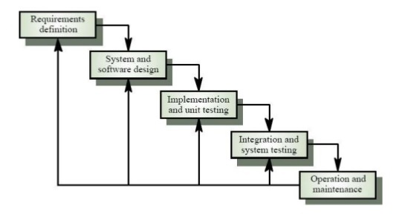

Figure 1: Waterfall model

For more information: <http://www.waterfall-model.com/sashimi-waterfall->[model/](http://www.waterfall-model.com/sashimi-waterfall-model/)

Explanation: We use Modified Waterfall Development Model for Vehicle Rental System application development for several reasons, mostly because:

* List of functional requirements and non-functional requirements may be made change during Design phase because vehicle type and vehicle element can be change which will decide which function will be change and redesign.
* Architecture which is made from Design phase may be changed during Implementation phase because some of Android Phone application development supporting features may be known during implementation, and it may change the architecture. Besides that, some functions may be updated or changed, requiring design document should be updated.

### Roles and responsibilities

|  |  |  |  |
| --- | --- | --- | --- |
| No | Full name | Role in Group | Responsibilities |
| 1 | Nguyễn Thị Cẩm  Hương | Project manager | * Specify user requirement * Control the development process * Give out technique and business analysis support |
| 2 | Nguyễn Thanh Hải | BA, Developer, Tester | * Clarifying requirements * Prepare documents * GUI Design * Designing database * Coding * Create test plan * Testing |
| 3 | Vũ Đức Mạnh | Team leader, BA, Developer, Tester | * Managing process * Clarifying requirements * Prepare documents * GUI Design * Designing database * Coding * Create test plan * Testing |
| 4 | Nguyễn Văn Khải | BA, Developer, Tester | * Clarifying requirements * Prepare documents * GUI Design * Designing database * Coding * Create test plan * Testing |

Table 7 Roles and responsibilities

### Tools and Techniques

|  |  |
| --- | --- |
| Tool / Technique | Name / version |
| Frontend | nodeJS (reactJS) |
| Backend | Java, Spring Framework, JSP, Hibernate |
| Web server | Apache Tomcat 8.5.31 |
| Development tool | Android Studio 3.+, IntelliJ IDEA 14 |
| DBMS | MySQL 5.6 |
| Source control | Git |
| Modeling tool | StarUML 5.0 |
| Document tool | Microsoft Word 2016 |

Table 8 Tools and Techniques

## Project Management Plan

### Software development life cycle

Below are all the major tasks that need to be performed sequentially during the development of the system.

|  |  |  |  |  |  |
| --- | --- | --- | --- | --- | --- |
| Phase | Description | Deliverables | Resource needed | Dependencies and Constrains | Risk |
| Requirements Definition | Identify and clarify system requirements. | Report No.1 Introduction. | 20 man-days | N/A | - Missing requirement.  - Project’s scope can be unclear.  - Lack of member share and understand. |
| System and Software Design | - Identify hardware and software requirements.  - Decide software architect and clarify software detail design.  - Design database. | Report No.2 Software Project Management Plan, Report No. 3 Software Requirement Specification and  Report No. 4 Software Design Description. | 50 man-days | Depend on Requirements Definition. | - Misunderstood or unclear system’s requirement.  - Lack of practical experience leading to unreasonable design. |
| Implementation and Unit Testing | - Implements all functions of system.  - Create test plan.  - Perform Unit testing. | Software package. | 120 man-days | - Base on Software Requirement Specification and Software Design Description.  - Coding try to follow coding convention. | - Member does not performs unit test.  - Lack of practical experience. |
| Integration and System Testing | - Perform integration test and system test. | Report No. 5 System Implementation & Test | 35 man-days | Implementation and Unit Testing are finished. | - Lack of testing experience leading to lack of test cases.  - Not enough time for performing test. |
| Operation and Maintenance | - Deploy the system  - Create the user’s manuals.  - Do routine maintenance activities. | Report No.6 Software User’s Manual | 15 man-days | Integration and System Testing are finished. | User’s manual may be difficult for user to understand and confuse. |

Table 9 Software development life cycle

### Phase Detail

#### Phase 1: Requirements Definition

|  |  |  |
| --- | --- | --- |
| Task | Description | Author |
| Collect requirements | Find which systems currently provide similar service, theirs  strengths and weakness. | Nguyen Thanh Hai  Nguyen Duc Manh  Nguyen Van Khai |
| Identify and clarify system requirements. | Research current systems to collect requirements.  Define main and needed functions the system must include. | Nguyen Thanh Hai  Nguyen Duc Manh  Nguyen Van Khai |
| Prototype | Build a prototype of proposed system (Website/Mobile). | Nguyen Thanh Hai  Nguyen Duc Manh  Nguyen Van Khai |

#### Phase 2: System and Software Design

|  |  |  |
| --- | --- | --- |
| Task | Description | Author |
| Identify hardware and software requirements. | Find out the suitable hardware and software for the system, as well as its minimum and recommended requirements. | Nguyen Thanh Hai  Nguyen Duc Manh  Nguyen Van Khai |
| Decide software architect and clarify software detail design. | - Define the major software components and interfaces.  - Draw core flow diagram, use case diagram, …  - Group meeting to review and modify. | Nguyen Thanh Hai  Nguyen Duc Manh  Nguyen Van Khai |
| Design database. | - Design database for the system. | Nguyen Thanh Hai  Nguyen Duc Manh  Nguyen Van Khai |

#### Phase 3: Implementation and Unit Testing

|  |  |  |
| --- | --- | --- |
| Task | Description | Author |
| Implements all functions of system. | Coding all the components. | Nguyen Thanh Hai  Nguyen Duc Manh  Nguyen Van Khai |
| Create test plan. | Planning for testing. | Nguyen Thanh Hai  Nguyen Duc Manh  Nguyen Van Khai |
| Perform Unit testing. | - Write Unit test cases.  - Implement Unit tests. | Nguyen Thanh Hai  Nguyen Duc Manh  Nguyen Van Khai |

#### Phase 4: Integration and System Testing

|  |  |  |
| --- | --- | --- |
| Task | Description | Author |
| Perform integration test and system test. | - Test groups of modules and test whole the system. | Nguyen Thanh Hai  Nguyen Duc Manh  Nguyen Van Khai |

#### Phase 5: Operation and Maintenance

|  |  |  |
| --- | --- | --- |
| Task | Description | Author |
| Deploy the system | Deploy the system in client environment. | Nguyen Thanh Hai  Nguyen Duc Manh  Nguyen Van Khai |
| Create the user’s manuals. | Create a guideline to instruct users using system. | Nguyen Thanh Hai  Nguyen Duc Manh  Nguyen Van Khai |
| Do routine maintenance activities. | Do routine maintenance activities for client system | Nguyen Thanh Hai  Nguyen Duc Manh  Nguyen Van Khai |

### Task sheet

Refer to “Task sheet” folder.

### All Meeting Minutes

Refer to “Meeting minutes” folder.

## Coding Convention

This project follows “Code Conventions for the Java TM Programming Language, by Sun Microsystems, rev April 20, 1999”.

<http://www.oracle.com/technetwork/java/codeconventions-150003.pdf>

We use followings naming convention from the reference to capable with current situation in our team:

* Naming:
  + Class names must be in Pascal case.
  + Variable names must be in Camel case.
  + Each Java class belongs to a single file.
* Intentions:
  + Use four spaces intentions.
  + Avoid lines with more than 80 characters
* Declaration:
  + One declaration per line is recommended since it encourages commenting.
  + In absolutely no case should variables and functions be declared on the same line.
  + Do not put different types on the same line.

# Software Requirement Specification

## User Requirement Specification

### Guest requirement

Guest is a person who doesn’t have access to the system. Guest can use some functions in the system. To use all functions, guest must login. These are some functions guest can use:

* Register.
* Login in Website to become staff.
* Login in Mobile Application to become member.

### Customer requirement

Customer is guest who uses his account to login to the system. The customer can use some following functions:

* View vehicle list
* View vehicle detail,
* View vehicle rental price and deposit.
* Search vehicle.
* Renting vehicle.
* Give feedback.
* View rental history.
* Update personal information.

### Vehicle owner requirement

Vehicle owner is guest who uses his account to login to the system and have vehicles rental in the system. The vehicle owner can use some following functions:

* View vehicle list
* View vehicle detail
* View vehicle rental price and deposit.
* Search vehicle.
* Renting vehicle.
* Give feedback.
* View rental history.
* Update personal information.
* View rental report.
* Manage vehicle.
* Create discount.
* Create rental bill.

### Staff requirement

Staff is people who works directly with system to manage information of customer, car owner and vehicle, staff can handle directly some problems if it happens from customer. Staff can use some following functions:

* Resolve member account request.
* Resolve vehicle request.
* Manage profile includes:
  + View profile information.
  + Edit profile information.
* Manage vehicle includes:
  + View vehicle information.
* Manage discount includes:
  + View discount.
  + Create discount.
* Manage report includes:
  + View total report.
  + View individual report.

## System Requirement Specification

### External Interface Requirement

#### User interface

* General requirement for graphics user interface of website and application on mobile device is the GUI should be simple, clear, intuitive, and reminiscent.
* Some design principle will be taken into consideration:
* User Interface Guidelines - Google [Ref: Appendix 1]
* Android Design Guidelines - Android Developers [Ref: Appendix 2]

#### Hardware Interface

* N/A

#### Software Interface

* Chromes (Version 66.0.3359.181), Firefox (version 59.0.2) with Resolution (1024 x 768) or bigger and must support JavaScript and HTML5.
* Mobile application: Android operating system (v 4.2 or above).

#### Communication Protocol

* Use HTTP protocol 1.1 for communication between the web browser and the web server.
* Use HTTP protocol 1.1 for communication between the mobile application and the web service.

### System Overview Use Case

#### Android Application Overview Use Case

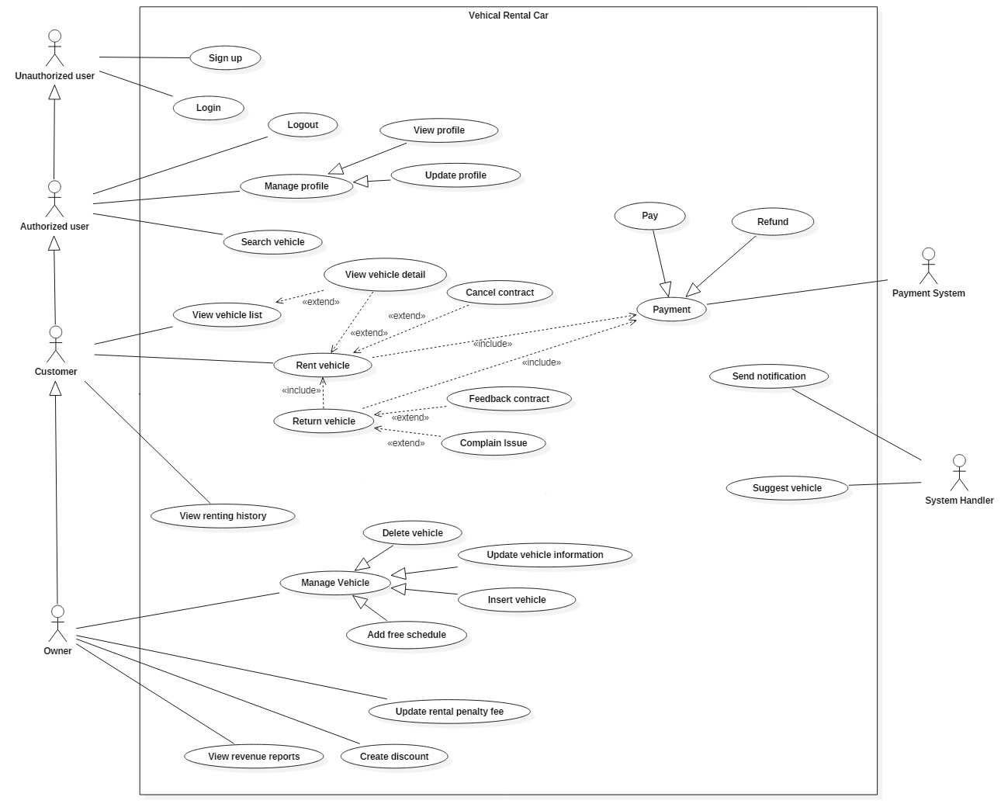

Figure 2: Android Application Overview Use Case

#### Website Overview Use Case

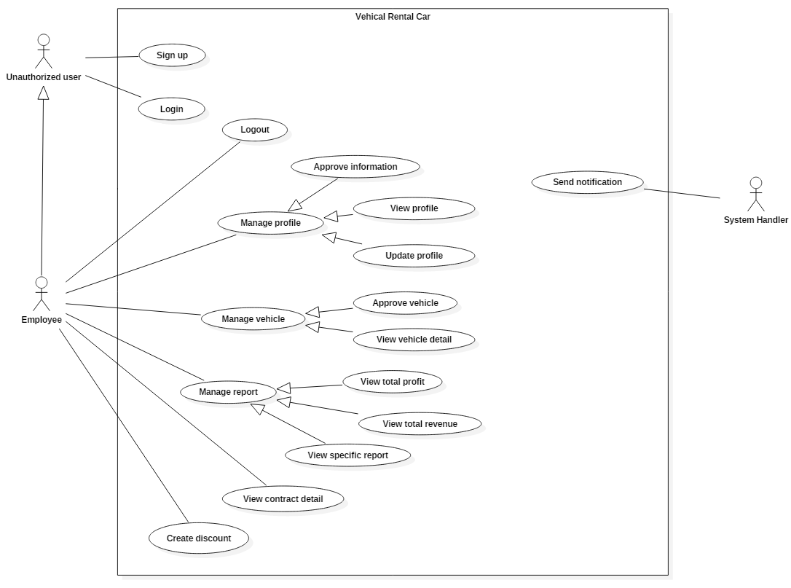

Figure 3 Web Application Overview Use Case

### List of Use Case

#### Android Application

##### <Unauthorized user> Overview Use Case

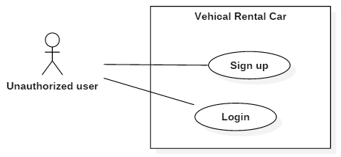

Figure 4 < Unauthorized user> Overview Use Case

###### < Unauthorized user > Sign up

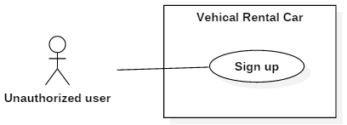

Figure 5 <Unauthorized user> Sign up

|  |  |  |  |
| --- | --- | --- | --- |
| USE CASE – VRS01 | | | |
| Use Case No. | VRSG01 | **Use Case Version** | 2.0 |
| Use Case Name | Sign up | | |
| Author | HaiNT | | |
| Date |  | **Priority** | Normal |
| Actor:   * Guest   Summary:   * This use case allows guest to create new account request in the system.   Goal:   * Guest create new account request success.   Triggers:   * Guest sends command to create account request.   Preconditions:   * N/A   Post Conditions:   * Success: New account will be created for guest. * Fail: Show error message.   Main Success Scenario:   |  |  |  | | --- | --- | --- | | Step | Actor Action | System Response | | 1 | Guest goes to new account view. | Display new view with following information.  System requires information from guest:  **Personal information** (all information below are required)   * ID Card number: number input, required, length 9 or 12. * Username: free text input, required, length 3 – 80. * Password: free text input, required, length 3 – 80. * Full Name: free text input, required, length 3 – 80. * Address: free text input, required, length 3 – 250. * Email: free text input, required, length 3 – 250. * Phone number: free text input, required, length 8 – 15. * Paypal ID: free text input, length 15. * Check boxes for customer to choose customer is vehicle owner or not. | | 2 | Guest inputs information. |  | | 3 | Guest sends command to create new account request. | System validate information, request for confirmation and redirect to home screen.  [Exception 1, 2] |   Alternative Scenario: N/A  Exceptions:   |  |  |  | | --- | --- | --- | | No | Actor Action | System Response | | 1 | Guest sends command to create new account request | System shows error message to ask user input missing required fields. | | 2 | Guest’s email is existed in the system | Show message to notify guest that their email is existed in the system. | | 3 | Guest’s vehicle frame number is existed in the system | Show message to notify guest that their vehicle is existed in the system. | | 4 | If paypal login failed | Show message to notify user that payment failed and the renew request has been aborted. |   Relationships: Payment  Business Rules:   * New customer account and new vehicle will be store in the system with inputted information and wait for employee confirm. * The initial status of account and vehicle will be set to “Draft”. * When customer completed paypal validate process:   + if paypal validate successful, account status would change from “Draft” to “Pending”.  + If paypal validate unsuccessful, the account status is not changed.   * Staff will receive a notification about new account request, they verify account information and vehicle information, in this case, account status would change from “Pending” to “Ready”. * System must ensure has no duplicate customer or vehicle. * A message will be sent to user to notify account ready to use, user can start using the system. * Policy term is specified by the system. * Policy types are loaded from system * A notification will be sent to staff after the process is completed. | | | |

Table 10 Use case VRSG01 - <Unauthorized user> Sign up

###### < Unauthorized user > Login

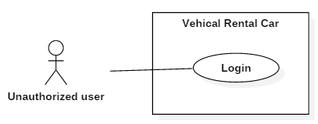

Figure 6 <Unauthorized user> Login

|  |  |  |  |
| --- | --- | --- | --- |
| USE CASE – VRS02 | | | |
| Use Case No. | VRSG02 | **Use Case Version** | 2.0 |
| Use Case Name | Login | | |
| Author | HaiNT | | |
| Date |  | **Priority** | Normal |
| Actor:   * Guest   Summary:   * This use case allows guest to login in the system.   Goal:   * Guest login success.   Triggers:   * Guest sends command to login request.   Preconditions:   * N/A   Post Conditions:   * Success: Redirect to home page. * Fail: Show error message.   Main Success Scenario:   |  |  |  | | --- | --- | --- | | Step | Actor Action | System Response | | 1 | Guest goes to login screen. | Display new view with following information.   * Username: free text input, required, length 3 – 80. * Password: free text input, required, length 3 – 80. * Login: button. * Register: button | | 2 | Guest inputs information. |  | | 3 | Guest sends “Login” command  [Alternative 1] | System validate data and return login result.  [Exception 1, 2] |   Alternative Scenario:   |  |  |  | | --- | --- | --- | | No | Actor Action | System Response | | 1 | If user click on “Register” button | Display new view with following information.  System requires information from guest:  **Personal information** (all information below are required)   * ID Card number: number input, required, length 9 or 12. * Username: free text input, required, length 3 – 80. * Password: free text input, required, length 3 – 80. * Full Name: free text input, required, length 3 – 80. * Address: free text input, required, length 3 – 250. * Email: free text input, required, length 3 – 250. * Phone number: free text input, required, length 8 – 15. * Paypal ID: free text input, length 15.   Check boxes for customer to choose customer is vehicle owner or not.  [Alternative 2] | | **2** | User inputs information. | [Alternative 3] | | **3** | User sends command to continue process. | System validate information and request for confirmation.  [Exception 1, 3]  Redirect to insert vehicle picture view  [Alternative 4] | | **4** | User select image | [Alternative 5] | | **5** | User send finish process command | Show message create vehicle request is waiting for approved. |   Exceptions:   |  |  |  | | --- | --- | --- | | No | Actor Action | System Response | | 1 | Guest sends command to create new account request | System shows error message to ask user input missing required fields. | | 2 | Guest’s email is existed in the system | Show message to notify guest that their email is existed in the system. | | 3 | Guest’s vehicle frame number is existed in the system | Show message to notify guest that their vehicle is existed in the system. | | 4 | If paypal login failed | Show message to notify user that payment failed and the renew request has been aborted. |   Relationships: Payment  Business Rules:   * New customer account and new vehicle will be store in the system with inputted information and wait for employee confirm. * The initial status of account and vehicle will be set to “Draft”. * When customer completed paypal validate process:   + if paypal validate successful, account status would change from “Draft” to “Pending”.  + If paypal validate unsuccessful, the account status is not changed.   * Staff will receive a notification about new account request, they verify account information and vehicle information, in this case, account status would change from “Pending” to “Ready”. * System must ensure has no duplicate customer or vehicle. * A message will be sent to user to notify account ready to use, user can start using the system. * Policy term is specified by the system. * Policy types are loaded from system * A notification will be sent to staff after the process is completed. | | | |

Table 11 Use case VRSG01 - <Unauthorized user> Login

##### <Customer> Overview Use Case

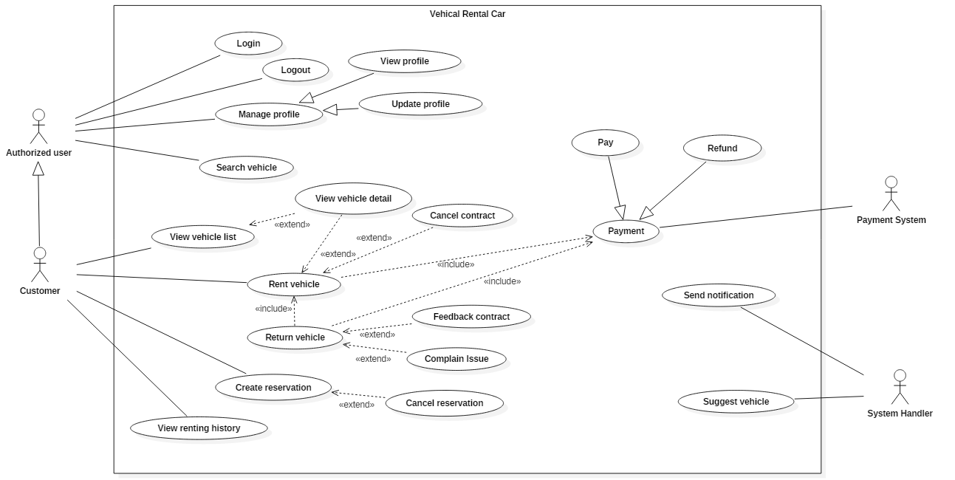

Figure 7 <Customer> Overview Use Case

###### <Customer> Rent vehicle

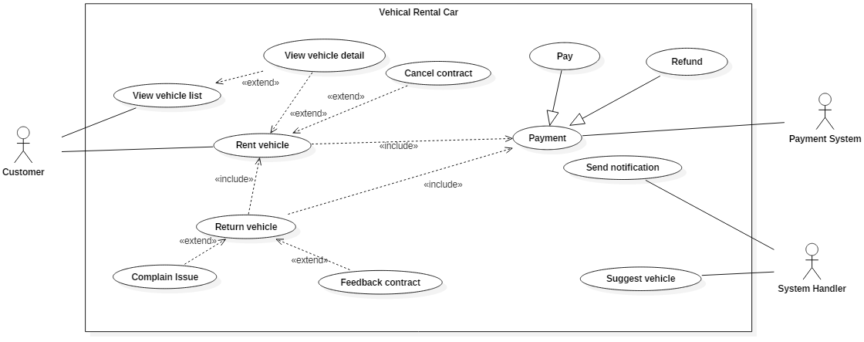

Figure 8 <Customer> Rent vehicle

|  |  |  |  |
| --- | --- | --- | --- |
| USE CASE – VRSC01 | | | |
| Use Case No. | VRSC01 | **Use Case Version** | 2.0 |
| Use Case Name | Rent vehicle | | |
| Author | HaiNT | | |
| Date |  | **Priority** | High |
| Actor:   * Customer.   Summary:   * This use case helps user to find vehicles which are near customer location and create a rental request.   Goal:   * User can create rent vehicles request successfully.   Triggers:   * User sends “Find vehicle” command.   Preconditions:   * User must login into the system with role Customer. * Account’s status must be “Ready”. * Customer device must be enabled GPS location and have internet connection.   Post Conditions:   * Success: User rent vehicle successfully * Fail: Show error message.   Main Success Scenario:   |  |  |  | | --- | --- | --- | | Step | Actor Action | System Response | | 1 | User goes to find vehicle view. | Display user location on map and “Find vehicle” button | | 2 | User sends find vehicle command. | Display new view with following information:  - Vehicle name: text  - Vehicle price: text  - Vehicle picture: text  - Vehicle description: text  And let user select one of vehicle  [Exception 1] | | 3 | User select chosen vehicle | Forward to vehicle detail view to process renting vehicle.  [Exception 2] | | 4 | User sends rent vehicle command | Display new view with following information:  - Renting hours: int  - Renting days: int  - Temporary amount: int  - Start renting: button  And let user select renting hours and renting days | | 5 | User send start renting command | Forward to paypal page  [Exception 3] | | 6 | User login to paypal and execute payment process | Show message to notify user that contract have been created.  [Exception 4] |   Alternative Scenario: N/A  Exceptions:   |  |  |  | | --- | --- | --- | | No | Actor Action | System Response | | 1 | If device GPS and internet connection is not enabled | Show message to notify user that device GPS and internet is not enable and redirect to device setting. | | 2 | If vehicle data is wrong | Show message to notify user that vehicle detail is wrong and the vehicle detail has been aborted. | | 3 | If user not select anything and click on “Rent” | Show message to notify user that user must select time to continue process. | | 4 | If user cannot complete payment | Show message to notify user that payment is not success and renting process has been aborted. |   Relationships: N/A.  Business Rules:   * If account status is not “Ready” user cannot start renting vehicle. * If device GPS and internet connection is not enabled, system cannot find user location and suitable vehicle near user. * If user cannot complete payment process, system will cancel reservation. | | | |

Table 12 Use case VRSC01 - <Customer> Rent vehicle

###### <Customer> Cancel Contract

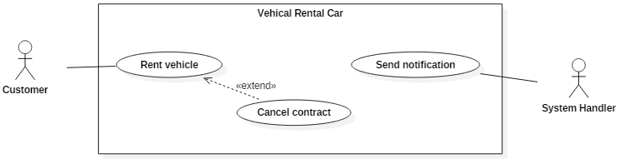

Figure 9 <Customer> Cancel contract

|  |  |  |  |
| --- | --- | --- | --- |
| USE CASE – VRSC02 | | | |
| Use Case No. | VRSC02 | **Use Case Version** | 2.0 |
| Use Case Name | Cancel contract | | |
| Author | HaiNT | | |
| Date |  | **Priority** | High |
| Actor:   * Customer.   Summary:   * This case allows users who have a vehicle rental request which is on standby mode, can cancel their car reservation.   Goal:   * User can cancel a reservation successfully.   Triggers:   * User sends “Cancel” command.   Preconditions:   * User must login into the system with role Customer. * Account’s status must be “Ready”. * Customer device must be enabled GPS location and have internet connection. * Customer must have a vehicle reservation and vehicle is not yet delivered   Post Conditions:   * Success: Show cancel reservation success message. * Fail: Show error message.   Main Success Scenario:   |  |  |  | | --- | --- | --- | | Step | Actor Action | System Response | | 1 | User sends cancel vehicle command in waiting vehicle view. | Display confirm dialog “Do you really want cancel reservation” | | 2 | User select Yes option.  [Alternative 1] | Display new view with following information:  - Cancel policy: text  - Cancellation fee: text  - Total refund: text  - Accept: button | | 3 | User select accept command vehicle | Display dialog with following text:   * System is processing for complete your request. Please wait for a few minutes to complete transaction   [Exception 1] |   Alternative Scenario:   |  |  |  | | --- | --- | --- | | No | Actor Action | System Response | | 1 | If user select No option | Dialog disable, reservation process still continues. |   Exceptions:   |  |  |  | | --- | --- | --- | | No | Actor Action | System Response | | 1 | If system fail to process refund for customer | Show message to notify user that user request is still processing, please wait for a few minutes and redo refund process. |   Relationships: Include Rent vehicle process.  Business Rules:   * If user not have a vehicle reservation or vehicle is already delivered, cancel process cannot be executed * If the system can not complete the refund process, the system must automatically redo the process until it succeeds. | | | |

Table 13 Use case VRSC02 - <Customer> Cancel contract

###### <Customer> View renting history

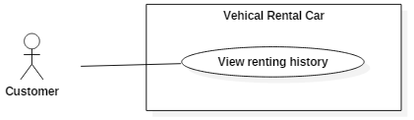

Figure 10 <Customer> View renting history

|  |  |  |  |
| --- | --- | --- | --- |
| USE CASE – VRSC04 | | | |
| Use Case No. | VRSC04 | **Use Case Version** | 2.0 |
| Use Case Name | View renting history | | |
| Author | HaiNT | | |
| Date |  | **Priority** | Normal |
| Actor:   * Customer.   Summary:   * This use case allow user to view all of the customer’s transactions in the past.   Goal:   * Customer can view rental history.   Triggers:   * Customer sends view history request.   Preconditions:   * User must login into the system with role Customer. * User account status is “Ready”.   Post Conditions:   * Success: Show the customer’s transactions history to the user. * Fail: Show error message.   Main Success Scenario:   |  |  |  | | --- | --- | --- | | Step | Actor Action | System Response | | 1 | User goes to rental history view. | Display rental history view with following information:   * + Rental start time: date   + Rental end time: date   + Rental price: int   [Alternative 1] |   Alternative Scenario:   |  |  |  | | --- | --- | --- | | No | Actor Action | System Response | | 1 | If user have not rented vehicle yet | Display rental history view with blank data. |   Exceptions: N/A  Relationships: N/A  Business Rules:   * The information is loaded from the system. * List of transactions will be sorted by date in descending order. * User rental history view will be shown no matter user is rented vehicle or not. | | | |

Table 14 Use case VRSC04 - <Customer> View renting history

###### <Customer> View profile information

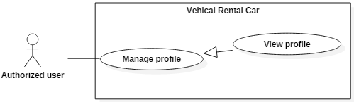

Figure 11 <Customer> View profile information

|  |  |  |  |
| --- | --- | --- | --- |
| USE CASE – VRSC05 | | | |
| Use Case No. | VRSC05 | **Use Case Version** | 2.0 |
| Use Case Name | View profile information | | |
| Author | HaiNT | | |
| Date |  | **Priority** | Medium |
| Actor:   * Customer.   Summary:   * This use case allow user to view their information and profile in the system.   Goal:   * User view account information stored in the system successfully.   Triggers:   * User sends view account information command.   Preconditions:   * User must login into the system with role Customer.   Post Conditions:   * Success: Show the customer’s information to the user. * Fail: Show error message.   Main Success Scenario:   |  |  |  | | --- | --- | --- | | Step | Actor Action | System Response | | 1 | User sends view account information command. | Display account information view that show user list of account information includes:   * ID number: int * Paypal ID: int * Username: text * Password: text * Fullname: text * Address: text * Phone: int * Edit information transaction: button |   Alternative Scenario: N/A  Exceptions: N/A  Relationships: N/A  Business Rules:   * The information is loaded from the system. | | | |

Table 15 Use case VRSC04 - <Customer> View profile information

###### <Customer> Update profile

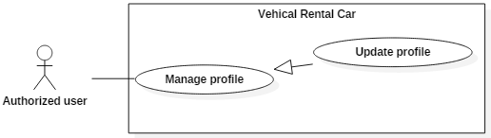

Figure 12 <Customer> Update profile

|  |  |  |  |
| --- | --- | --- | --- |
| USE CASE – VRSC06 | | | |
| Use Case No. | VRSC06 | **Use Case Version** | 2.0 |
| Use Case Name | Update profile | | |
| Author |  | | |
| Date |  | **Priority** | Medium |
| Actor:   * Customer.   Summary:   * This use case allow user to updated their profile and information store in the system.   Goal:   * User sends a profile update request to the employee.   Triggers:   * User sends update information command.   Preconditions:   * User must login into the system with role Customer. * User must be stand at manage information view.   Post Conditions:   * Success: Show message update information is waiting for approved. * Fail: Show error message.   Main Success Scenario:   |  |  |  | | --- | --- | --- | | Step | Actor Action | System Response | | **1** | User goes to update information view. | Display update information view allow user to update information includes:   * Full name: free text input, required, length 3-80. * Password: free text input, required, length 8-20. * Address: free text input, required, length 10-250. * Phone: free text input, required, length 8-15. * Paypal ID: free text input, required, length 8-25. | | **2** | User fill required information |  | | **3** | User sends request compensation command | Show message to notify that request is submit successful and waiting for approved.  [Exception 1, 2] |   Alternative Scenario:   |  |  |  | | --- | --- | --- | | No | Actor Action | System Response | | **1** | User input missed one of requirement information. | Show message to notify user what required information is missing. | | **2** | The inputted information length is out of range. | Show message to notify user what information is out of range. |   Exceptions: N/A  Relationships: N/A  Business Rules:   * The information is loaded from the system. * Compensation request will be sent to the system with inputted information. * A notification will be sent to staff after the process is completed. | | | |

Table 16 Use case VRSC06 - <Customer> Update profile

##### <Owner> Overview Use Case

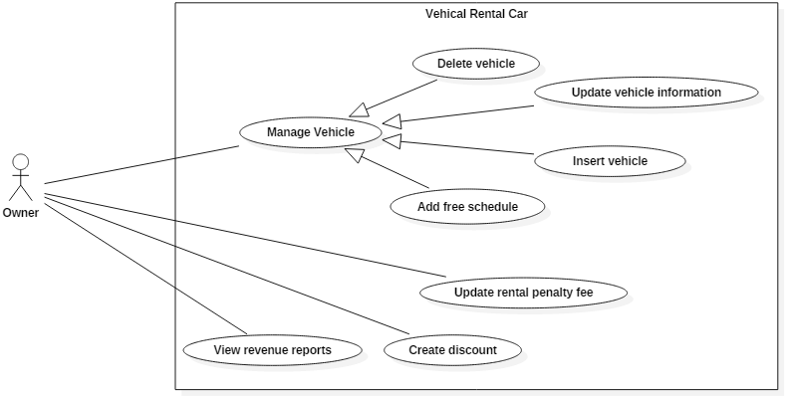

Figure 13 <Owner> Overview Use Case

###### <Owner> Insert vehicle

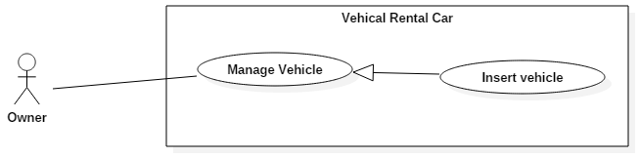

Figure 14 <Owner> Insert vehicle

|  |  |  |  |
| --- | --- | --- | --- |
| USE CASE – VRSO01 | | | |
| Use Case No. | VRSO01 | **Use Case Version** | 2.0 |
| Use Case Name | Insert vehicle | | |
| Author | HaiNT | | |
| Date |  | **Priority** | High |
| Actor:   * Owner.   Summary:   * This use case allow owner to request insert new vehicle information to the system.   Goal:   * User sends a create vehicle request to the employee.   Triggers:   * User sends new vehicle request command.   Preconditions:   * User must login into the system with role Owner. * Account status must be “Ready”   Post Conditions:   * Success: New vehicle request will be sent to the system. * Fail: Show error message.   Main Success Scenario:   |  |  |  | | --- | --- | --- | | Step | Actor Action | System Response | | 1 | User sends insert vehicle information command. | Display new view with following information.   * Frame number: free text input, required, length 6-32. * Vehicle plate: free text input, required, length 6-32. * Vehicle name: free text input, length 1-250. * Engine type: text * Transmission type: text * Number of seats: text * Manufacture year: free integer input, length 4 * Rent cost: free integer input, length 1-250. * Deposit: free integer input, length 1-250. * Description: free text input, length 1-250. * Relate document: can be multiple optional selected from these selections:   + ID card   + Vehicle registration certificate   + Driving license * Next: button | | 2 | Guest inputs information. |  | | 3 | Guest sends command to continue process. | System validate information and request for confirmation.  [Exception 1, 2]  Redirect to insert vehicle picture view | | 4 | Guest select vehicle picture. |  | | 5 | Guest sends command to create new vehicle request. | Show message to notify that request is submit successful and waiting for approved. |   Alternative Scenario: N/A  Exceptions:   |  |  |  | | --- | --- | --- | | No | Actor Action | System Response | | 1 | Owner sends command to continue process request | System shows error message to ask owner input missing required fields. | | 2 | Owner’s vehicle frame number is existed in the system | Show message to notify owner that their vehicle is existed in the system. |   Relationships: N/A  Business Rules:   * Account status must be “Ready” * One vehicle can only be own by one owner. * A notification will be sent to staff after the process is completed. | | | |

Table 17 Use case VRSO01 - <Owner> Insert vehicle

###### <Owner> Update vehicle information

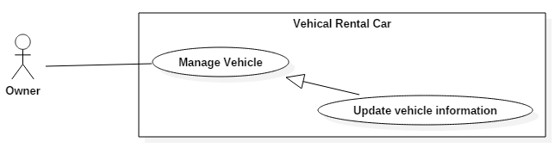

Figure 15 <Owner> Update vehicle information

|  |  |  |  |
| --- | --- | --- | --- |
| USE CASE – VRSO02 | | | |
| Use Case No. | VRSO02 | **Use Case Version** | 2.0 |
| Use Case Name | Update vehicle information | | |
| Author | HaiNT | | |
| Date |  | **Priority** | Medium |
| Actor:   * Owner.   Summary:   * This use case help user to send their update vehicle information request to the employee.   Goal:   * User sends an update vehicle information request to the employee   Triggers:   * User sends update vehicle information command.   Preconditions:   * User must login into the system with role Owner. * There is at least 1 vehicle belongs to owner in the system.   Post Conditions:   * Success: Show message update information is waiting for approve. * Fail: Show error message.   Main Success Scenario:   |  |  |  | | --- | --- | --- | | Step | Actor Action | System Response | | 1 | User sends update vehicle request command. | Display new view with following information.   * Frame number: text * Vehicle plate: free text input, required, length 6-32. * Vehicle name: free text input, length 1-250. * Engine type: text * Transmission type: text * Number of seat: text * Manufacture year: free integer input, length 4 * Rent cost: free integer input, length 1-250. * Deposit: free integer input, length 1-250. * Description: free text input, length 1-250. * Relate document: can be multiple optional selected from these selections:   + ID card   + Vehicle registration certificate   + Driving license * Next: button | | 2 | User inputs information. |  | | 3 | User sends command to continue process. | System validate information and request for confirmation.  [Exception 1, 2]  Redirect to insert vehicle picture view | | 4 | User select vehicle picture |  | | 5 | User sends command to update vehicle request. | Show message to notify that request is submit successful and waiting for approved. |   Alternative Scenario: N/A  Exceptions:   |  |  |  | | --- | --- | --- | | No | Actor Action | System Response | | 1 | Owner sends command to continue process request | System shows error message to ask owner input missing required fields. | | 2 | Owner’s vehicle frame number is existed in the system | Show message to notify owner that their vehicle is existed in the system. |   Relationships: N/A  Business Rules:   * The information is loaded from the system. * Account status must be “Ready”. * One vehicle can only be own by one owner. * A notification will be sent to staff after the process is completed. | | | |

Table 18 Use case VRSO02 - <Owner> Update vehicle information

###### <Owner> Delete vehicle

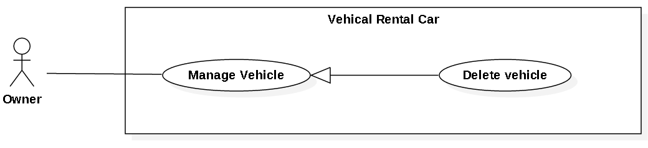

Figure 16 <Owner> Delete vehicle

|  |  |  |  |
| --- | --- | --- | --- |
| USE CASE – VRSO03 | | | |
| Use Case No. | VRSO03 | **Use Case Version** | 2.0 |
| Use Case Name | Delete vehicle | | |
| Author | HaiNT | | |
| Date |  | **Priority** | Medium |
| Actor:   * Owner.   Summary:   * This use case helps user to delete vehicle in the system.   Goal:   * User delete vehicle successfully.   Triggers:   * User sends delete vehicle command.   Preconditions:   * User must login into the system with role Owner. * There is at least 1 vehicle belongs to owner in the system.   Post Conditions:   * Success: Show message vehicle deleted successfully. * Fail: Show error message.   Main Success Scenario:   |  |  |  | | --- | --- | --- | | Step | Actor Action | System Response | | 1 | User sends delete vehicle command | Display confirm dialog “Do you really want to delete vehicle” and following information includes:   * Yes: button * No: button | | 2 | User select Yes option  [Alternative 1] | Show message vehicle deleted success. Vehicle’s isDelete flag is on. |   Alternative Scenario:   |  |  |  | | --- | --- | --- | | No | Actor Action | System Response | | 1 | User select No option | Dialog disable, delete vehicle process aborted. |   Exceptions: N/A  Relationships: N/A  Business Rules:   * Account status must be “Ready”. * Vehicle information will be deleted from database. | | | |

Table 19 Use case VRSO03 - <Owner> Delete vehicle

###### <Owner> View revenue report

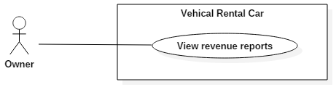

Figure 17 <Owner> View revenue report

|  |  |  |  |
| --- | --- | --- | --- |
| USE CASE – VRSO04 | | | |
| Use Case No. | VRSO04 | **Use Case Version** | 2.0 |
| Use Case Name | View revenue report | | |
| Author |  | | |
| Date |  | **Priority** | Medium |
| Actor:   * Owner.   Summary:   * This use case allow owner to view the rental profit report of vehicle stored in the system.   Goal:   * User can view vehicle rental profit report.   Triggers:   * User sends view report command.   Preconditions:   * User must login into the system with role Owner. * There is at least 1 vehicle belongs to owner in the system.   Post Conditions:   * Success: Vehicle report is show. * Fail: Show error message.   Main Success Scenario:   |  |  |  | | --- | --- | --- | | Step | Actor Action | System Response | | 1 | User goes to view profit report view. | Display new view contains the following information:   * Today income: text * Month income: text * Vehicle list: list * Vehicle item: hyperlink * Menu: button | | 2 | User send More detail command.  [Alternative 1] | Display new view list of items contains the following information:   * Vehicle name: text * Today vehicle income: text * Month vehicle income: text * Vehicle commission: text * Vehicle detail: text * Finish: button * Back: button | | 3 | User sends finish view report command. | Redirect to view profit report screen. |   Alternative Scenario:   |  |  |  | | --- | --- | --- | | No | Actor Action | System Response | | 1 | If user select Cancel button | Redirect to find vehicle screen. |   Exceptions: N/A  Relationships: N/A  Business Rules:   * User must login into the system with role Owner. * There is at least 1 vehicle belongs to owner in the system. * If vehicle of owner had not been rented, vehicle income is 0. | | | |

Table 20 Use case VRSO04 - <Owner> View revenue report

###### <Owner> Update penalty fee

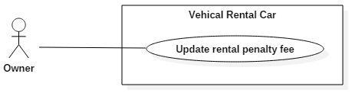

Figure 19 <Owner> Update penalty fee

|  |  |  |  |
| --- | --- | --- | --- |
| USE CASE – VRSO07 | | | |
| Use Case No. | VRSO07 | **Use Case Version** | 2.0 |
| Use Case Name | Update penalty fee | | |
| Author |  | | |
| Date |  | **Priority** | Medium |
| Actor:   * Owner.   Summary:   * This use case helps owner to updated penalty fee into rental bill for entire vehicle renting process and bill will be sent to the renter.   Goal:   * Owner can update penalty into rental bill and send to customer successfully.   Triggers:   * Customers send return vehicle request.   Preconditions:   * User must login into the system with role Owner. * There is at least 1 vehicle belongs to owner in the system. * Owner vehicle is being rented by customer.   Post Conditions:   * Success: Show create bill success message. * Fail: Show error message.   Main Success Scenario:   |  |  |  | | --- | --- | --- | | Step | Actor Action | System Response | | 1 | Customers **send request to end the renting process.** | The system sends a notice to the vehicle owner to inform them that their vehicle is finish rented. | | 2 | Owner send Update penalty fee command. | Display new view contains the following information:   * Rental time information: text * Extra time penalty: text * Interior fee: free integer input, length 1-20. * Exterior fee: free integer input, length 1-20. * Rental detail: text * Total cost: text * Finish: button | | 3 | User sends Finish bill command. | System send bill information to Customer. “**Update bill success” message show.** |   Alternative Scenario: N/A  Exceptions: N/A  Relationships: N/A  Business Rules:   * The information is loaded from the system. * User must login into the system with role Owner. * Delivery fee and damage cost default is 0. | | | |

Table 22 Use case VRSO07 - <Owner> Update penalty fee

###### <Owner> Create discount

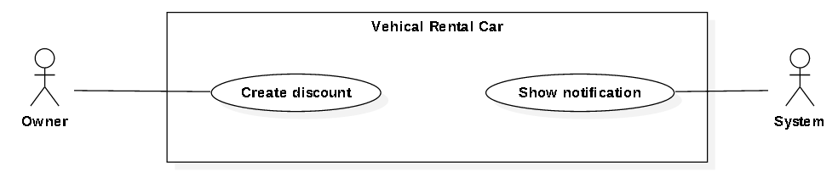

Figure 20 <Owner> Create discount

|  |  |  |  |
| --- | --- | --- | --- |
| USE CASE – VRSO08 | | | |
| Use Case No. | VRSO08 | **Use Case Version** | 2.0 |
| Use Case Name | Create discount | | |
| Author |  | | |
| Date |  | **Priority** | Medium |
| Actor:   * Owner.   Summary:   * This use case helps owner to create vehicle discount apply to their vehicle exist in the system.   Goal:   * Owner create vehicle discount successfully.   Triggers:   * Customers send create discount command.   Preconditions:   * User must login into the system with role Owner. * There is at least 1 vehicle belongs to owner in the system.   Post Conditions:   * Success: Show create discount success message. * Fail: Show error message.   Main Success Scenario:   |  |  |  | | --- | --- | --- | | Step | Actor Action | System Response | | 1 | Owner send Create discount command. | Display new view contains the following information:   * Discount value: text * Discount content: free text input, length 1-250. * End discount date: text * Vehicle apply discount: select list * Confirm: button * Cancel: button | | 3 | User sends Confirm command.  [Alternative 1] | Discount information send to server. “Create discount success” message show. |   Alternative Scenario:   |  |  |  | | --- | --- | --- | | No | Actor Action | System Response | | 1 | If user select cancel button | Create discount process aborted |   Exceptions: N/A  Relationships: N/A  Business Rules:   * The information is loaded from the system. * User must login into the system with role Owner. * Discount information is saved to system database. | | | |

Table 23 Use case VRSO08 - <Owner> Create discount

#### Website Application

##### <Employee> Overview Use Case

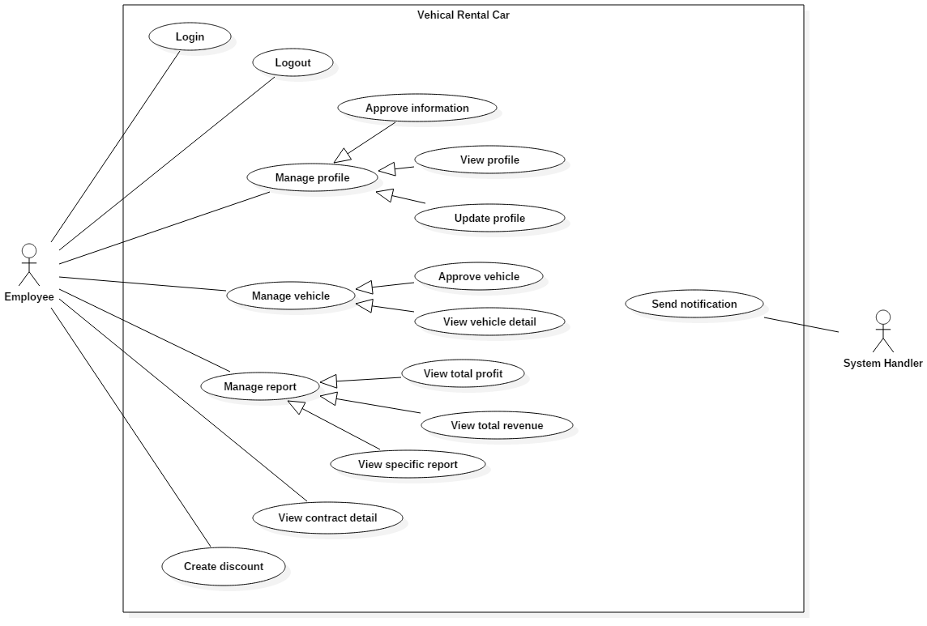

Figure 21 <Employee> Overview Use Case

##### <Employee> Approve information

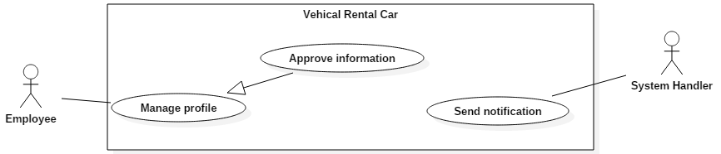

Figure 22 <Employee> Approve information

|  |  |  |  |
| --- | --- | --- | --- |
| USE CASE – VRSE01 | | | |
| Use Case No. | VRSE01 | **Use Case Version** | 2.0 |
| Use Case Name | Approve information | | |
| Author |  | | |
| Date |  | **Priority** | High |
| Actor:   * Employee.   Summary:   * This use case helps employee to view, verify and approve account information.   Goal:   * Employee approve account information successfully.   Triggers:   * Employee receive a create account request from customer.   Preconditions:   * User must login into the system with role Employee.   Post Conditions:   * Success: New account information will be saved to database. * Fail: Show error message.   Main Success Scenario:   |  |  |  | | --- | --- | --- | | Step | Actor Action | System Response | | 1 | User sends approve information command. | Display a new view with flowing information:   * ID number: textview. * Account username: textview. * Fullname: textview * Address: textview * Paypal number: textview * Phone: textview * ID picture: image * Account Status: button * Done: button * Back: button   [Exceptions 1] | | 2 | Employee select “Approve” in account status dropdown  [Alternative 1] | System save data to database.  Account status change to Ready. | | 3 | Employee select Done button  [Alternative 2] | Page re-load. Information dialog disable. |   Alternative Scenario:   |  |  |  | | --- | --- | --- | | No | Actor Action | System Response | | 1 | Employee select “Approve” in account status dropdown  [Alternative 1] |  | | 2 | Employee select Back button | Redirect to previous page. |   Exceptions:   |  |  |  | | --- | --- | --- | | No | Actor Action | System Response | | 1 | System not show account information | System reload view and re-fetch data from database. |   Relationships: N/A  Business Rules:   * The information is loaded from the system. * User must login into the system with role Employee | | | |

Table 24 Use case VRSE01 - <Employee> Approve information

###### <Employee> Update profile

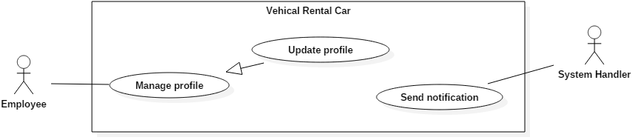

Figure 23 <Employee> Update profile

|  |  |  |  |
| --- | --- | --- | --- |
| USE CASE – VRSE02 | | | |
| Use Case No. | VRSE02 | **Use Case Version** | 2.0 |
| Use Case Name | Update profile | | |
| Author |  | | |
| Date |  | **Priority** | Medium |
| Actor:   * Employee.   Summary:   * This use case help employee to update customer information have been stored in the system.   Goal:   * Employee update customer information successfully.   Triggers:   * Employee sends update account information command.   Preconditions:   * User must login into the system with role Employee.   Post Conditions:   * Success: Update account information will be saved to database. * Fail: Show error message.   Main Success Scenario:   |  |  |  | | --- | --- | --- | | Step | Actor Action | System Response | | 1 | Employee sends update account request command. | Display update view shows to user:   * ID number: text. * Account username: text. * Fullname: free text input, length 1-250. * Address: free text input, length 1-250. * Paypal number: free text input, length 1-250. * Phone: free text input, length 1-250. * Done: button   [Exception 1] | | 2 | Employee inputs information. |  | | 3 | Employee sends Done command. | System validate information.  [Exception 2,3]  Save data to database.  Update data success message show. |   Alternative Scenario: N/A  Exceptions:   |  |  |  | | --- | --- | --- | | No | Actor Action | System Response | | 1 | System not show account information | System reload view and re-fetch data from database. | | 2 | Employee sends command to continue process request | System shows error message to ask Employee input missing required fields. | | 3 | Customer ID number is existed in the system | Show message to notify Employee that ID number is existed in the system. |   Relationships: N/A  Business Rules:   * The information is loaded from the system. * User must login into the system with role Employee | | | |

Table 25 Use case VRSE02 - <Employee> Update profile

###### <Employee> View profile

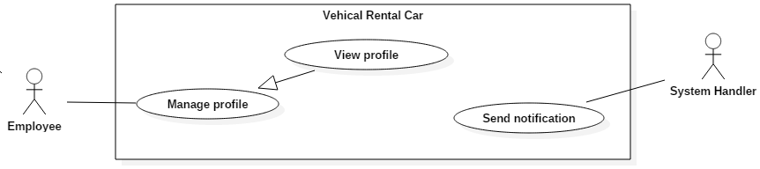

Figure 24 <Employee> View profile

|  |  |  |  |
| --- | --- | --- | --- |
| USE CASE – VRSE03 | | | |
| Use Case No. | VRSE03 | **Use Case Version** | 2.0 |
| Use Case Name | View profile | | |
| Author |  | | |
| Date |  | **Priority** | Medium |
| Actor:   * Employee.   Summary:   * This use case allow employee to view the customer information stored in the system.   Goal:   * User can view account information.   Triggers:   * User sends view information command.   Preconditions:   * User must login into the system with role Employee.   Post Conditions:   * Success: Show information of account. * Fail: Show error message.   Main Success Scenario:   |  |  |  | | --- | --- | --- | | Step | Actor Action | System Response | | 1 | User sends view information command | Display table contain account information with flowing information:   * Account status: text. * Detail: button. | | 2 | User sends view detail command | Display a new view with flowing information:   * ID number: text. * Account username: text. * Fullname: text * Address: text * Paypal number: text * Phone: text * Back: button   [Exceptions 1] | | 3 | User sends view detail command | Redirect to previous page |   Alternative Scenario: N/A  Exceptions:   |  |  |  | | --- | --- | --- | | No | Actor Action | System Response | | 1 | System not show account information | System reload view and re-fetch data from database. |   Relationships: N/A  Business Rules:   * Account status must be “Ready”. * User must login into the system with role Employee | | | |

Table 26 Use case VRSE03 - <Employee> View profile

###### <Employee> Approve vehicle

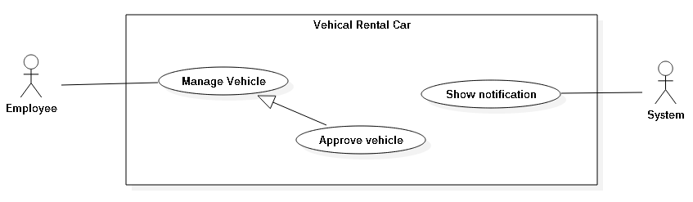

Figure 25 <Employee> Approve vehicle

|  |  |  |  |
| --- | --- | --- | --- |
| USE CASE – VRSE04 | | | |
| Use Case No. | VRSE04 | **Use Case Version** | 2.0 |
| Use Case Name | Approve vehicle | | |
| Author |  | | |
| Date |  | **Priority** | High |
| Actor:   * Employee.   Summary:   * This use case helps employee to view, verify and approve vehicle information.   Goal:   * Employee approve vehicle successfully.   Triggers:   * Employee receive a request of create vehicle from owner.   Preconditions:   * User must login into the system with role Employee.   Post Conditions:   * Success: New vehicle information will be saved to database. * Fail: Show error message.   Main Success Scenario:   |  |  |  | | --- | --- | --- | | Step | Actor Action | System Response | | 1 | Employee sends approve vehicle command. | Display a new view with flowing information:   * Frame number: text. * Vehicle name: text. * Engine type: text * Number of seats: text * Manufacture year: text * Vehicle registration certificate picture: image * Approve Status: dropdown * Decline: button * Edit: button   [Exceptions 1] | | 2 | Employee select Approve in approve status dropdown  [Alternative 1] | System save data to database.  Vehicle status change to Ready. | | 3 | Employee select Done button  [Alternative 2] | System redirect to vehicle information page. |   Alternative Scenario:   |  |  |  | | --- | --- | --- | | No | Actor Action | System Response | | 1 | Employee select Decline in approve status dropdow | System save data to database with vehicle status change to Reject. | | 2 | Employee select Back button | Redirect to previous page |   Exceptions:   |  |  |  | | --- | --- | --- | | No | Actor Action | System Response | | 1 | System not show account information | System reload view and re-fetch data from database. |   Relationships: N/A  Business Rules:   * The information is loaded from the system. * User must login into the system with role Employee | | | |

Table 27 Use case VRSE04 - <Employee> Approve vehicle

###### <Employee> View vehicle detail

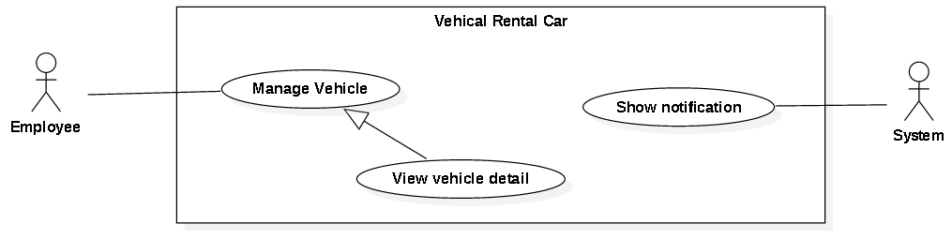

Figure 28 <Employee> View vehicle detail

|  |  |  |  |
| --- | --- | --- | --- |
| USE CASE – VRSE07 | | | |
| Use Case No. | VRSE07 | **Use Case Version** | 2.0 |
| Use Case Name | View vehicle detail | | |
| Author |  | | |
| Date |  | **Priority** | Medium |
| Actor:   * Employee.   Summary:   * This use case helps employee to view vehicle detail stored in the system.   Goal:   * Employee can view vehicle detail.   Triggers:   * Employee sends view vehicle command.   Preconditions:   * User must login into the system with role Employee.   Post Conditions:   * Success: Show detail information of vehicle. * Fail: Show error message.   Main Success Scenario:   |  |  |  | | --- | --- | --- | | Step | Actor Action | System Response | | 1 | User sends view vehicle detail command | Display a new view with flowing information:   * Frame number: text. * Vehicle name: text. * Engine type: text * Number of seats: text * Manufacture year: text * Back: button   [Exceptions 1] | | 2 | User sends back command | Redirect to manage vehicle page. |   Alternative Scenario: N/A  Exceptions:   |  |  |  | | --- | --- | --- | | No | Actor Action | System Response | | 1 | System not show account information | System reload view and re-fetch data from database. |   Relationships: N/A  Business Rules:   * Account status must be “Ready”. * User must login into the system with role Employee | | | |

Table 30 Use case VRSE07 - <Employee> View vehicle detail

###### <Employee> View total profit

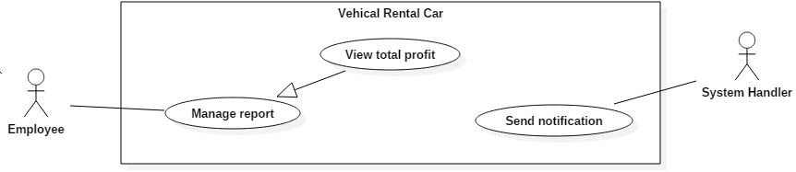

Figure 29 <Employee> View total profit

|  |  |  |  |
| --- | --- | --- | --- |
| USE CASE – VRSE08 | | | |
| Use Case No. | VRSE08 | **Use Case Version** | 2.0 |
| Use Case Name | View total profit | | |
| Author |  | | |
| Date |  | **Priority** | Medium |
| Actor:   * Employee.   Summary:   * This use case helps employee to view total report in the system.   Goal:   * Employee can view total report.   Triggers:   * Employee sends view total report command.   Preconditions:   * User must login into the system with role Employee.   Post Conditions:   * Success: Show total report. * Fail: Show error message   Main Success Scenario:   |  |  |  | | --- | --- | --- | | Step | Actor Action | System Response | | 1 | Employeegoes to view total report view. | Display new view contains the following information:   * Account status chart: pie chart * Vehicle status chart: pie chart |   Alternative Scenario: N/A  Exceptions: N/A  Relationships: extend by View report (Actor select between view total and view specific report)  Business Rules:   * User must login into the system with role Employee. * The information is loaded from the system. | | | |

Table 31 Use case VRSE08 - <Employee> View total profit

##### <Payment system> Overview Use Case

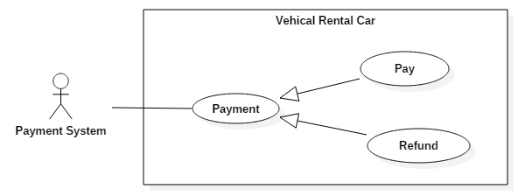

Figure 33 <Payment> Overview payment

###### <Payment system> Pay

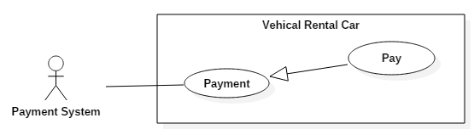

Figure 34 <Payment> Pay

|  |  |  |  |
| --- | --- | --- | --- |
| USE CASE – VRSP01 | | | |
| Use Case No. | VRSP01 | **Use Case Version** | 2.0 |
| Use Case Name | Pay | | |
| Author |  | | |
| Date |  | **Priority** | High |
| Actor:   * Payment system.   Summary:   * This use case allows payment system process the payment transaction.   Goal:   * Payment process is completed.   Triggers:   * Customer sends pay for charge by payment system command.   Preconditions:   * User must login into the system with role Customer.   Post Conditions:   * Success: Payment is completed successfully. * Fail: Show error message.   Main Success Scenario:   |  |  |  | | --- | --- | --- | | Step | Actor Action | System Response | | 1 | Customer select payment via PayPal. | Summary of customer payment:   * Description: text. * Amount: text. * Total: text.   Payment view is shown with following labels and fields:   * Customer’s PayPal account: free text input, required, length 3 – 250 * Customer’s PayPal password: free text input, required, length 6 – 32 | | 2 | Customer fills out the form. |  | | 3 | Customer sends pay command. | * Validate data   [Alternative 1]  [Exception 1, 2, 3]   * Process payment in PayPal |   Alternative Scenario:   |  |  |  | | --- | --- | --- | | No | Actor Action | System Response | | 1 | Identity information is not match. | Show message notify customer input wrong email or password. |   Exceptions:   |  |  |  | | --- | --- | --- | | No | Actor Action | System Response | | 1 | Missing of required fields | Show message notify staff input missed fields | | 2 | Length of field’s value is out of range | Show message notify staff which field’s value is out of range | | 3 | Entered email address is not a valid email | Show message notify entered email is not valid |   Relationships:   * <Customer> Rent vehicle   Business Rules:   * Use PayPal API to validate customer email and password. * PayPal will send notification to alert transaction is failed or succeeded. * An email address must be validated by this regular expression:   /^([a-z0-9_\.-]+)@([\da-z\.-]+)\.([a-z\.]{2,6})$/ | | | |

Table 34 Use case VRSP01 - <Payment> Pay

## Software System Attribute

### Usability

#### Graphic User Interface

All the texts, labels and alerts will be written in English

#### Usability

* The system usability is easy to use that will need less than 2 days of training for company staffs to use the system.

#### Installation

* User can follow installation and manual guide for installation. If there are any problems, user cans contacts developer for help.

### Reliability

* System notification success rate is less than 2 failed notifications per 1000 sent.
* Web service API response success rate is less than 2 failed requests per 10,000 requests.

### Availability

* N/A

### Security

* All input data are validated before saving to database.
* All privacy information such as password is encrypted to ensure security.
* Users is authentication/authorization for all users when they login to the system.

### Maintainability

* The system is separated into modules.

### Portability

* Admin, employee can use application on every supported web browser.
* Customer can use mobile application on every Android smartphone that have version greater than 4.0.

### Performance

* Requests from web application are responded in less than 10 seconds at 8 Mbps bandwidth speed.
* Mobile checker application should return card information in less than 1 minute at 8 Mbps bandwidth speed.

## Conceptual Diagram

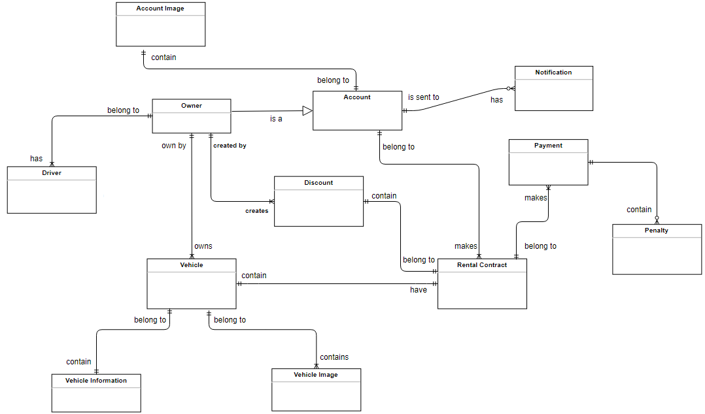

Figure 35 Conceptual diagram

**Data Dictionary**

|  |  |
| --- | --- |
| Entity Data dictionary: describe all content of all entities | |
| Entity Name | **Description** |
| Account | Abstract entity describes a user in system |
| Owner | Contain the owner information. |
| Rental Contract | Contain the contract information. |
| Payment | Contain the payment information. |
| Owner | Contain the owner information. |
| Vehicle | Contain the vehicle information. |
| Create Request | Contain the request information. |
| Notification | Contain the notification information |
| Account Image | Contain the account image information. |
| Vehicle Image | Contain the vehicle image information |
| Vehicle Information | Contain the vehicle information |
| Driver | Contain the driver information. |
| Discount | Contain the discount information |
| Penalty | Contain the penalty information |

Table 35 Conceptual Diagram Data Dictionary

# Software Design Description

## Design Overview

* This document describes the technical and user interface design Vehicles Rental System using web and mobile device. It includes the architectural design, he detailed design of common functions and business functions and the design of database model.
* The architectural design describes the overall architecture of the system and the architecture of each main component and subsystem.
* The detailed design describes static and dynamic structure for each component and functions. It includes class diagrams, class explanations and sequence diagrams for each use cases.
* The database design describes the relationships between entities and details of each entity.
* Document overview:
  + Section 2: gives an overall description of the system architecture design.
  + Section 3: gives component diagrams that describe the connection and integration of the system.
  + Section 4: gives the detail design description, which includes class diagram, class explanation, and sequence diagram to details the application functions.
  + Section 5: describe a fully attributed Entity Relationship Diagram.

## System Architecture Design

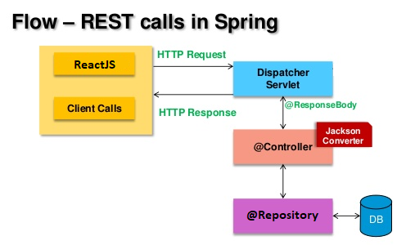

Figure 36 System architecture design

This diagram is referenced and modified from an original concept from: Chapter 6 Architecture Design, SOFTWARE ENGINEERING 9th Edition, by Ian Sommerville.



### Web Application architecture description

In Web Application, the system is developed under J2EE MVC architecture style. We choose this architecture for Web application because of in scope of 4-member team, MVC architecture make it easier to split the big project into small modules and make it easier to assign each module for members in our team.

This project follows MVC architecture with following components:

* **Servlet (Controller)** is the parts of the application that acts like event handler to handles user interaction. Typically, controller read data from a request and calls appropriate Business’s method then selects view to return to user.
* **JSP/HTML (View)** is the parts of the application that handles the display of the data. The selection of View is under control of Controller.
* **Business** is the parts of the application that do business processing to solve domain problems.
* **Model** is the parts of the application that acts like a data transfer object between the system and database.
* **Web Service** is the parts of the application that acts like event handler for web and mobile communication via REST method.

### Mobile Application architecture description

The application is developed as an Android native application. In general, the application architecture conforms to Android architecture.



**Reference:** [Android Developer Guide - Application Fundamentals](http://developer.android.com/guide/components/fundamentals.html)

This project follows Android application architecture with following component:

* **Activity** is the basic core of an android application that handles user input, create thread to run asynchronous tasks, send request and receive data from server via web services ...

## Component Diagram

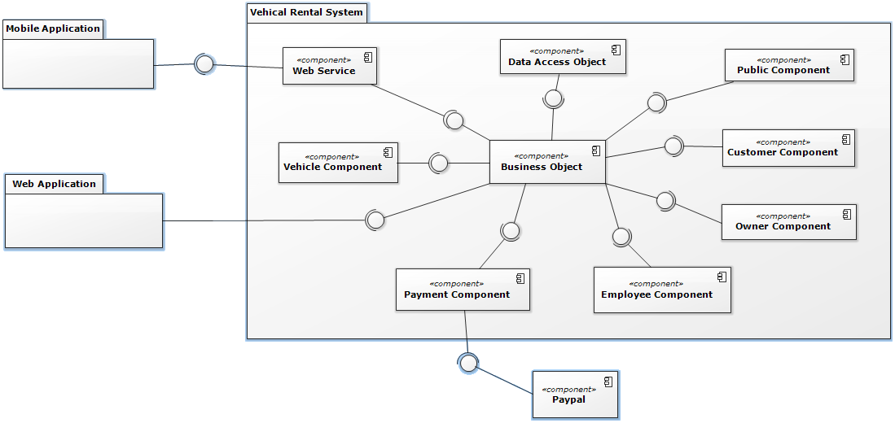

Figure 37 Component Diagram

|  |  |
| --- | --- |
| Component Dictionary: Describes components | |
| Web Application | Web application package: View, Controller |
| Mobile Application | Mobile application package |
| PayPal | Handle payment process with PayPal API |
| Payment Component | Component to handle payment process |
| Web Service | operations o handle interaction between the system and database.Provide API for mobile applications to interact with the system. |
| Employee Component | Component to handle staff activities in the system |
| Customer Component | Component to handle customer activities in the system |
| Vehicle Activities | Component to handle vehicle activities in the system |
| Public Component | Component to handle guest activities in the system |
| Owner Component | Component to handle owner activities in the system |
| Business Objects | Common objects to handle domain business operations for each component |
| Data Access Objects | Component to handle interaction between the system and database |

Table 36 Component Dictionary



## Detailed Description

### Class Diagram

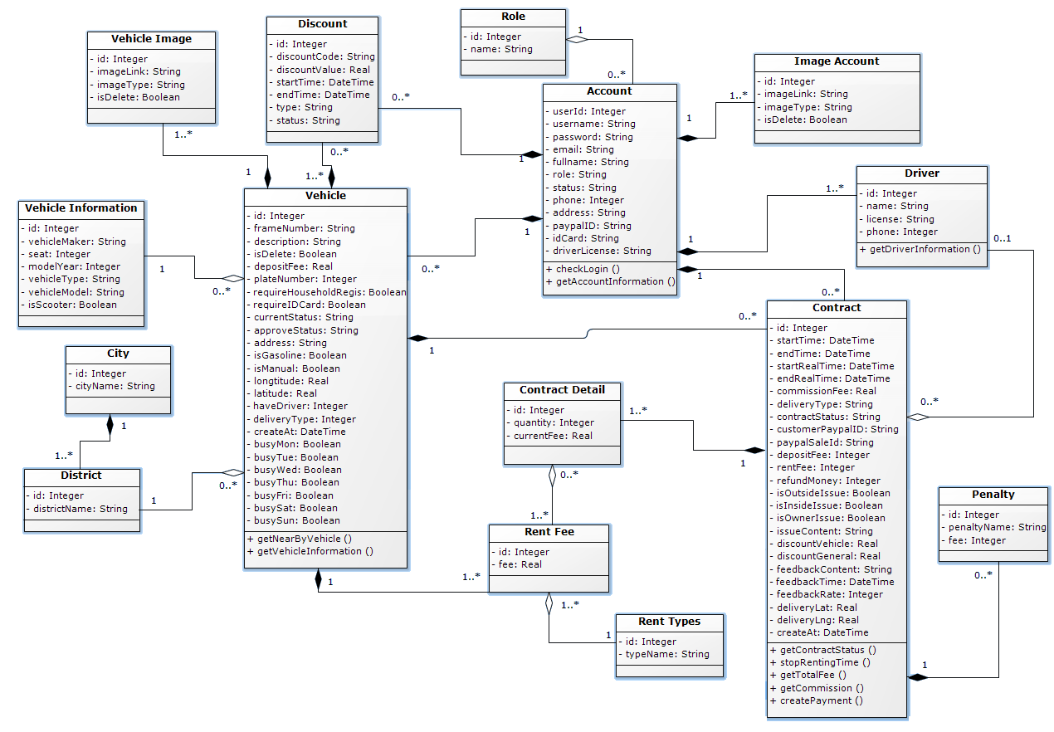

Figure 38 Class diagram

|  |  |  |
| --- | --- | --- |
| Class dictionary: describe Class | | |
| Class Name | **Mapping column with Conceptual diagram** | **Description** |
| Account | Account | Contain the account information. |
| Role | N/A | Not exist in conceptual diagram. But needed in class diagram to know what role of the account belong to |
| Vehicle | Vehicle | Contain the vehicle information |
| Contract | Rental Contract | Contain the contract information. |
| Vehicle Image | Vehicle Image | Contain the vehicle image information. |
| Image Account | Account Image | Contain the account image information. |
| Vehicle Information | Vehicle Information | Contain the vehicle detail information. |
| Discount | Discount | Not exist in conceptual diagram. But needed in class diagram to know what vehicle discount is read. |
| Driver | Driver | Contain the driver information. |
| Penalty | Penalty | Contain the penalty fee information. |
| Contract Detail | N/A | Not exist in conceptual diagram. But needed in class diagram to know the contract detail information. |
| Rent Fee | N/A | Not exist in conceptual diagram. But needed in class diagram to know vehicle rental fee |
| Rent Type | N/A | Not exist in conceptual diagram. But needed in class diagram to know type of rental fee |
| City | N/A | Not exist in conceptual diagram. But needed in class diagram to know the city name |
| District | N/A | Not exist in conceptual diagram. But needed in class diagram to know thel district name |

Table 37 Class dictionary

### Class Diagram Explanation

#### Account

|  |  |  |  |
| --- | --- | --- | --- |
| Attribute | Type | Visibility | Description |
| userId | Integer | Private | Unique identifier of an account |
| Username | String | Private | Account’s username. |
| Password | String | Private | Account’s password. |
| Email | String | Private | Account’s email. |
| Fullname | String | Private | Account’s fullname. |
| Role | String | Private | Account’s role. |
| Status | String | Private | Account’s status. |
| Phone | String | Private | Account’s phone number. |
| Address | String | Private | Account’s address. |
| paypalID | String | Private | The account’s paypal ID. |
| idCard | String | Private | The account’s personal ID number. |
| driverLicense | String | Private | The account’s driver license number. |

Table 38 Account Attribute

|  |  |  |  |
| --- | --- | --- | --- |
| Method | Return Type | Visibility | Description |
| Getter | Attribute type | Public | Get attribute value. |
| Setter | Void | Public | Set value of attribute. |

Table 39 Account Method

#### Contract

|  |  |  |  |
| --- | --- | --- | --- |
| Attribute | Type | Visibility | Description |
| Id | Integer | Private | Unique identifier of a contract |
| startTime | DateTime | Private | The start time of the contract. |
| endTime | DateTime | Private | The end time of the contract. |
| startRealTime | DateTime | Private | The real start time of the contract. |
| endRealTime | DateTime | Private | The real end time of the contract. |
| comissionFee | Integer | Private | The comission cost of the contract. |
| deliveryType | String | Private | The delivery type of vehicle. |
| contractStatus | String | Private | The status of contract. |
| customerPaypalId | String | Private | The paypal Id of customer. |
| paypalSaleId | String | Private | The paypal Id of system. |
| depositFee | Integer | Private | The deposit fee of the contract. |
| rentFee | Integer | Private | The rental fee of the contract. |
| refundMoney | Integer | Private | The refund amount of the contract |
| Is_outside_issue | Boolean | Private | Check the exterior is damaged or not. |
| Is_inside_issue | Boolean | Private | Check the interior is damaged or not. |
| Is_owner_issue | Boolean | Private | Check some issue about vehicle owner or not. |
| Issue_content | String | Private | Content of the contract issue |
| Discount_vehicle | Float | Private | The discount amount of the vehicle |
| Discount_general | Float | Private | The discount amount of the system |
| Feedback_content | String | Private | Feedback content |
| Feedback_time | DateTime | Private | Feedback last modified time |
| Feedback_rate | Integer | Private | The number of stars of feedback |
| Delivery_lat | Float | Private | The latitude of location the vehicle needed to delivery to |
| Delivery_lng | Float | Private | The longitude of location the vehicle needed to delivery to |
| Create_at | DateTime | Private | Contract’s created time |

Table 40 Contract Attribute

|  |  |  |  |
| --- | --- | --- | --- |
| Method | Return Type | Visibility | Description |
| Getter | Attribute type | Public | Get attribute value. |
| Setter | Void | Public | Set value of attribute. |

Table 41 Contract Method

#### Vehicle

|  |  |  |  |
| --- | --- | --- | --- |
| Attribute | Type | Visibility | Description |
| Id | Integer | Private | Unique identifier of a vehicle |
| frameNumber | Integer | Private | Frame number of a vehicle |
| Description | String | Private | The description of vehicle. |
| isDelete | Boolean | Private | The vehicle status is deleted or not. |
| depositFee | Integer | Private | The vehicle deposit price. |
| plateNumber | Integer | Private | The plate number of vehicle. |
| requireIDCard | Boolean | Private | The vehicle renting required ID card or not. |
| requireHousehold | Boolean | Private | The vehicle renting required house hold registration or not. |
| currentStatus | String | Private | The vehicle current status. |
| approveStatus | String | Private | The approve vehicle status. |
| address | String | Private | The vehicle’s address. |
| isGasoline | Boolean | Private | Check vehicle is run by gasoline or not. |
| isManual | Boolean | Private | Check vehicle is manual transmission or not. |
| longtitude | Float | Private | Vehicle’s longtitude |
| latitude | Float | Private | Vehicle’s latitude |
| haveDriver | Integer | Private | Vehicle is included driver or not |
| deliveryType | Integer |  | Vehicle delivery type |
| createdAt | DateTime | Private | The time vehicle is created |
| busyMon | Boolean | Private | Check vehicle is busy on monday or not |
| busyTue | Boolean | Private | Check vehicle is busy on tuesday or not |
| busyWed | Boolean | Private | Check vehicle is busy on wednesday or not |
| busyThu | Boolean | Private | Check vehicle is busy on thursday or not |
| busyFri | Boolean | Private | Check vehicle is busy on friday or not |
| busySat | Boolean | Private | Check vehicle is busy on saturday or not |
| busySun | Boolean | Private | Check vehicle is busy on sunday or not |
|  |  |  |  |

Table 42 Vehicle Attribute

|  |  |  |  |
| --- | --- | --- | --- |
| Method | Return Type | Visibility | Description |
| Getter | Attribute type | Public | Get attribute value. |
| Setter | Void | Public | Set value of attribute. |

Table 43 Vehicle Method

#### Image Account

|  |  |  |  |
| --- | --- | --- | --- |
| Attribute | Type | Visibility | Description |
| Id | Integer | Private | Unique identifier of an image |
| imageLink | String | Private | The link where image is stored |
| imageType | String | Private | The type of image. |
| isDelete | Boolean | Private | The image status is deleted or not. |

Table 44 Image Attribute

|  |  |  |  |
| --- | --- | --- | --- |
| Method | Return Type | Visibility | Description |
| Getter | Attribute type | Public | Get attribute value. |
| Setter | Void | Public | Set value of attribute. |

Table 45 Image Method

#### Driver

|  |  |  |  |
| --- | --- | --- | --- |
| Attribute | Type | Visibility | Description |
| Id | Integer | Private | Unique identifier of a driver |
| name | String | Private | Driver’s name |
| license | String | Private | Driver license number of the driver |
| phone | Integer | Private | Driver’s phone number |

Table 46 Driver Attribute

|  |  |  |  |
| --- | --- | --- | --- |
| Method | Return Type | Visibility | Description |
| Getter | Attribute type | Public | Get attribute value. |
| Setter | Void | Public | Set value of attribute. |

Table 47 Driver Method

#### Penalty

|  |  |  |  |
| --- | --- | --- | --- |
| Attribute | Type | Visibility | Description |
| Id | Integer | Private | unique identifier of a penalty |
| Name | String | Private | The penalty’s name. |
| Fee | Integer | Private | The price of the penalty. |

Table 48 Penalty Attribute

|  |  |  |  |
| --- | --- | --- | --- |
| Method | Return Type | Visibility | Description |
| Getter | Attribute type | Public | Get attribute value. |
| Setter | Void | Public | Set value of attribute. |

Table 49 Penalty Method

#### Discount

|  |  |  |  |
| --- | --- | --- | --- |
| Attribute | Type | Visibility | Description |
| Code | String | Private | Unique identifier of a discount code |
| discountCode | String | Private | The dscount code |
| discountValue | Float | Private | The discount values |
| startTime | DateTime | Private | The start discount time |
| endTime | DateTime | Private | The end discount time |
| type | String | Private | The discount type |

Table 50 Discount Attribute

|  |  |  |  |
| --- | --- | --- | --- |
| Method | Return Type | Visibility | Description |
| Getter | Attribute type | Public | Get attribute value. |
| Setter | Void | Public | Set value of attribute. |

Table 51 Discount Method

#### Vehicle Image

|  |  |  |  |
| --- | --- | --- | --- |
| Attribute | Type | Visibility | Description |
| Id | Integer | Private | Unique identifier of a vehicle image. |
| imageLink | String | Private | The link where image is stored |
| imageType | String | Private | The type of image |
| isDelete | Boolean | Private | The image status is deleted or not. |

Table 52 Vehicle Image Attribute

|  |  |  |  |
| --- | --- | --- | --- |
| Method | Return Type | Visibility | Description |
| Getter | Attribute type | Public | Get attribute value. |
| Setter | Void | Public | Set value of attribute. |

Table 53 Vehicle Image Method

#### Vehicle Information

|  |  |  |  |
| --- | --- | --- | --- |
| Attribute | Type | Visibility | Description |
| Id | Int | Private | Unique identifier of the vehicle type. |
| vehicleMarker | String | Private | Vehicle manufacturer name |
| Seat | Integer | Private | The number of vehicle seat |
| modelYear | Integer | Private | Vehicle manufacture year |
| vehicleType | String | Private | Type of vehicle |
| vehicleModel | String | Private | Model name of the vehicle |
| isScooter | Boolean | Private | Check if vehicle is scooter or not |

Table 54 Vehicle Information Attribute

|  |  |  |  |
| --- | --- | --- | --- |
| Method | Return Type | Visibility | Description |
| Getter | Attribute type | Public | Get attribute value. |
| Setter | Void | Public | Set value of attribute. |

Table 55 Vehicle Information Method

#### Rent type

|  |  |  |  |
| --- | --- | --- | --- |
| Attribute | Type | Visibility | Description |
| Id | Integer | Private | Unique identifier of rent type |
| typeName | String | Private | The name of rental type |

Table 56 Rent type Attribute

|  |  |  |  |
| --- | --- | --- | --- |
| Method | Return Type | Visibility | Description |
| Getter | Attribute type | Public | Get attribute value. |
| Setter | Void | Public | Set value of attribute. |

Table 57 Rent type Method

#### Rent Fee

|  |  |  |  |
| --- | --- | --- | --- |
| Attribute | Type | Visibility | Description |
| Id | Integer | Private | Unique identifier of rent fee |
| Fee | Float | Private | The rental fee |

Table 58 Rent fee Attribute

|  |  |  |  |
| --- | --- | --- | --- |
| Method | Return Type | Visibility | Description |
| Getter | Attribute type | Public | Get attribute value. |
| Setter | Void | Public | Set value of attribute. |

Table 59 Rent fee Method

#### Role

|  |  |  |  |
| --- | --- | --- | --- |
| Attribute | Type | Visibility | Description |
| Id | Integer | Private | Unique identifier of role |
| Name | String | Private | The name of role |

Table 60 Role Attribute

|  |  |  |  |
| --- | --- | --- | --- |
| Method | Return Type | Visibility | Description |
| Getter | Attribute type | Public | Get attribute value. |
| Setter | Void | Public | Set value of attribute. |

Table 61 Role Method

#### District

|  |  |  |  |
| --- | --- | --- | --- |
| Attribute | Type | Visibility | Description |
| Id | Integer | Private | Unique identifier of rent fee |
| districtName | String | Private | The name of district |

Table 62 District Attribute

|  |  |  |  |
| --- | --- | --- | --- |
| Method | Return Type | Visibility | Description |
| Getter | Attribute type | Public | Get attribute value. |
| Setter | Void | Public | Set value of attribute. |

Table 63 District Method

#### City

|  |  |  |  |
| --- | --- | --- | --- |
| Attribute | Type | Visibility | Description |
| Id | Integer | Private | Unique identifier of rent fee |
| cityName | String | Private | The name of city |

Table 64 City Attribute

|  |  |  |  |
| --- | --- | --- | --- |
| Method | Return Type | Visibility | Description |
| Getter | Attribute type | Public | Get attribute value. |
| Setter | Void | Public | Set value of attribute. |

Table 65 City Method

#### Contract Detail

|  |  |  |  |
| --- | --- | --- | --- |
| Attribute | Type | Visibility | Description |
| Id | Integer | Private | Unique identifier of rent fee |
| quantity | Integer | Private | The quantity of rent fee |
| currentFee | Float | Private | The current fee of contract |

Table 66 Contract Detail Attribute

|  |  |  |  |
| --- | --- | --- | --- |
| Method | Return Type | Visibility | Description |
| Getter | Attribute type | Public | Get attribute value. |
| Setter | Void | Public | Set value of attribute. |

Table 67 Contract Detail Method

### Interactive Diagram

#### Android Application

##### Customer

##### View vehicle list

Summary: this diagram shown process of customer view vehicle list

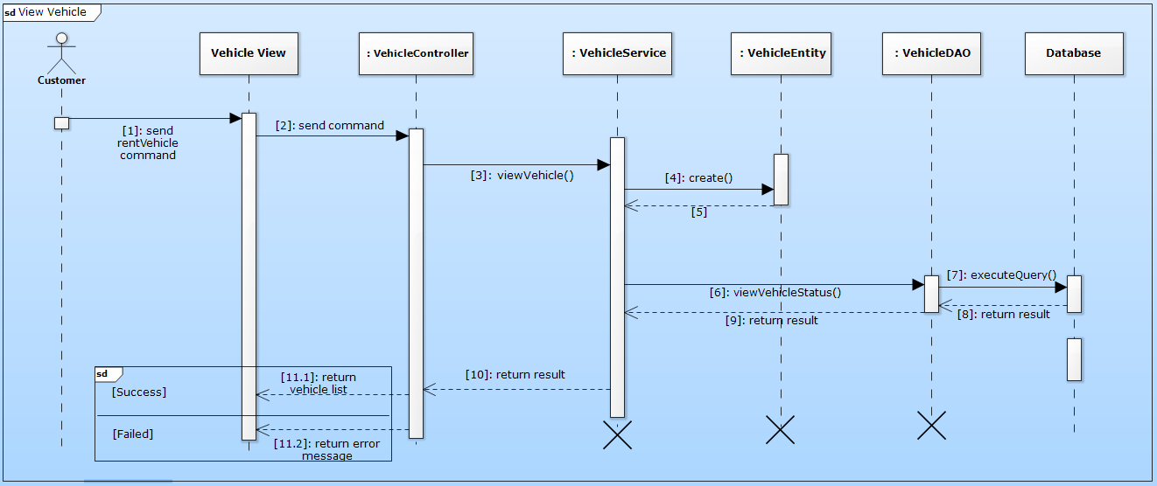

Figure 39 Sequence diagram - <Customer>View vehicle list

##### Create rental contract

Summary: this diagram shown process of customer create a rental contract vehicle

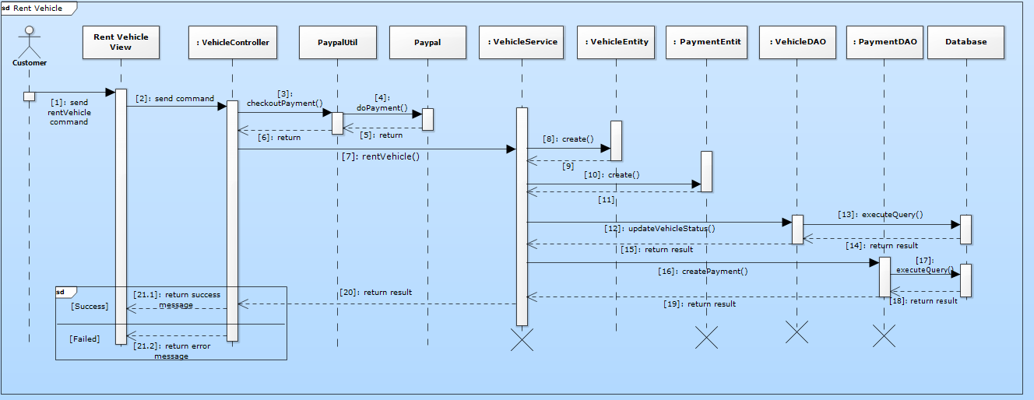

Figure 40 Sequence diagram - <Customer> Create rental contract

##### Cancel renting vehicle

Summary: this diagram shown process of customer cancels renting vehicle

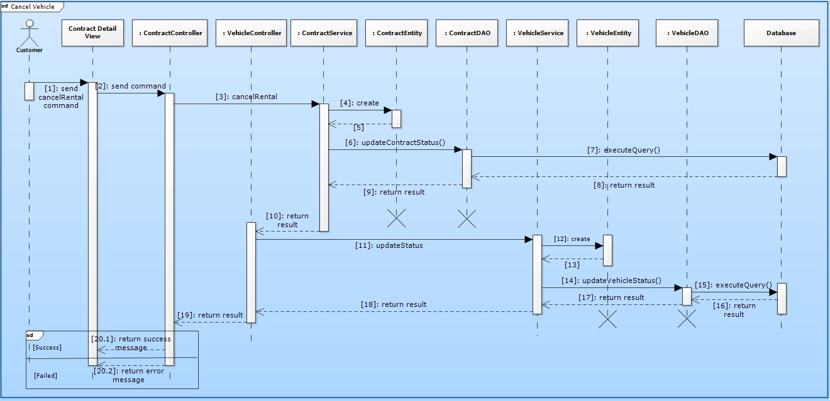

Figure 41 Sequence diagram - <Customer> Cancel renting vehicle

##### Complain rental contract

Summary: this diagram shown process of customer complain about bill in rental contract

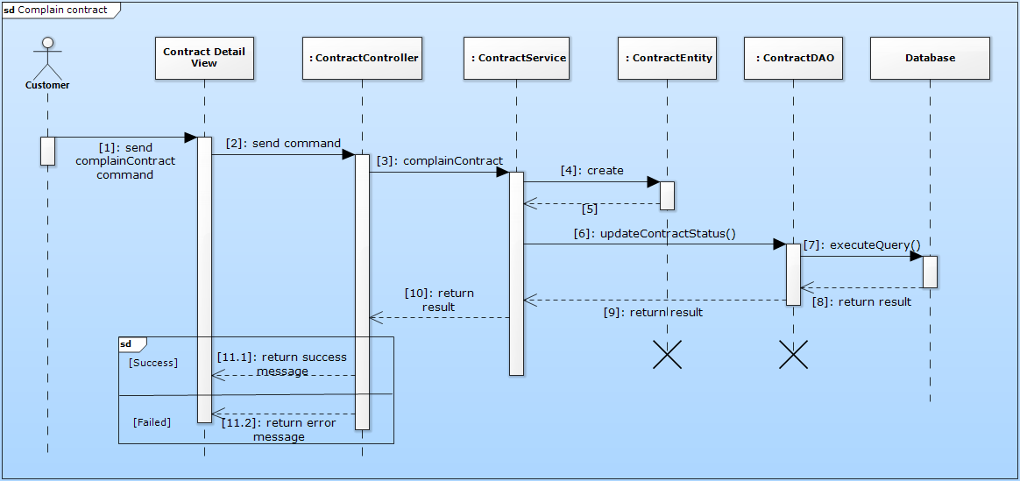

Figure 41 Sequence diagram - <Customer> Complain rental contract

##### PayPal payment

Summary: this diagram shown process of user does payment

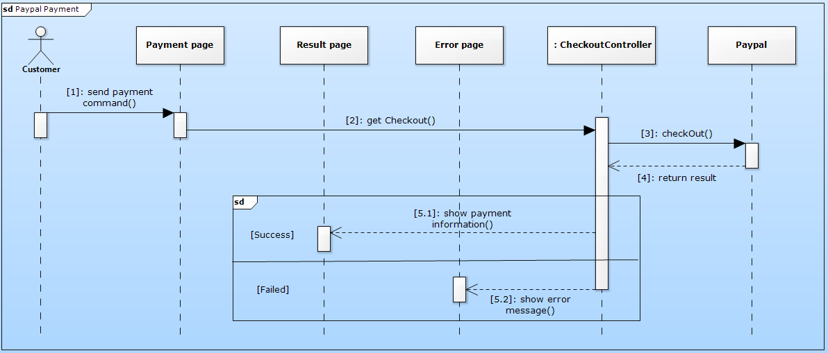

Figure 42 Sequence diagram - <Customer> PayPal payment

##### Owner

##### Create vehicle

Summary: this diagram shown process of owner create vehicle account

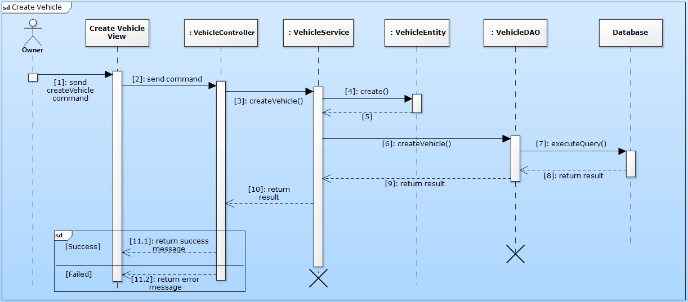

Figure 43 Sequence diagram - <Owner> Create vehicle

##### Update penalty bill

Summary: this diagram shown process of owner create renting bill

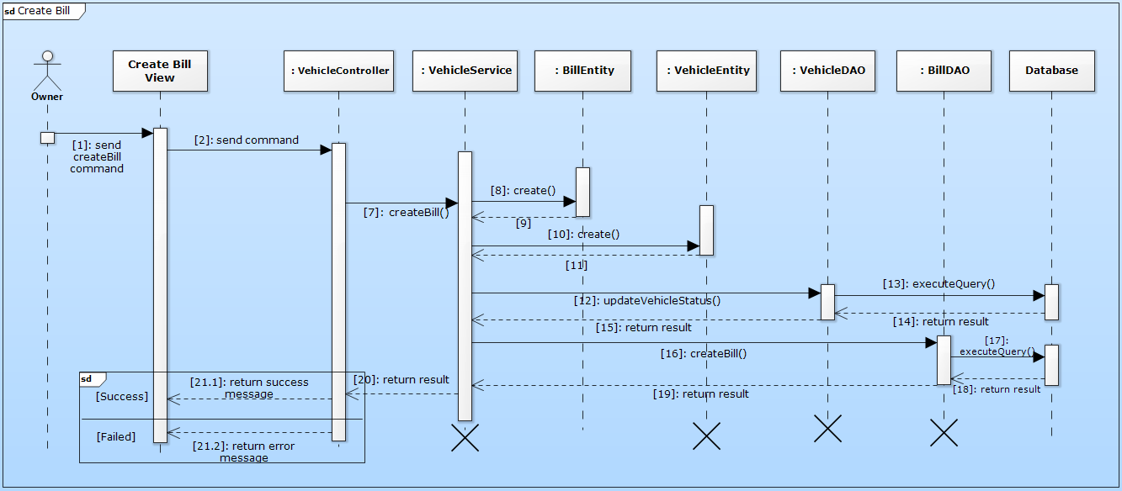

Figure 44 Sequence diagram - <Owner> Update penalty bill

##### Guest

##### Register new account

Summary: this diagram shown process of guest registers new account

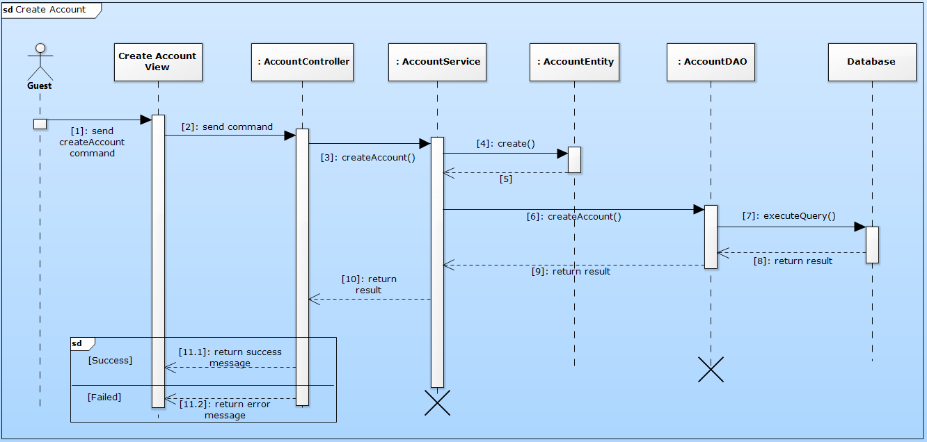

Figure 45 Sequence diagram - <Guest> Register new account

##### Website Application

##### Employee

##### Approve account

Summary: this diagram shown process of employee approve account

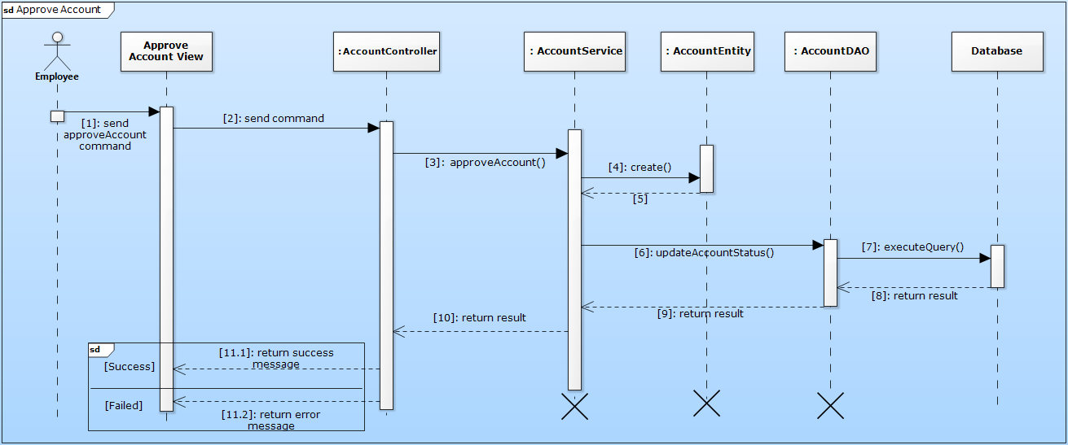

Figure 46 Sequence diagram - <Employee> Approve account

##### Approve vehicle

Summary: this diagram shown process of employee approve vehicle.

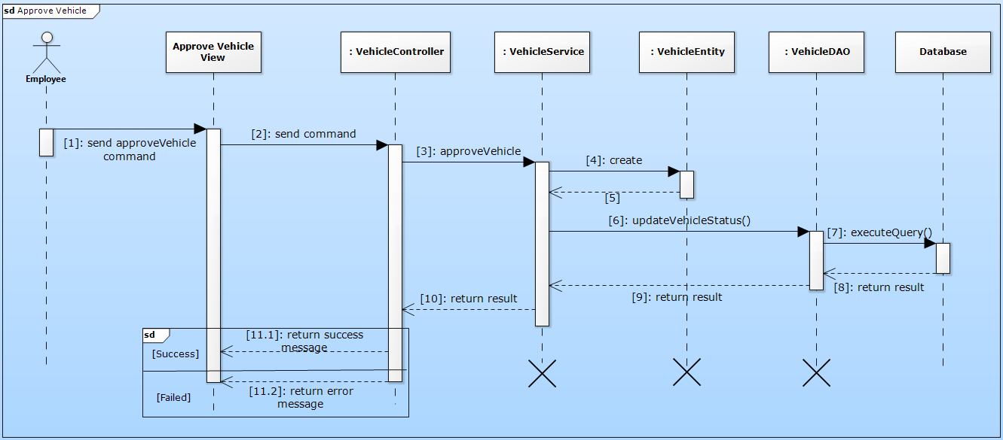

Figure 47 Sequence diagram - <Employee> Approve vehicle

##### Manage vehicle

Summary: this diagram shown process of employee manage vehicle.

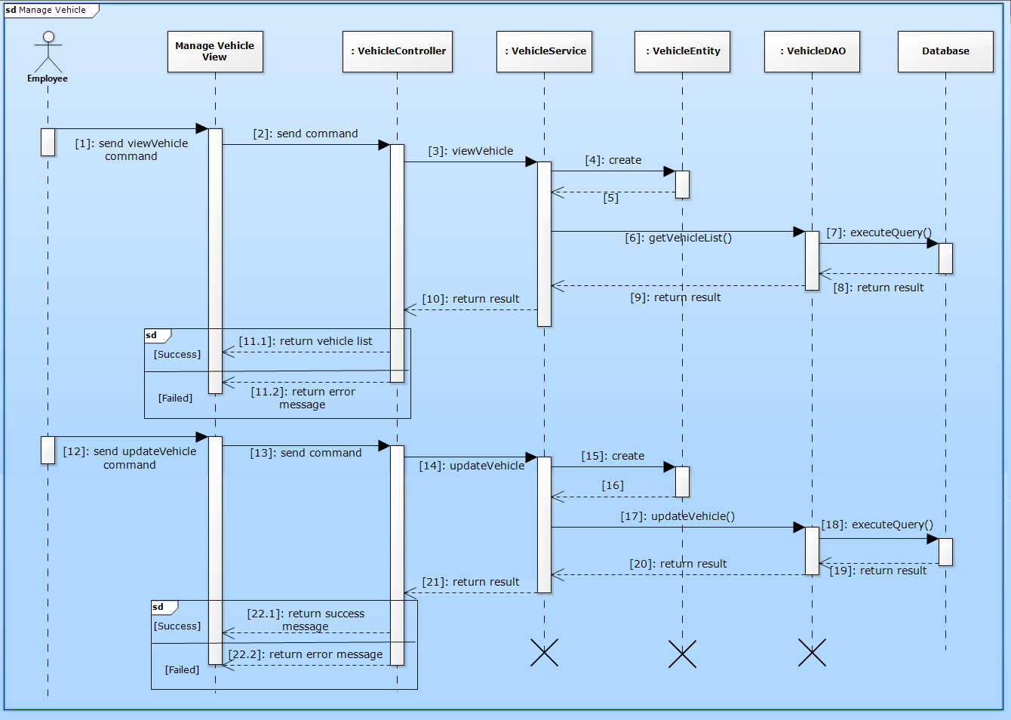

Figure 48 Sequence diagram - <Employee> Manage vehicle

## Interface

### Component Interface

#### Web Service Interface

|  |  |  |  |  |  |
| --- | --- | --- | --- | --- | --- |
| Signature | Description | Input | Output | Output Format | Exception |
| public ResponseObject getListNonVerifyAccount() | Get list of non-verified account | None | Json string List of non-verified account | List<AccountEntity> | JsonProcessingException |
| Contractlean if the update is successntractpublic ResponseObject getContracts(R r) | Search contracts by code or customer name | Request object r contains:  Keyword: String | Json string List of ContractSearchResultDto | ContractEntity | JsonProcessingException |
| public ResponseObject updateAccountStatus(R r) | Update account status | Request object r contains:  accountID: String  status: Enum(String) | ResponseBody for update success or fail | ResponseBody | JsonProcessingException  NoResultException |
| public ResponseObject createVehicle(R r) | Create new vehicle | Request object r contains:  vehicleInformation: VehicleInfomation,  vehicleImage: List<File> | ResponseBody for create vehicle success or fail | ResponseBody | JsonProcessingException  NoResultException |
| public ResponseObject createContract(R r) | Create new contract | Request object r contains:  customerID: int,  ownID: int,  vehicle: List<> | ResponseBody for create constract success or fail | ResponseBody | JsonProcessingException |

Table 68 Web Services Interfaces

|  |  |
| --- | --- |
| Entity | Description |
| ContractEntity | contractCode  startDate  expiredDate  status  contractFee  plate  brand  modelCode  vehicleType  color  engine  chassis  capacity  yearOfManufacture  weight  seatCapacity  cancelDate  cancelReason  cancelNote  staffCode  contractTypeId  customerCode  needRenewPayment  lastModified  createdDate |
| CustomerEntity | customerCode  name  address  email  phone  personalId  password  isDefaultPassword  lastModified |

Table 69 Output format description

|  |  |
| --- | --- |
| Exception | Description |
| JsonProcessingException | encountered when processing (parsing, generating) JSON content that are not pure I/O problems |
| NoResultException | Thrown by the persistence provider when getSingleResult() is executed on a query and there is no result to return |

Table 70 Exception description

### Web application Design

#### Employee Interface Design

##### Employee home page

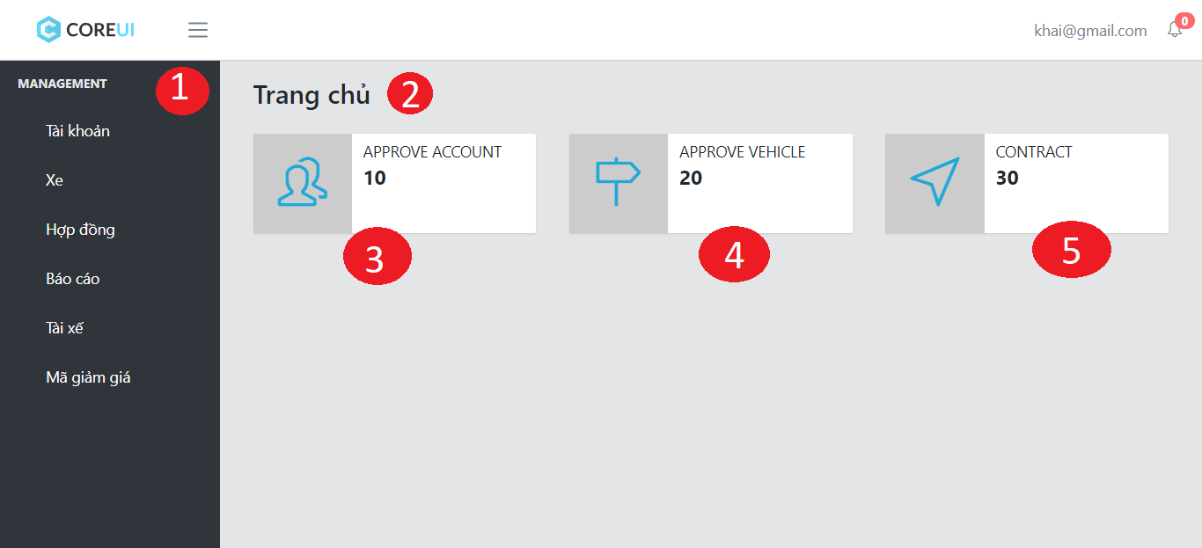

Figure 50 Interface - <Employee> Home page

**Fields**

|  |  |  |  |  |  |  |  |
| --- | --- | --- | --- | --- | --- | --- | --- |
| No | Field Name | Description | Read only | Mandatory | Control Type | Data Type | Length |
| 1 | Menu | Navigation bar | Yes | Yes | Menu bar | N/A | N/A |
| 2 | Title | Title of the page | Yes | Yes | Label | N/A | N/A |

Table 71 Employee home page fields

**Buttons/Hyperlinks**

|  |  |  |  |  |
| --- | --- | --- | --- | --- |
| No | Function | Description | Validation | Outcome |
| 3 | approveAccount | Navigate to manage account page | N/A | Transfer to list contract page |
| 4 | approveVehicle | Navigate to manage vehicle page | N/A | Transfer to manage vehicle page |
| 5 | manageContract | Navigate to manage contract page | N/A | Transfer to approve account page |

Table 72 Employee home page buttons/hyperlinks

##### Manage account

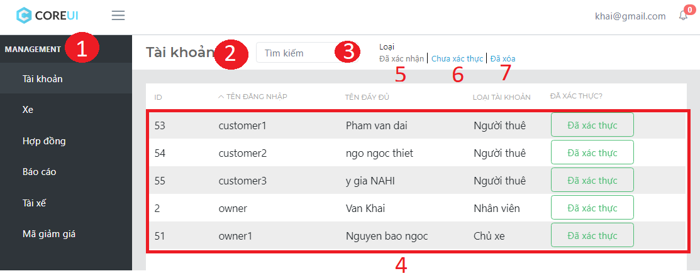

Figure 51 Interface - < Employee> Manage account

**Fields**

|  |  |  |  |  |  |  |  |
| --- | --- | --- | --- | --- | --- | --- | --- |
| No | Field Name | Description | Read only | Mandatory | Control Type | Data Type | Length |
| 1 | Menu | Navigation bar | Yes | Yes | Menu bar | N/A | N/A |
| 2 | Title | Title of the page | Yes | Yes | Label | N/A | N/A |
| 3 | txtSearchValue | Fill search keyword | No | Yes | Textbox | String | N/A |
| 4 | Table | Table of contain account information | Yes | Yes | Table | N/A | N/A |

Table 73 < Employee> Manage approve account fields

**Buttons/Hyperlinks**

|  |  |  |  |  |
| --- | --- | --- | --- | --- |
| No | Function | Description | Validation | Outcome |
| 5 | btnApprove | Load table contain information of approved account | N/A | Reload account information table |
| 6 | btnNotApprove | Load table contain information of approved account | N/A | Reload account information table |
| 7 | btnDeleteAccount | Load table contain information of delete account | N/A | Reload account information table |

Table 74 < Employee> Manage approve account buttons/hyperlinks

##### Approve account

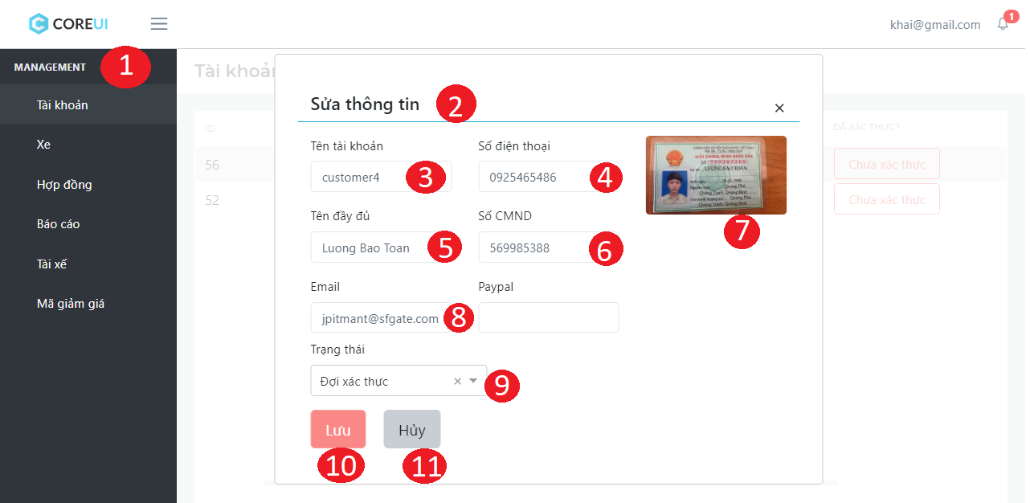

Figure 52 Interface - < Employee> Approve account

**Fields**

|  |  |  |  |  |  |  |  |
| --- | --- | --- | --- | --- | --- | --- | --- |
| No | Field Name | Description | Read only | Mandatory | Control Type | Data Type | Length |
| 1 | Menu | Navigation bar | Yes | Yes | Menu bar | N/A | N/A |
| 2 | Title | Title of the page | Yes | Yes | Label | N/A | N/A |
| 3 | txtName | Account’s name | Yes | Yes | Textview | String | 3 – 80 |
| 4 | txtPhone | Account’s phone number | Yes | Yes | Textview | Integer | 8 – 15 |
| 5 | txtFullname | Account’s fullname | Yes | Yes | Textview | Integer | 8 – 15 |
| 6 | txtPersonal ID | Account’s ID number | Yes | Yes | Textview | Integer | 8 – 15 |
| 7 | imgID | Account’s ID card picture | Yes | Yes | Image | N/A | N/A |
| 8 | txtEmail | Account’s email | Yes | Yes | Textview | String | 3 – 250 |

Table 75 < Employee> Approve account fields

**Buttons/Hyperlinks**

|  |  |  |  |  |
| --- | --- | --- | --- | --- |
| No | Function | Description | Validation | Outcome |
| 9 | drpStatus | Drop down contain status of the account | N/A | Transfer to approve account page |
| 10 | btnApprove | Approve account information is valid | N/A | Transfer to approve account page |
| 11 | btnCancel | Decline account information because it not valid | N/A | Transfer to approve account page |

Table 76 < Employee> Approve account buttons/hyperlinks

##### View account detail

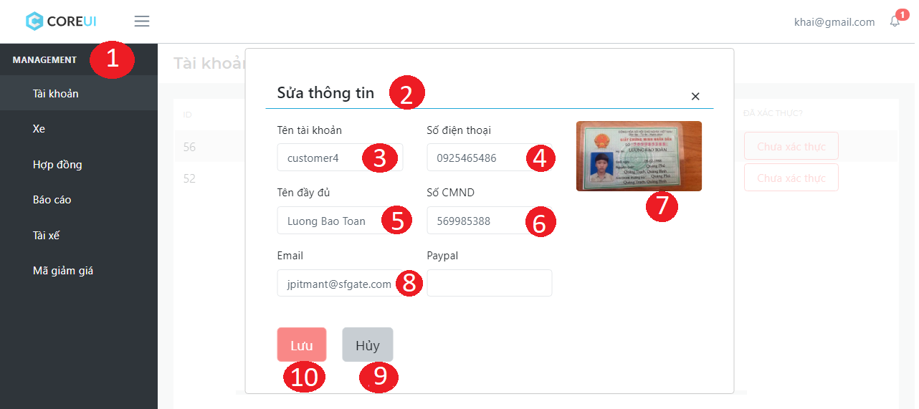

Figure 54 Interface - <Employee> View account detail

**Fields**

|  |  |  |  |  |  |  |  |
| --- | --- | --- | --- | --- | --- | --- | --- |
| No | Field Name | Description | Read only | Mandatory | Control Type | Data Type | Length |
| 1 | Menu | Navigation bar | Yes | Yes | Menu bar | N/A | N/A |
| 2 | Title | Title of the page | Yes | Yes | Label | N/A | N/A |
| 3 | txtName | Account’s name | Yes | Yes | Textview | String | 3 – 80 |
| 4 | txtPhone | Account’s phone number | Yes | Yes | Textview | Integer | 8 – 15 |
| 5 | txtFullname | Account’s fullname | Yes | Yes | Textview | Integer | 8 – 15 |
| 6 | txtPersonal ID | Account’s ID number | Yes | Yes | Textview | Integer | 8 – 15 |
| 7 | imgID | Account’s ID card picture | Yes | Yes | Image | N/A | N/A |
| 8 | txtEmail | Account’s email | Yes | Yes | Textview | String | 3 – 250 |

Table 79 <Employee> View account detail fields

**Buttons/Hyperlinks**

|  |  |  |  |  |
| --- | --- | --- | --- | --- |
| No | Function | Description | Validation | Outcome |
| 10 | btnApprove | Approve account information is valid | N/A | Transfer to approve account page |
| 9 | btnCancel | Decline account information because it not valid | N/A | Transfer to approve account page |

Table 80 <Employee> View account detail buttons/hyperlinks

##### Manage approve vehicle

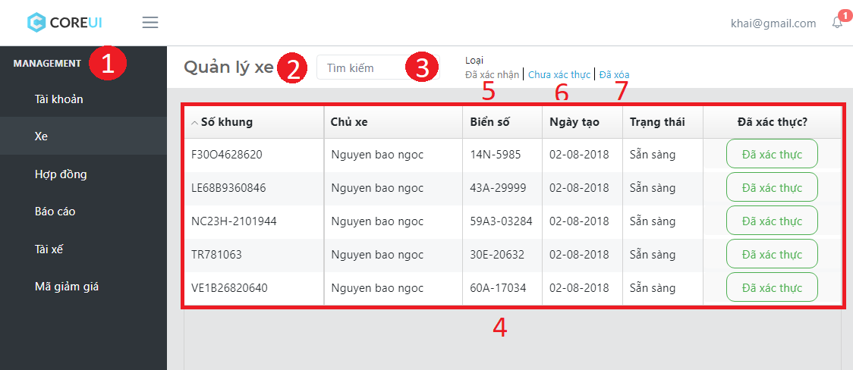

Figure 55 Interface - <Employee> Manage approve vehicle

**Fields**

|  |  |  |  |  |  |  |  |
| --- | --- | --- | --- | --- | --- | --- | --- |
| No | Field Name | Description | Read only | Mandatory | Control Type | Data Type | Length |
| 1 | Menu | Navigation bar | Yes | Yes | Menu bar | N/A | N/A |
| 2 | Title | Title of the page | Yes | Yes | Label | N/A | N/A |
| 3 | txtSearchValue | Fill search keyword | No | Yes | Textbox | String | N/A |
| 4 | Table | Table of contain vehicle information | Yes | Yes | Table | N/A | N/A |

Table 81 <Employee> Manage approve vehicle fields

**Buttons/Hyperlinks**

|  |  |  |  |  |
| --- | --- | --- | --- | --- |
| No | Function | Description | Validation | Outcome |
| 5 | btnApprove | Load table contain information of approved vehicle | N/A | Reload vehicle information table |
| 6 | btnNotApprove | Load table contain information of approved vehicle | N/A | Reload vehicle information table |
| 7 | btnDeleteVehicle | Load table contain information of delete vehicle | N/A | Reload vehicle information table |

Table 82 <Employee> Manage approve vehicle buttons/hyperlinks

##### Approve vehicle

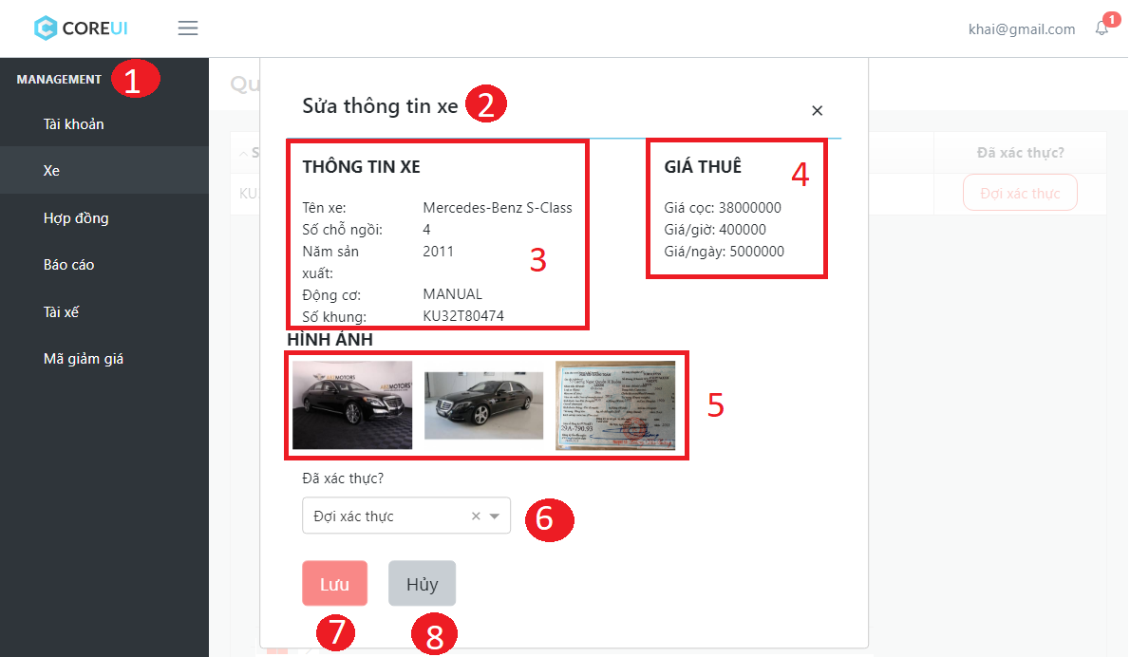

Figure 56 Interface - <Employee> Approve vehicle

**Fields**

|  |  |  |  |  |  |  |  |
| --- | --- | --- | --- | --- | --- | --- | --- |
| No | Field Name | Description | Read only | Mandatory | Control Type | Data Type | Length |
| 1 | Menu | Navigation bar | Yes | Yes | Menu bar | N/A | N/A |
| 2 | Title | Title of the page | Yes | Yes | Label | N/A | N/A |
| 3 | lblVehicleInfo | Table contain detail information of vehicle | Yes | Yes | Label | String | 3 – 80 |
| 4 | lblPrice | Table contain price vehicle | Yes | Yes | Textview | String | 3 – 250 |
| 5 | imgVehicle | Images of vehicle | Yes | Yes | Image | N/A | N/A |

Table 83 <Employee> Approve vehicle fields

**Buttons/Hyperlinks**

|  |  |  |  |  |
| --- | --- | --- | --- | --- |
| No | Function | Description | Validation | Outcome |
| 6 | drpStatus | Drop down contain status of vehicle | N/A | Transfer to approve vehicle page |
| 7 | btnSave | Approve account information is valid | N/A | Transfer to approve vehicle page |
| 8 | btnCancel | Decline account information because it not valid | N/A | Transfer to approve vehicle page |

Table 84 <Employee> Approve vehicle buttons/hyperlinks

##### View vehicle detail

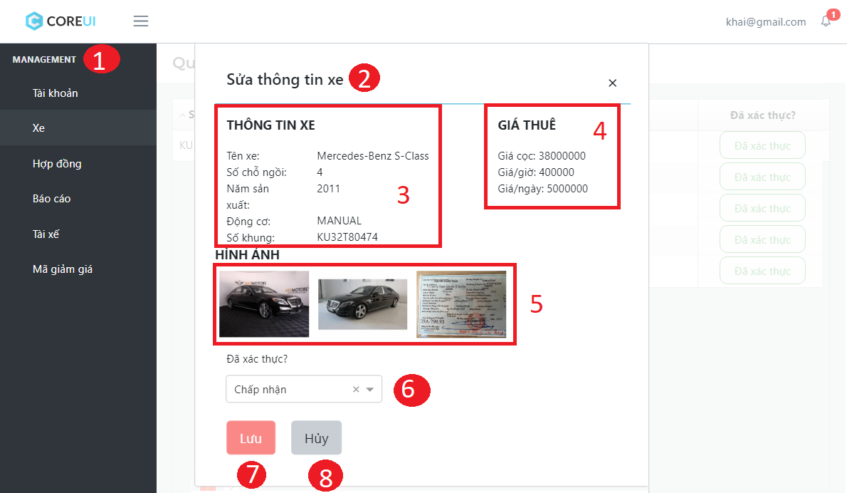

Figure 58 Interface - <Employee> View vehicle detail

**Fields**

|  |  |  |  |  |  |  |  |
| --- | --- | --- | --- | --- | --- | --- | --- |
| No | Field Name | Description | Read only | Mandatory | Control Type | Data Type | Length |
| 1 | Menu | Navigation bar | Yes | Yes | Menu bar | N/A | N/A |
| 2 | Title | Title of the page | Yes | Yes | Label | N/A | N/A |
| 3 | lblVehicleInfo | Table contain detail information of vehicle | Yes | Yes | Label | String | 3 – 80 |
| 4 | lblPrice | Table contain price vehicle | Yes | Yes | Textview | String | 3 – 250 |
| 5 | imgVehicle | Images of vehicle | Yes | Yes | Image | N/A | N/A |

Table 87 <Employee> View vehicle detail fields

**Buttons/Hyperlinks**

|  |  |  |  |  |
| --- | --- | --- | --- | --- |
| No | Function | Description | Validation | Outcome |
| 6 | drpStatus | Drop down contain status of vehicle | N/A | Transfer to approve vehicle page |
| 7 | btnSave | Approve account information is valid | N/A | Transfer to approve vehicle page |
| 8 | btnCancel | Decline account information because it not valid | N/A | Transfer to approve vehicle page |

Table 88 <Employee> View vehicle detail buttons/hyperlinks

##### Manage report

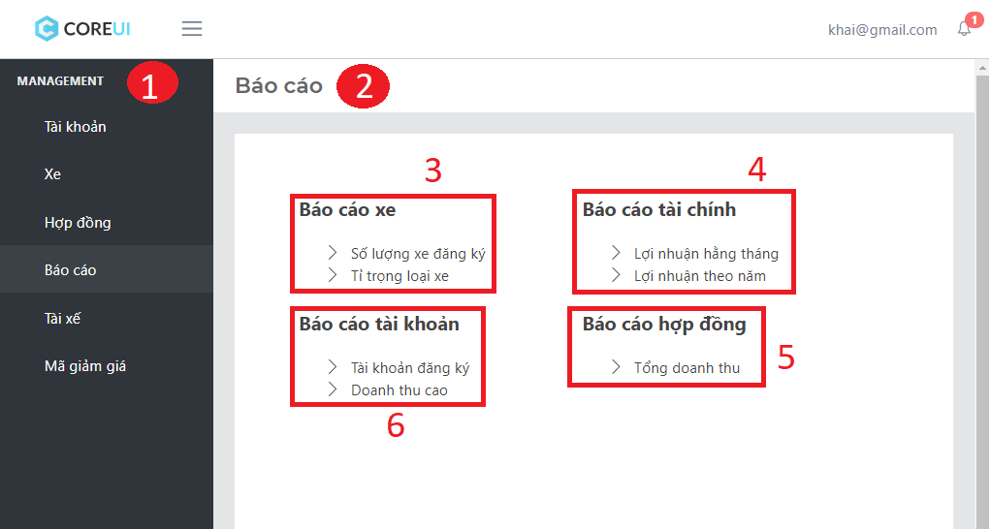

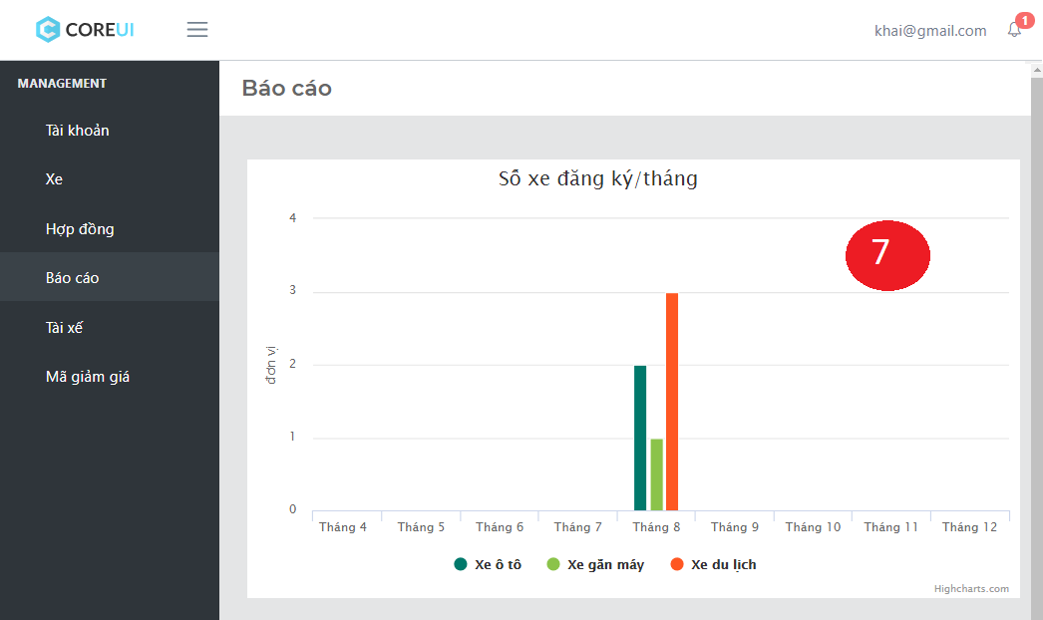

Figure 59 Interface - <Employee> Manage report

**Fields**

|  |  |  |  |  |  |  |  |
| --- | --- | --- | --- | --- | --- | --- | --- |
| No | Field Name | Description | Read only | Mandatory | Control Type | Data Type | Length |
| 1 | Menu | Navigation bar | Yes | Yes | Menu bar | N/A | N/A |
| 2 | Title | Title of the page | Yes | Yes | Label | N/A | N/A |
| 7 | Chart | Statistics chart | Yes | No | Chart | N/A | N/A |

Table 89 <Employee> Manage report fields

**Buttons/Hyperlinks**

|  |  |  |  |  |
| --- | --- | --- | --- | --- |
| No | Function | Description | Validation | Outcome |
| 3 | vehicleReport | Group contain hyperlink for vehicle report | N/A | Transfer to statistics chart |
| 4 | financeReport | Group contain hyperlink for finance report | N/A | Transfer to statistics chart |
| 4 | accountReport | Group contain hyperlink for account report | N/A | Transfer to statistics chart |
| 4 | contractReport | Group contain hyperlink for contract report | N/A | Transfer to statistics chart |

Table 90 <Employee> Manage report buttons/hyperlinks

### Android application Design

#### Customer Interface Design

##### Register account

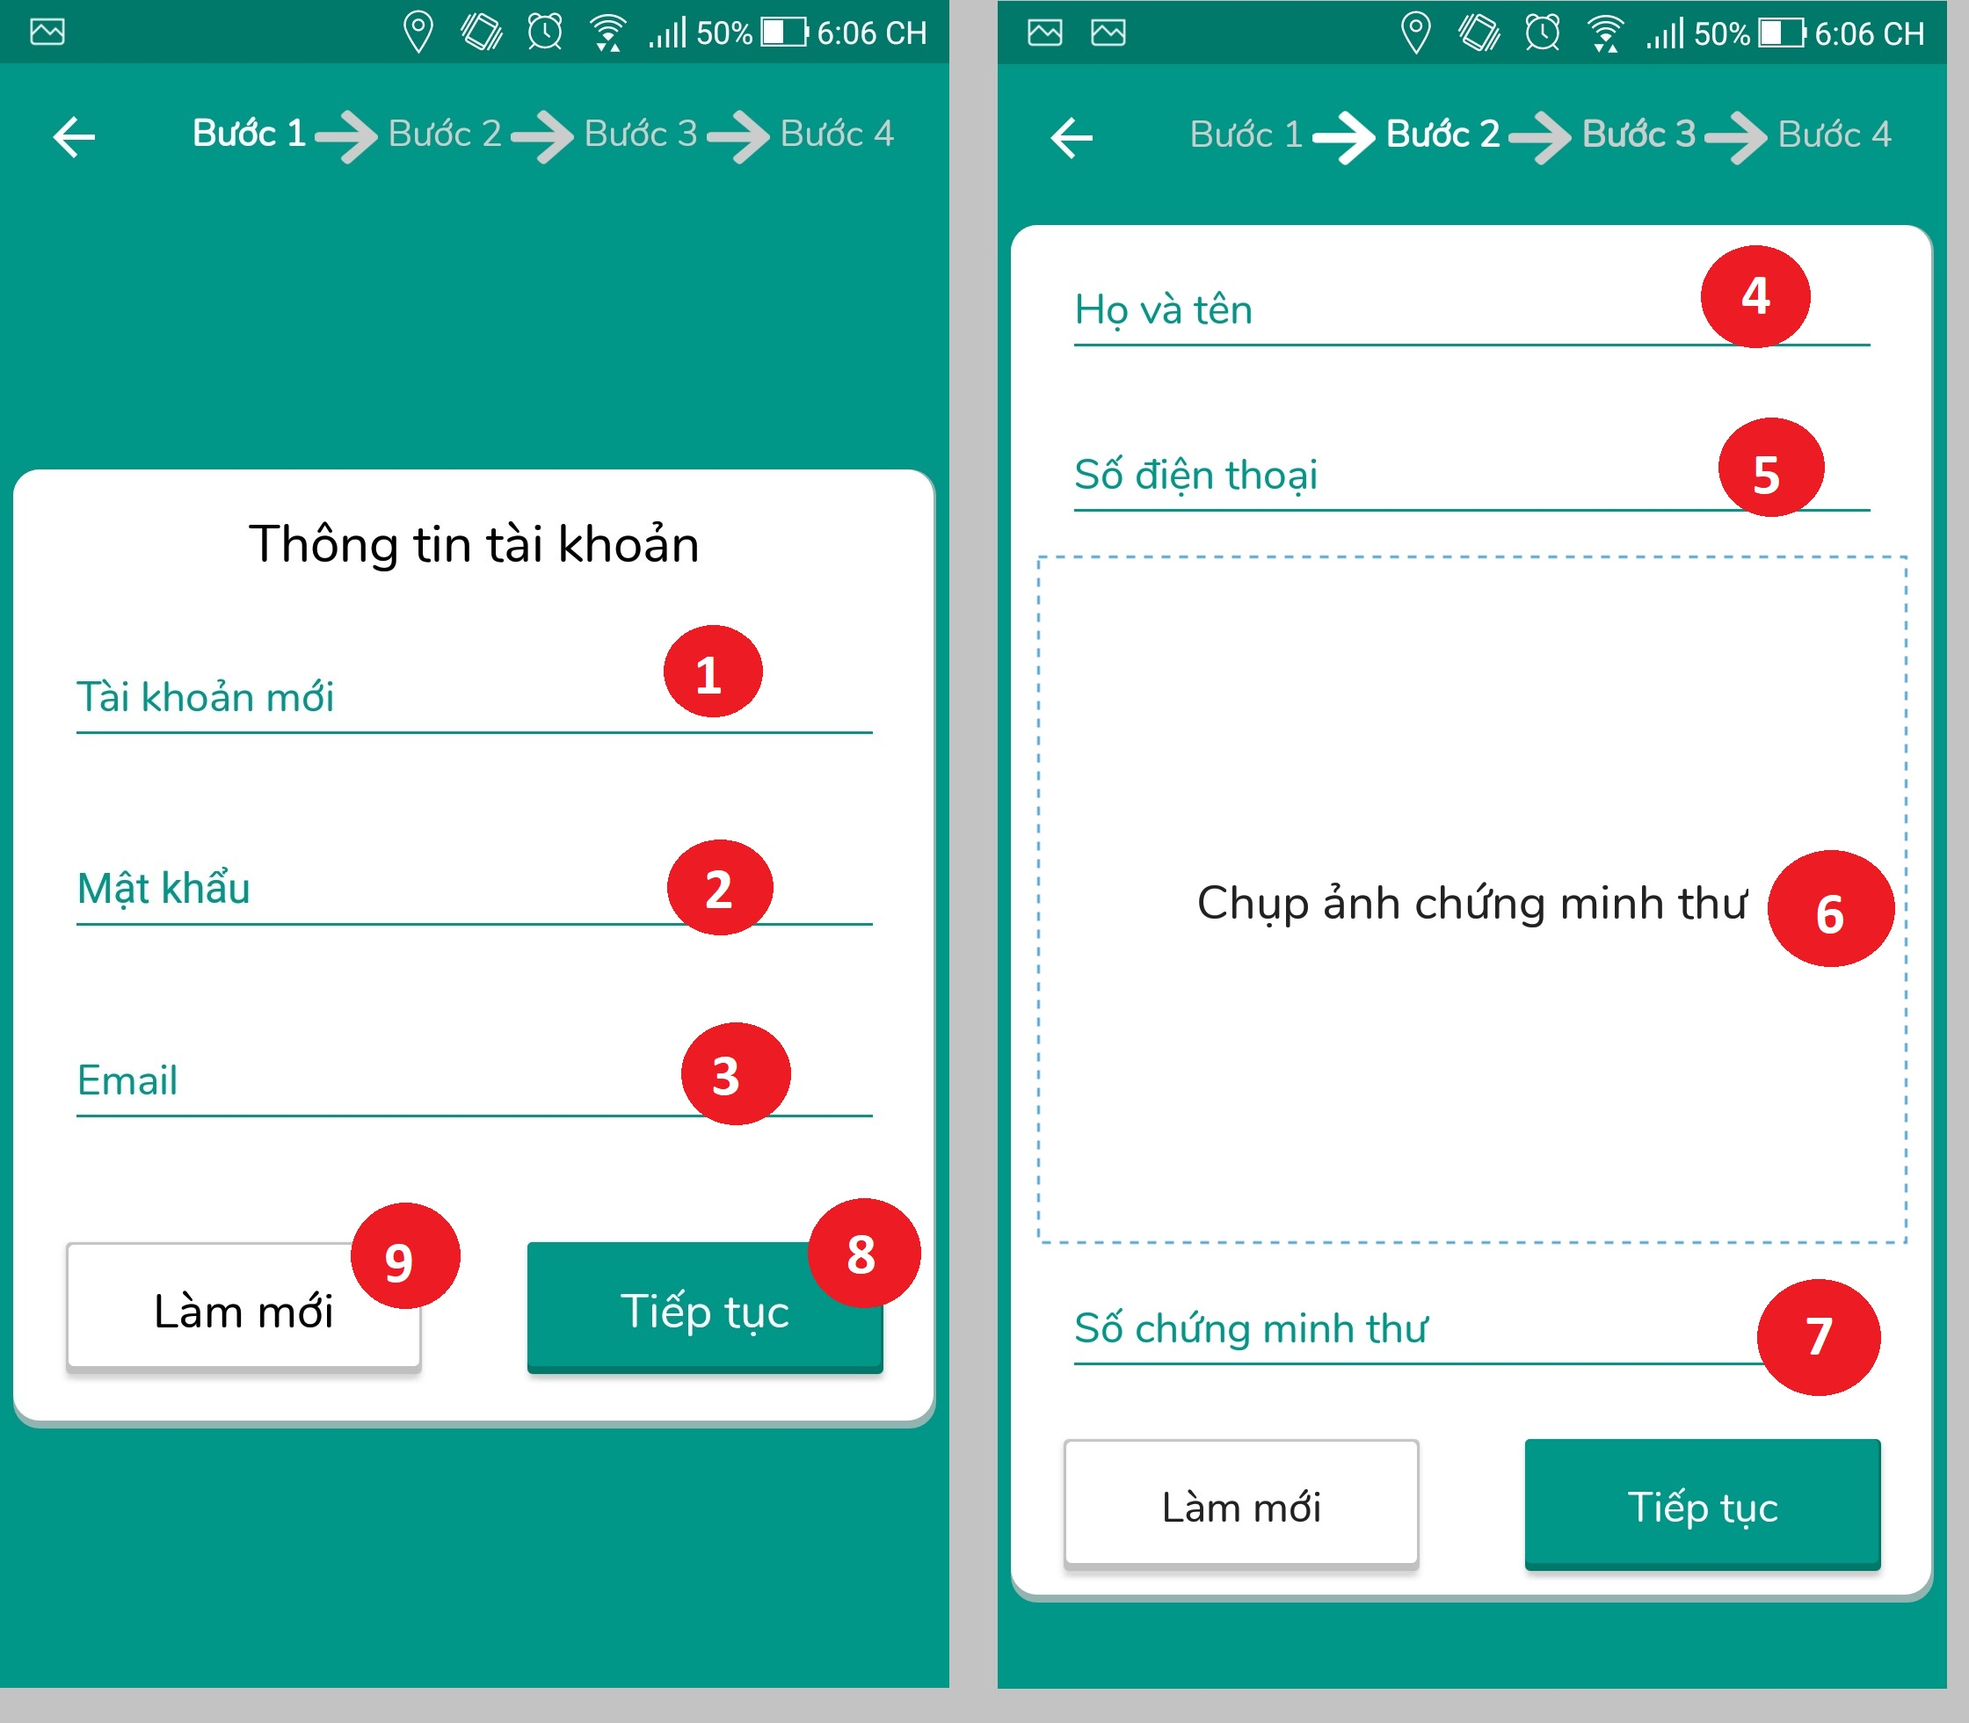

Figure 60 Interface - <Customer> Register account

**Fields**

|  |  |  |  |  |  |  |  |
| --- | --- | --- | --- | --- | --- | --- | --- |
| No | Field Name | Description | Read only | Mandatory | Control Type | Data Type | Length |
| 1 | txtUsername | Fill customer username | No | Yes | Textbox | String | 8-250 |
| 2 | txtPassword | Fill customer password | No | Yes | Textbox | String | 8-250 |
| 3 | txtEmail | Fill customer email | No | Yes | Textbox | String | 8-250 |
| 4 | txtFullname | Fill customer full name | No | Yes | Textbox | String | 8-250 |
| 5 | txtPhone | Fill customer phone | No | Yes | Textbox | int | 8-12 |
| 6 | imgIDCard | Customer ID card image | Yes | Yes | Image | N/A | N/A |
| 7 | txtIDCard | Customer ID card number | No | Yes | Textbox | String | 8-50 |

Table 91 <Customer> Register account fields

**Buttons / Hyperlinks**

|  |  |  |  |  |
| --- | --- | --- | --- | --- |
| No | Function | Description | Validation | Outcome |
| 8 | btnNext | Confirm to create new customer | If customer doesn’t input mandatory field, system will notify | Transfer to select account role page |
| 9 | btnBack | Return to previous page | N/A | Transfer to previous page |

Table 92 <Customer> Register account buttons/hyperlinks

##### Customer home page

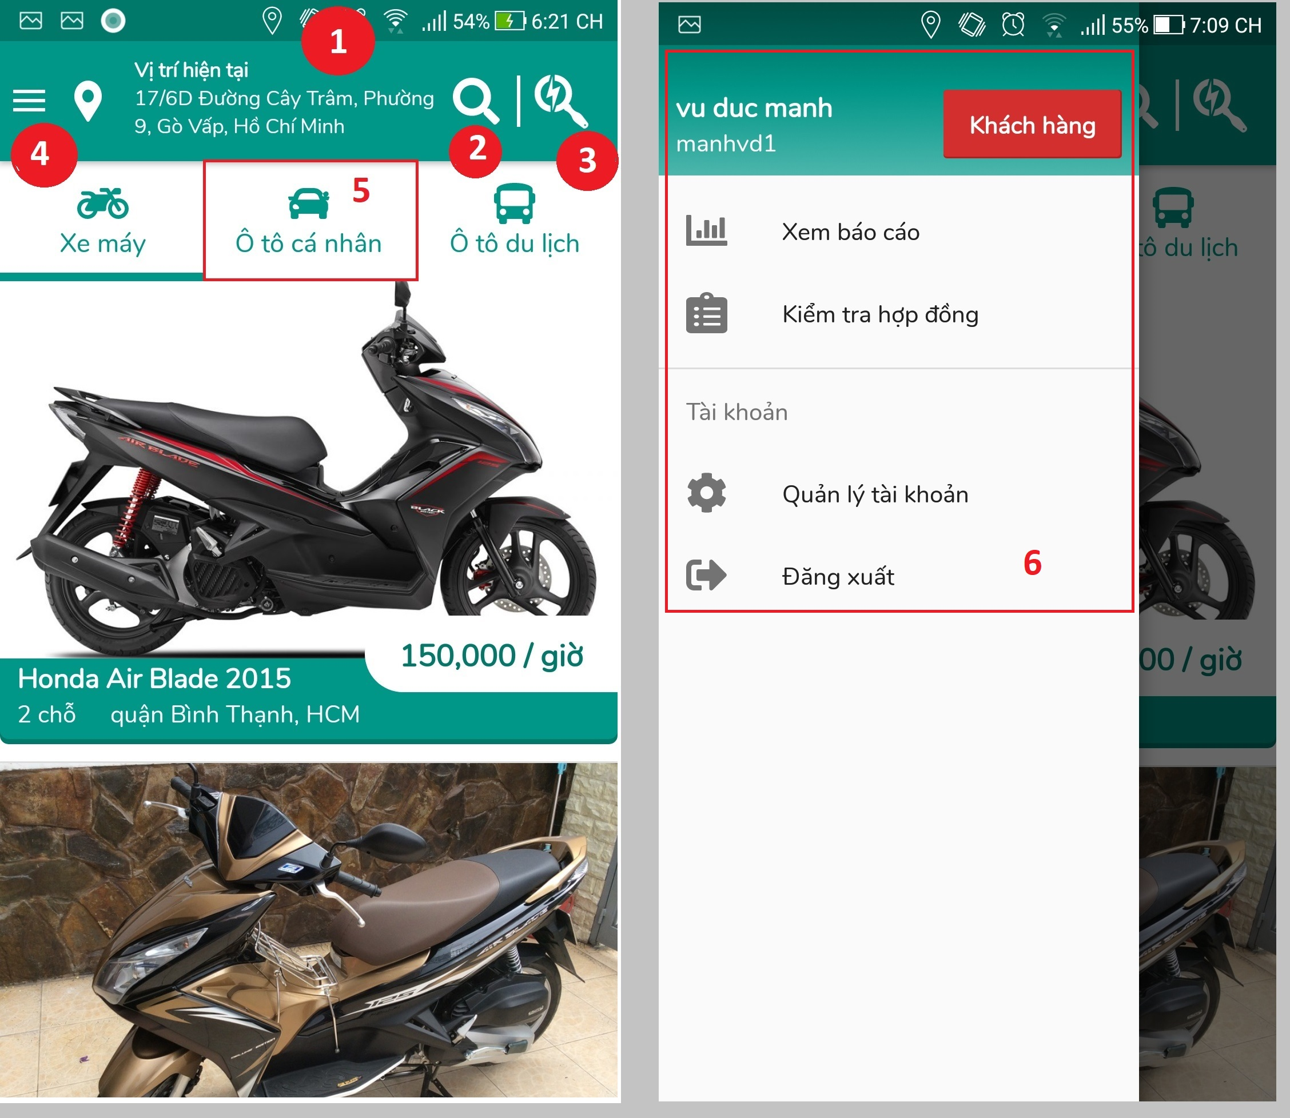

Figure 61 Interface - <Customer> Customer home page

**Fields**

|  |  |  |  |  |  |  |  |
| --- | --- | --- | --- | --- | --- | --- | --- |
| No | Field Name | Description | Read only | Mandatory | Control Type | Data Type | Length |
| 1 | txtLocation | User current location | Yes | Yes | Textview | N/A | N/A |
| 5 | tblVehicle | Vehicle type tab | Yes | Yes | Label | N/A | N/A |
| 6 | Menu | Owner’s menu | Yes | Yes | N/A | N/A | N/A |

Table 93 <Customer> Customer home page fields

**Buttons / Hyperlinks**

|  |  |  |  |  |
| --- | --- | --- | --- | --- |
| No | Function | Description | Validation | Outcome |
| 2 | btnSearch | Button to search vehicle | N/A | Show search input box |
| 3 | btnFilter | Button to advance filter search | N/A | Show advance filter box |
| 4 | btnMenu | Button to show menu | N/A | Show owner menu |

Table 94 <Customer> Customer home page buttons/hyperlinks

##### Advance vehicle filter

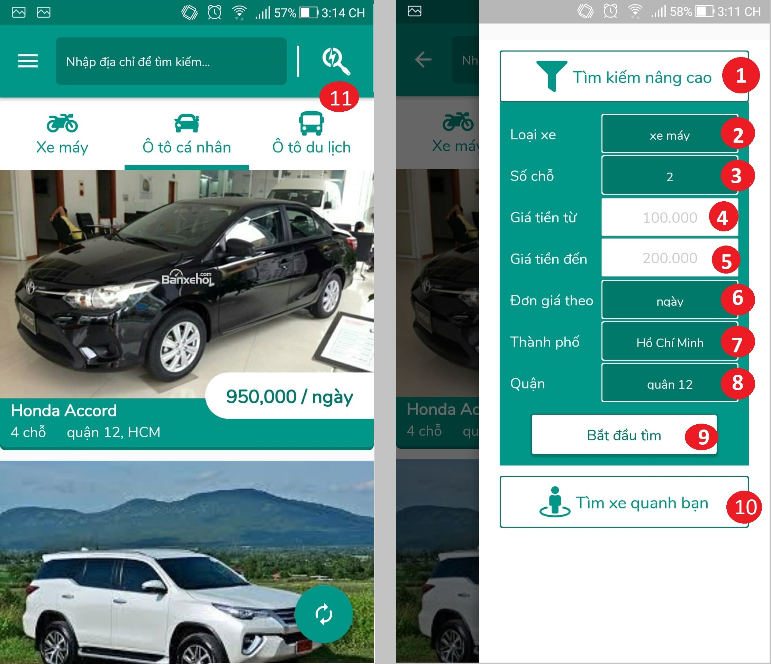

Figure 62 Interface - <Customer> Advance vehicle filter

**Fields:**

|  |  |  |  |  |  |  |  |
| --- | --- | --- | --- | --- | --- | --- | --- |
| No | Field Name | Description | Read only | Mandatory | Control Type | Data Type | Length |
| 4 | txtPriceFrom | Range price of vehicle from | Yes | Yes | Textview | N/A | N/A |
| 5 | txtPriceTo | Range price of vehicle to | Yes | Yes | Textview | N/A | N/A |

Table 95 <Customer> Advance vehicle filter

**Buttons / Hyperlinks**

|  |  |  |  |  |
| --- | --- | --- | --- | --- |
| No | Function | Description | Validation | Outcome |
| 1 | drpAdvanceFilter | Dropdown to display advance filter category | N/A | Advance filter category is display |
| 2 | drpVehicleType | Dropdown to display vehicle type category | N/A | Vehicle type list is show |
| 3 | drpSeat | Dropdown to display number of seats | N/A | Seat number list is show |
| 6 | drpPriceType | Dropdown to display type of price | N/A | Price type list is show |
| 7 | drpCity | Dropdown to display list of cities | N/A | City list is show |
| 8 | drpDistrict | Dropdown to display list of districts | N/A | Dictrict list is show |
| 9 | btnFilter | Confirm to start filter with selected data | N/A | Transfer to filter result view |
| 10 | btnNearby | Confirm to execute find nearby vehicle | N/A | Transfer to nearby vehicle map view |
| 11 | btnFilter | Show advance filter | N/A | Display advance filter view |

Table 96 <Customer> Search vehicle list button/hyperlinks

##### Vehicle detail

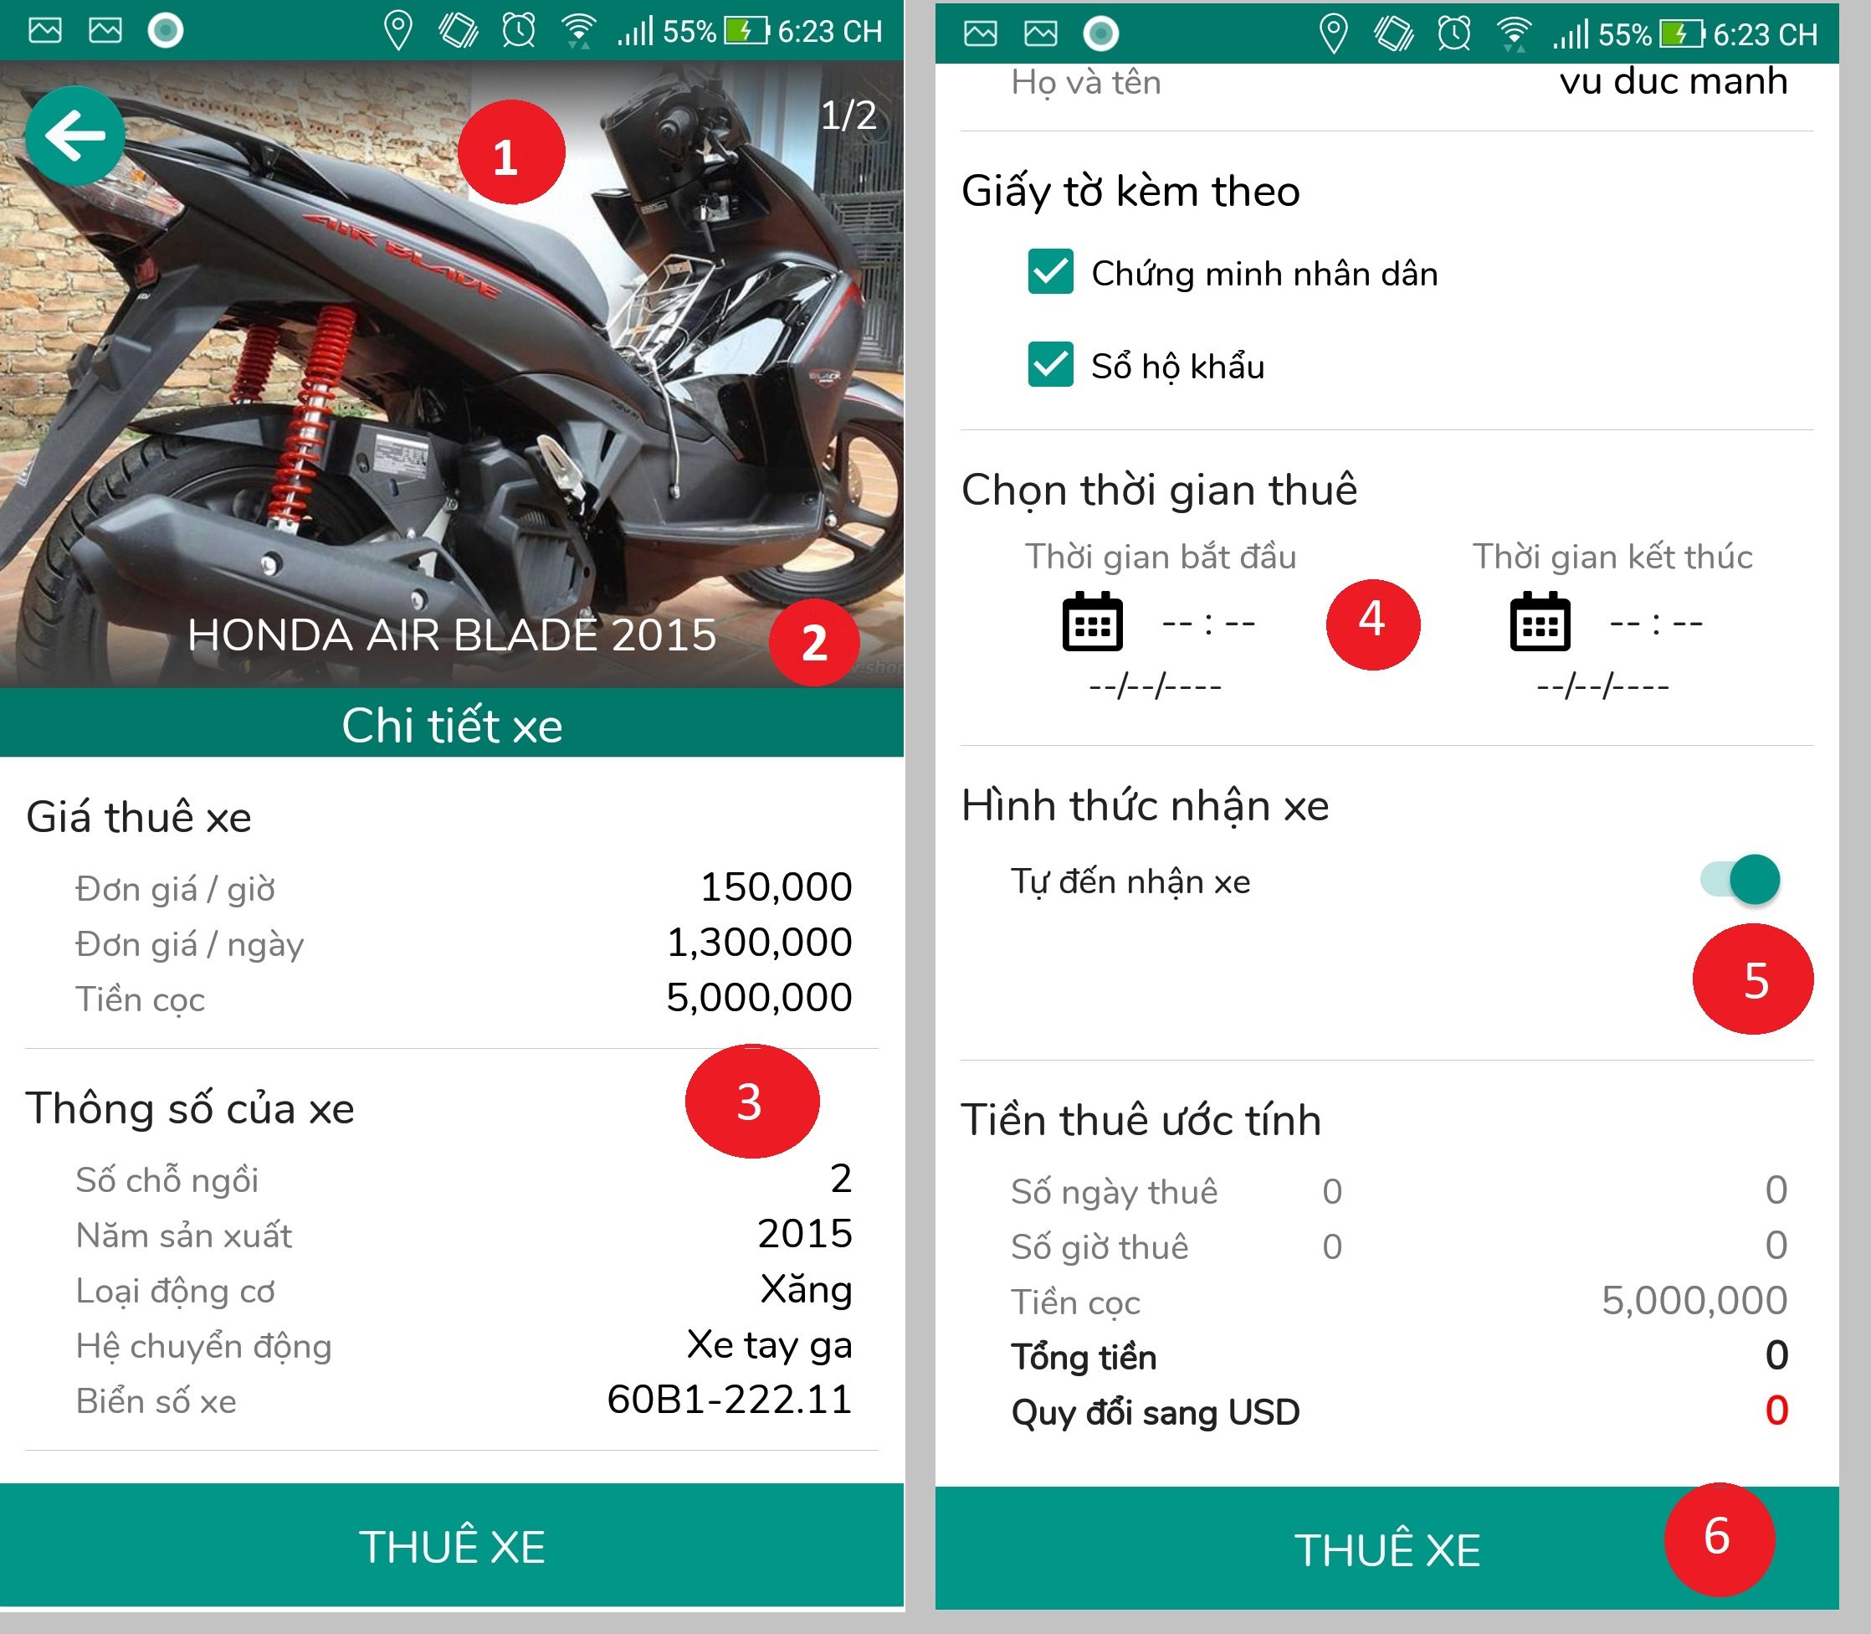

Figure 63 Interface - <Customer> Vehicle detail**Select paypment method**

**Fields**

|  |  |  |  |  |  |  |  |
| --- | --- | --- | --- | --- | --- | --- | --- |
| No | Field Name | Description | Read only | Mandatory | Control Type | Data Type | Length |
| 1 | imgVehicle | Vehicle’s avatar | Yes | Yes | Image | N/A | N/A |
| 2 | lblTitle | Vehicle title | Yes | Yes | Label | N/A | N/A |
| 3 | lblDetail | Vehicle detail | Yes | Yes | Label | N/A | N/A |

Table 97 <Customer> Vehicle detail fields

**Buttons / Hyperlinks**

|  |  |  |  |  |
| --- | --- | --- | --- | --- |
| No | Function | Description | Validation | Outcome |
| 4 | btnTime | Vehicle renting time | N/A | N/A |
| 5 | swtReceive | Vehicle receive type | N/A | N/A |
| 6 | btnRent | Confirm to rent vehicle | N/A | Transfer to select renting time page |

Table 98 <Customer> Vehicle detail button/hyperlinks

##### Select renting time

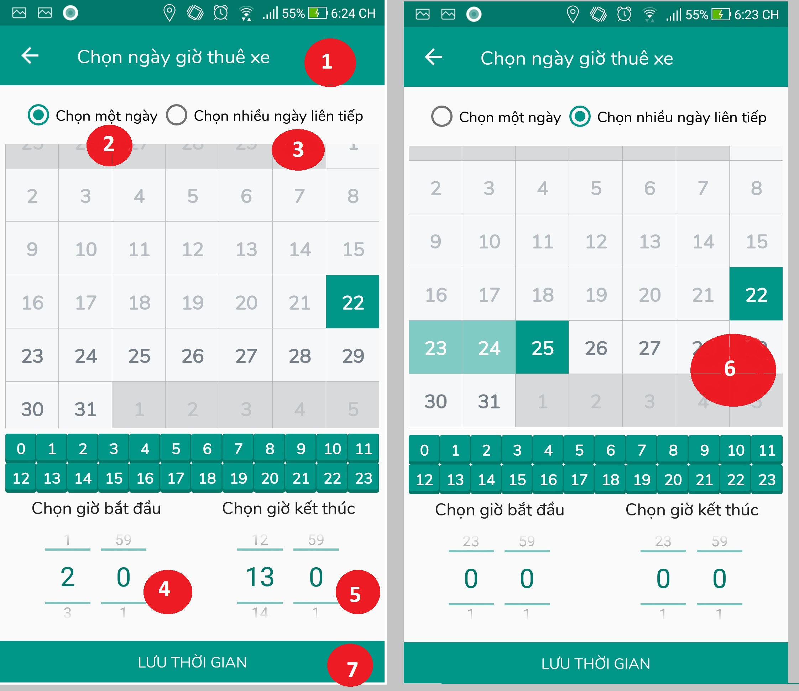

Figure 65 Interface - <Customer> Select renting time**Select paypment method**

**Fields**

|  |  |  |  |  |  |  |  |
| --- | --- | --- | --- | --- | --- | --- | --- |
| No | Field Name | Description | Read only | Mandatory | Control Type | Data Type | Length |
| 1 | lblTitle | Vehicle title | Yes | Yes | Label | N/A | N/A |
| 2 | rbtDay | Rent a car for a day | Yes | Yes | Button | N/A | N/A |
| 3 | rbtDays | Rent a car for days | Yes | Yes | Button | N/A | N/A |
| 4 | tmStart | Select start renting time | No | Yes | Time selecter | N/A | N/A |
| 5 | tmEnd | Select end renting time | No | Yes | Time selecter | N/A | N/A |
| 6 | cldDay | Calendar renting day | No | Yes | Calendar | N/A | N/A |

Table 99 <Customer> Select renting time field

**Buttons / Hyperlinks**

|  |  |  |  |  |
| --- | --- | --- | --- | --- |
| No | Function | Description | Validation | Outcome |
| 7 | btnRent | Confirm to start renting vehicle with selected time | If start time and end time is not selected, button not do anything | Transfer to paypal page |

Table 100 <Customer> Select renting time button/hyperlinks**Select paypment method**

##### Renting process

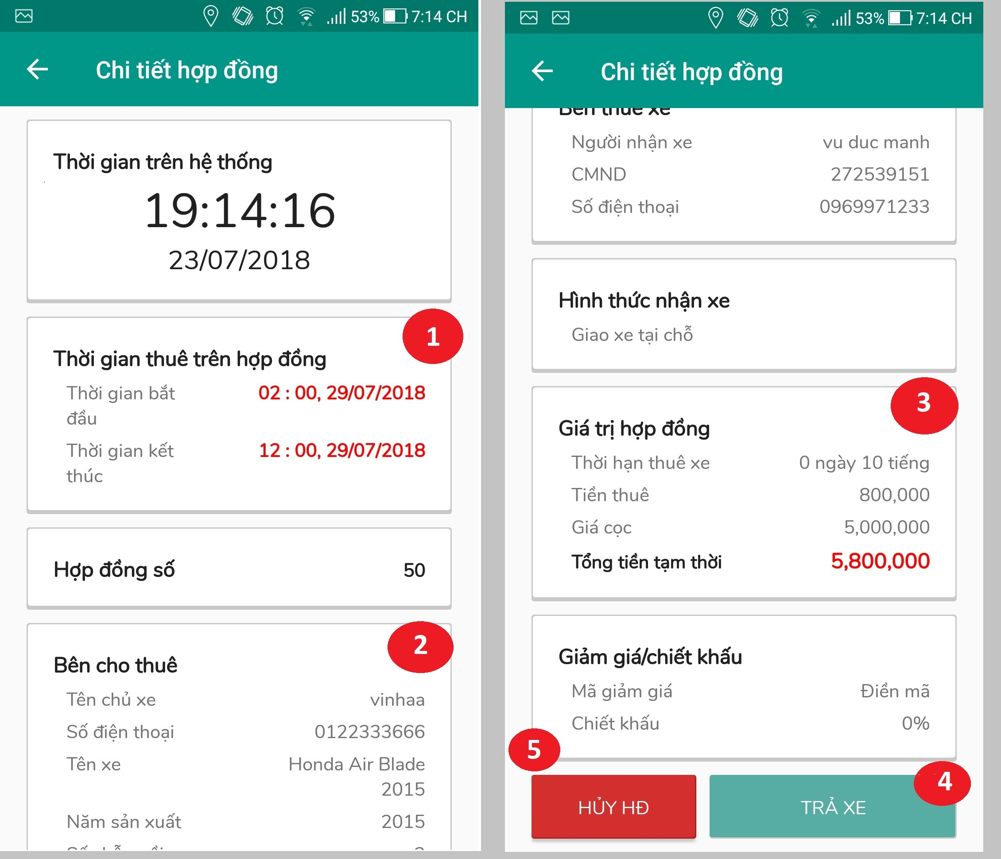

Figure 66 Interface - <Customer> Renting process

**Fields**

|  |  |  |  |  |  |  |  |
| --- | --- | --- | --- | --- | --- | --- | --- |
| No | Field Name | Description | Read only | Mandatory | Control Type | Data Type | Length |
| 1 | txtRentailTime | Contract time detail | Yes | Yes | Textview | String | 8-250 |
| 2 | txtOwnerDetail | Vehicle owner detail | Yes | Yes | Textview | String | 8-250 |
| 3 | txtRentalDetail | Detail of rental temporary charge | Yes | Yes | Textview | String | 8-250 |

Table 101 <Customer> Renting process method fields

**Buttons / Hyperlinks**

|  |  |  |  |  |
| --- | --- | --- | --- | --- |
| No | Function | Description | Validation | Outcome |
| 4 | btnReturn | Confirm finish using vehicle | N/A | Show confirm return vehicle popup |
| 5 | btnCancel | Cancel renting process | N/A | Show confirm cancel vehicle popup |

Table 102 <Customer> Renting process method buttons/hyperlinks

##### View rental bill

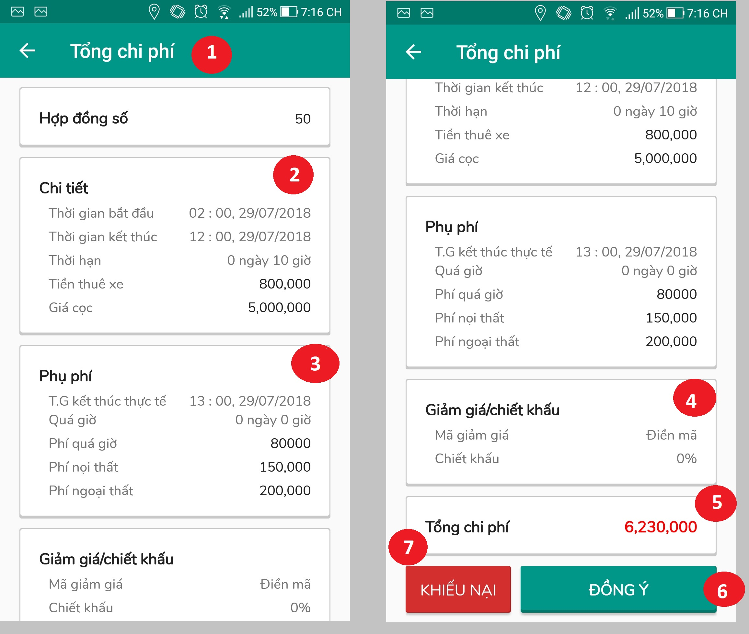

Figure 67 Interface - <Customer> View rental bill

**Fields**

|  |  |  |  |  |  |  |  |
| --- | --- | --- | --- | --- | --- | --- | --- |
| No | Field Name | Description | Read only | Mandatory | Control Type | Data Type | Length |
| 1 | lblTitle | Title | Yes | Yes | Label | N/A | N/A |
| 2 | rentalDetail | Table contain rental detail | Yes | Yes | Table | N/A | N/A |
| 3 | rentalsurcharge | Table contain surcharge detail | Yes | Yes | Table | N/A | N/A |
| 4 | discountDetail | Table contain discount detail | Yes | Yes | Table | N/A | N/A |
| 5 | rentalTotalCost | Rental total fee | Yes | Yes | Table | N/A | N/A |

Table 103 <Customer> View rental bill fields

**Buttons / Hyperlinks**

|  |  |  |  |  |
| --- | --- | --- | --- | --- |
| No | Function | Description | Validation | Outcome |
| 6 | btnAccept | Accept rental bill and cost is correct | N/A | Rental process complete, redirect to manage bill screen |
| 8 | btnComplain | Complain about rental cost | N/A | Transfer to live chat screen |

Table 104 <Customer> View rental bill buttons/hyperlinks

#### Owner Interface Design

##### Register vehicle

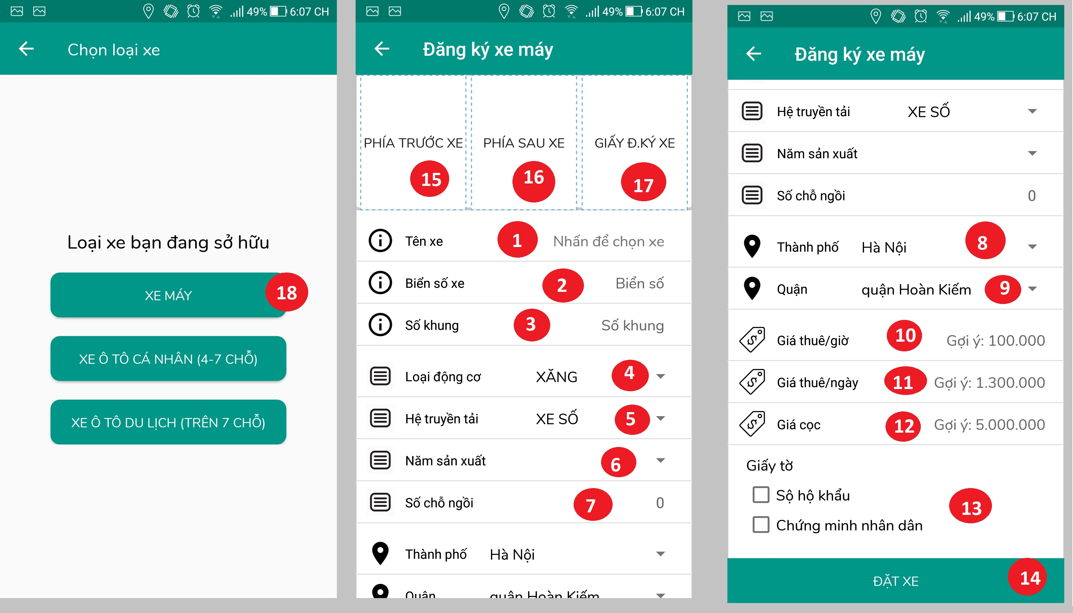

Figure 68 Interface - <Owner> Register vehicle

**Fields**

|  |  |  |  |  |  |  |  |
| --- | --- | --- | --- | --- | --- | --- | --- |
| No | Field Name | Description | Read only | Mandatory | Control Type | Data Type | Length |
| 1 | txtVehicleName | Fill vehicle name | No | Yes | Textbox | String | 8-250 |
| 2 | txtPlateVehicle | Fill vehicle plate number | No | Yes | Textbox | String | 8-250 |
| 3 | txtFrameNumber | Fill vehicle frame name | No | Yes | Textbox | String | 8-250 |
| 4 | sltEngineType | Select engine type | No | Yes | Textview | N/A | N/A |
| 5 | sltTransmissionType | Select transmission type | No | Yes | Textview | N/A | N/A |
| 6 | txtManufactureYear | Select manufacture year | No | Yes | TextView | N/A | N/A |
| 7 | txtSeat | Fill number of seat | No | Yes | TextView | N/A | N/A |
| 8 | txtCity | Fill city name where vehicle is residing | No | Yes | Dropdown | N/A | N/A |
| 9 | txtDistrict | Fill district name where vehicle is residing | No | Yes | Dropdown | N/A | N/A |
| 10 | txtRentFeePerHour | Fill rent fee per hour | No | Yes | Textbox | Int | 8-20 |
| 11 | txtRentFeePerDay | Fill rent fee per day | No | Yes | Textbox | Int | 8-20 |
| 12 | txtDepositFee | Fill deposit fee | No | Yes | Textbox | Int | 8-20 |
| 13 | sltPaper | Select paper required to start renting | No | Yes | Checkbox | N/A | N/A |
| 15 | imgFrontVehicle | Image of vehicle shooting from the front | Yes | Yes | Image | N/A | N/A |
| 16 | imgBackVehicle | image of vehicle shooting from the back | Yes | Yes | Image | N/A | N/A |
| 17 | imgVehicleRegis | Image registration vehicle registration | Yes | Yes | Image | N/A | N/A |

Table 107 <Owner> Register vehicle fields

**Buttons / Hyperlinks**

|  |  |  |  |  |
| --- | --- | --- | --- | --- |
| No | Function | Description | Validation | Outcome |
| 14 | btnCreate | Confirm to create new customer | If customer doesn’t input mandatory field, system will notify | Transfer to next page |
| 15 | btnBack | Return to previous page | N/A | Transfer to previous page |

Table 108 <Owner> Register vehicle buttons/hyperlinks

##### Owner home page

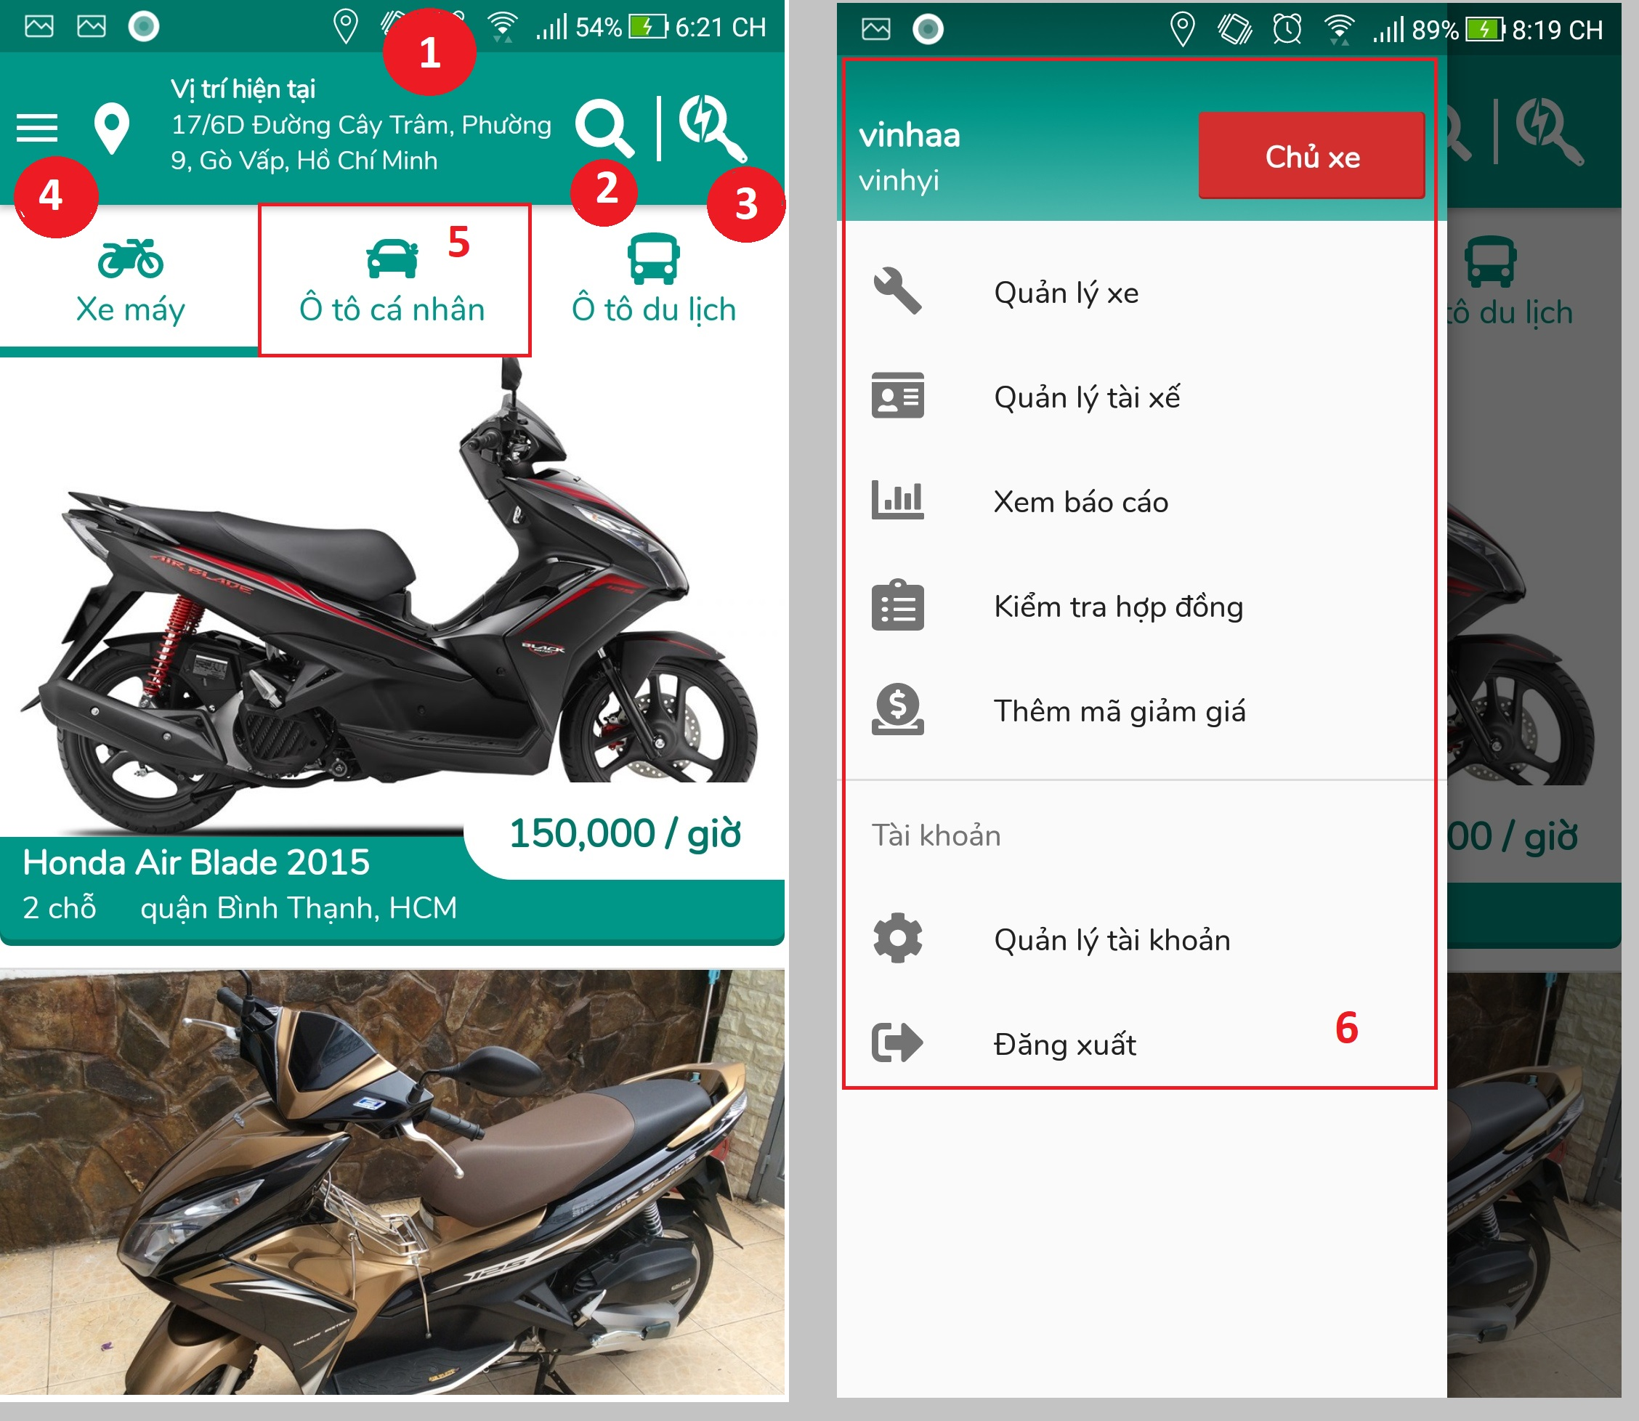

Figure 70 Interface - <Owner> Owner home page

**Fields**

|  |  |  |  |  |  |  |  |
| --- | --- | --- | --- | --- | --- | --- | --- |
| No | Field Name | Description | Read only | Mandatory | Control Type | Data Type | Length |
| 1 | txtLocation | User current location | Yes | Yes | Textview | N/A | N/A |
| 5 | tblVehicle | Vehicle type tab | Yes | Yes | Label | N/A | N/A |
| 6 | Menu | Owner’s menu | Yes | Yes | N/A | N/A | N/A |

Table 109 <Owner> Owner home page fields

**Buttons / Hyperlinks**

|  |  |  |  |  |
| --- | --- | --- | --- | --- |
| No | Function | Description | Validation | Outcome |
| 2 | btnSearch | Button to search vehicle | N/A | Show search input box |
| 3 | btnFilter | Button to advance filter search | N/A | Show advance filter box |
| 4 | btnMenu | Button to show menu | N/A | Show owner menu |

Table 110 <Owner> Owner home page buttons/hyperlinks

##### Create rental bill

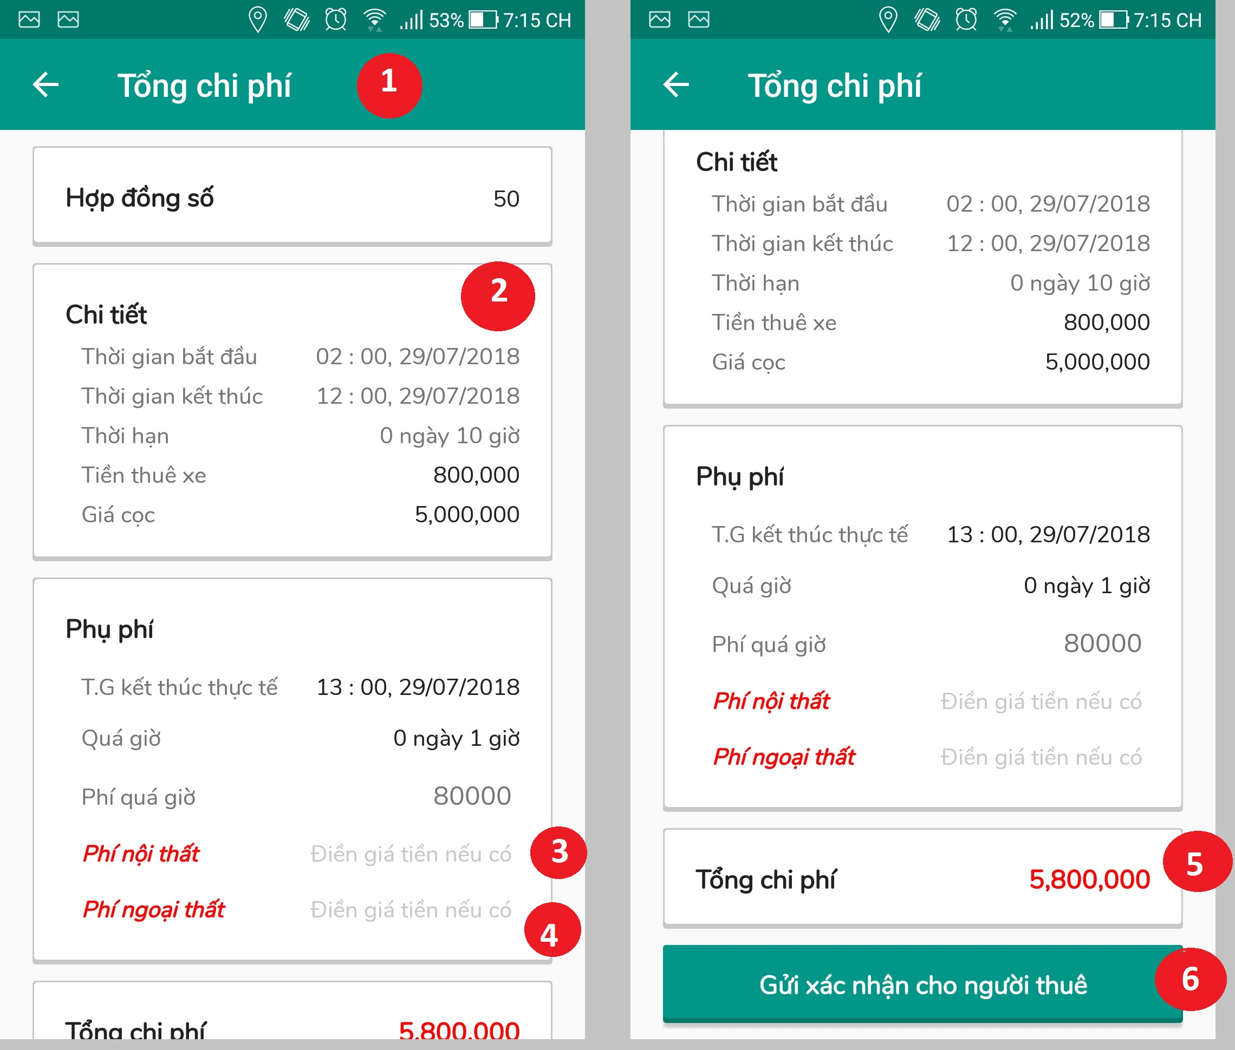

Figure 72 Interface - <Owner> Create rental bill

**Fields**

|  |  |  |  |  |  |  |  |
| --- | --- | --- | --- | --- | --- | --- | --- |
| No | Field Name | Description | Read only | Mandatory | Control Type | Data Type | Length |
| 1 | lblTitle | Title | Yes | Yes | Label | N/A | N/A |
| 2 | txtRentalDetail | Rental detail information | Yes | Yes | Textview | N/A | N/A |
| 3 | txtInterior | Fee for furniture damage | Yes | Yes | Textbox | Int | 4-20 |
| 4 | txtExterior | Fee for exterior damage | No | Yes | Textbox | Int | 4-20 |
| 5 | txtTotal | Total rental cost | No | Yes | Textview | N/A | N/A |

Table 111 <Owner> Create rental bill fields

**Buttons / Hyperlinks**

|  |  |  |  |  |
| --- | --- | --- | --- | --- |
| No | Function | Description | Validation | Outcome |
| 6 | btnSend | Confirm sending vehicle rental fee | If input is not number, system will send alert | Show sending success message |

Table 112 <Owner> Create rental bill buttons/hyperlinks

##### View rental report

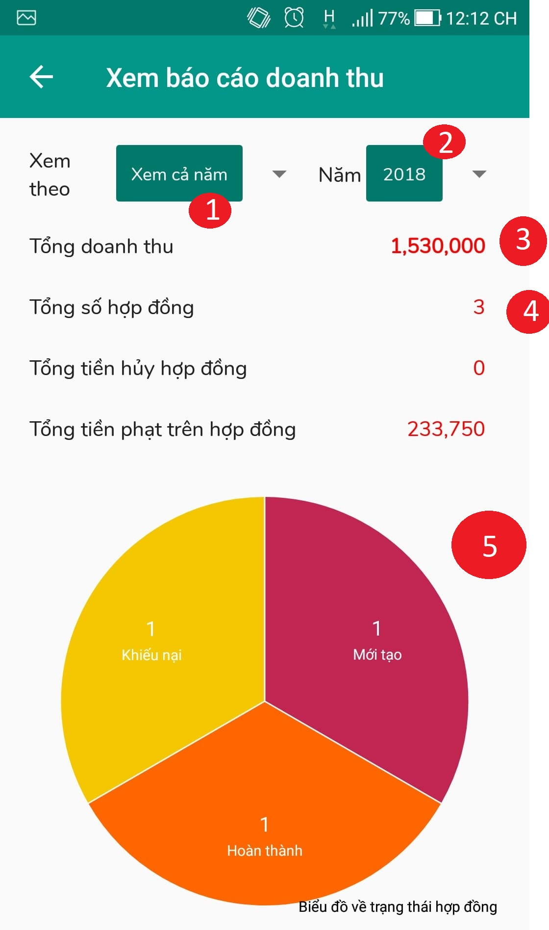

Figure 73 Interface - <Owner> View rental report

**Fields**

|  |  |  |  |  |  |  |  |
| --- | --- | --- | --- | --- | --- | --- | --- |
| No | Field Name | Description | Read only | Mandatory | Control Type | Data Type | Length |
| 3 | lblRevenue | Total revenue | Yes | Yes | Label | N/A | N/A |
| 4 | lblContract | Total number of rental contracts | Yes | Yes | Label | N/A | N/A |
| 5 | chrChart | Information pie chart | Yes | Yes | Label | N/A | N/A |

Table 114 <Owner> View rental report fields

**Buttons**

|  |  |  |  |  |
| --- | --- | --- | --- | --- |
| No | Function | Description | Validation | Outcome |
| 1 | btnMonth | Click on item list to view rental report detail follow by month | N/A | Reload report rental screen |
| 2 | btnYear | Click on item list to view rental report detail follow by year | N/A | Reload report rental screen |

Table 115 <Owner> View rental report – Buttons

##### Manage vehicle

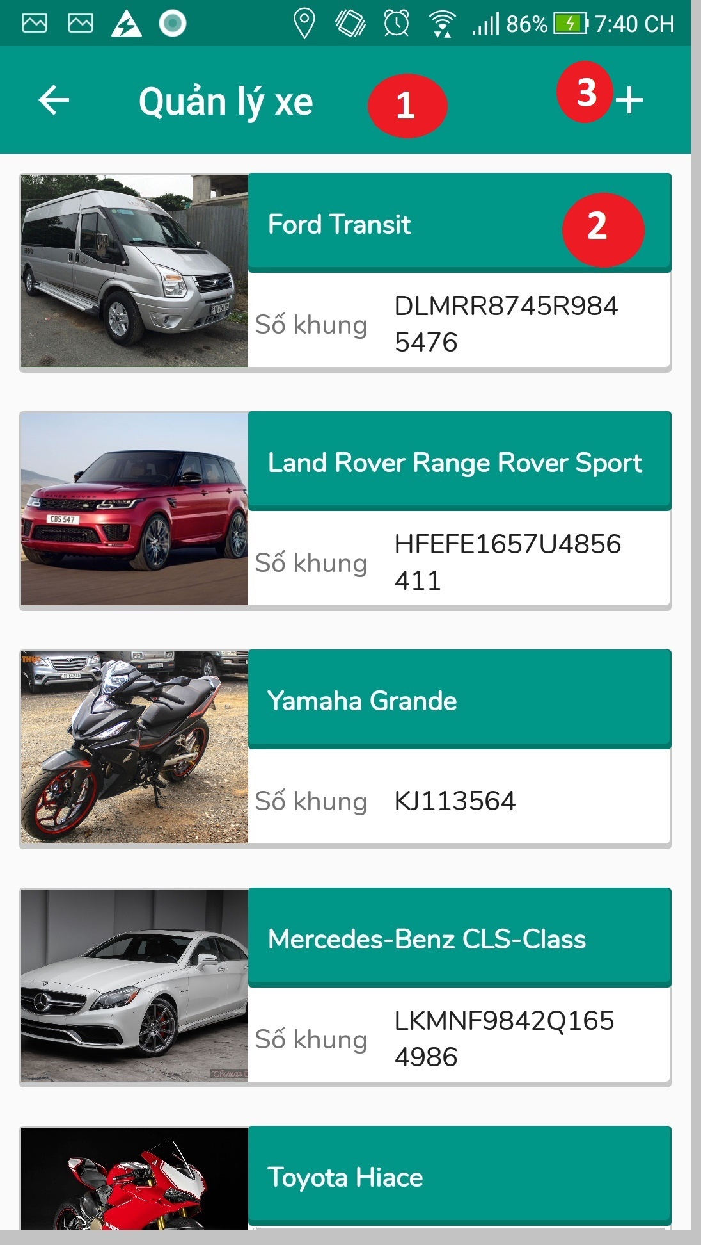

Figure 74 Interface - <Owner> Manage vehicle

**Fields**

|  |  |  |  |  |  |  |  |
| --- | --- | --- | --- | --- | --- | --- | --- |
| No | Field Name | Description | Read only | Mandatory | Control Type | Data Type | Length |
| 1 | Title | Title of the page | Yes | Yes | Label | N/A | N/A |
| 2 | vehicleItem | Item contain name and frame number of vehicle | Yes | Yes | Label | N/A | N/A |

Table 116 <Owner> Manage vehicle fields

**Buttons**

|  |  |  |  |  |
| --- | --- | --- | --- | --- |
| No | Function | Description | Validation | Outcome |
| 3 | btnAdd | Add new vehicle | N/A | Transfer to create vehicle screen |

Table 117 <Owner> Manage vehicle – Buttons

##### Owner vehicle detail

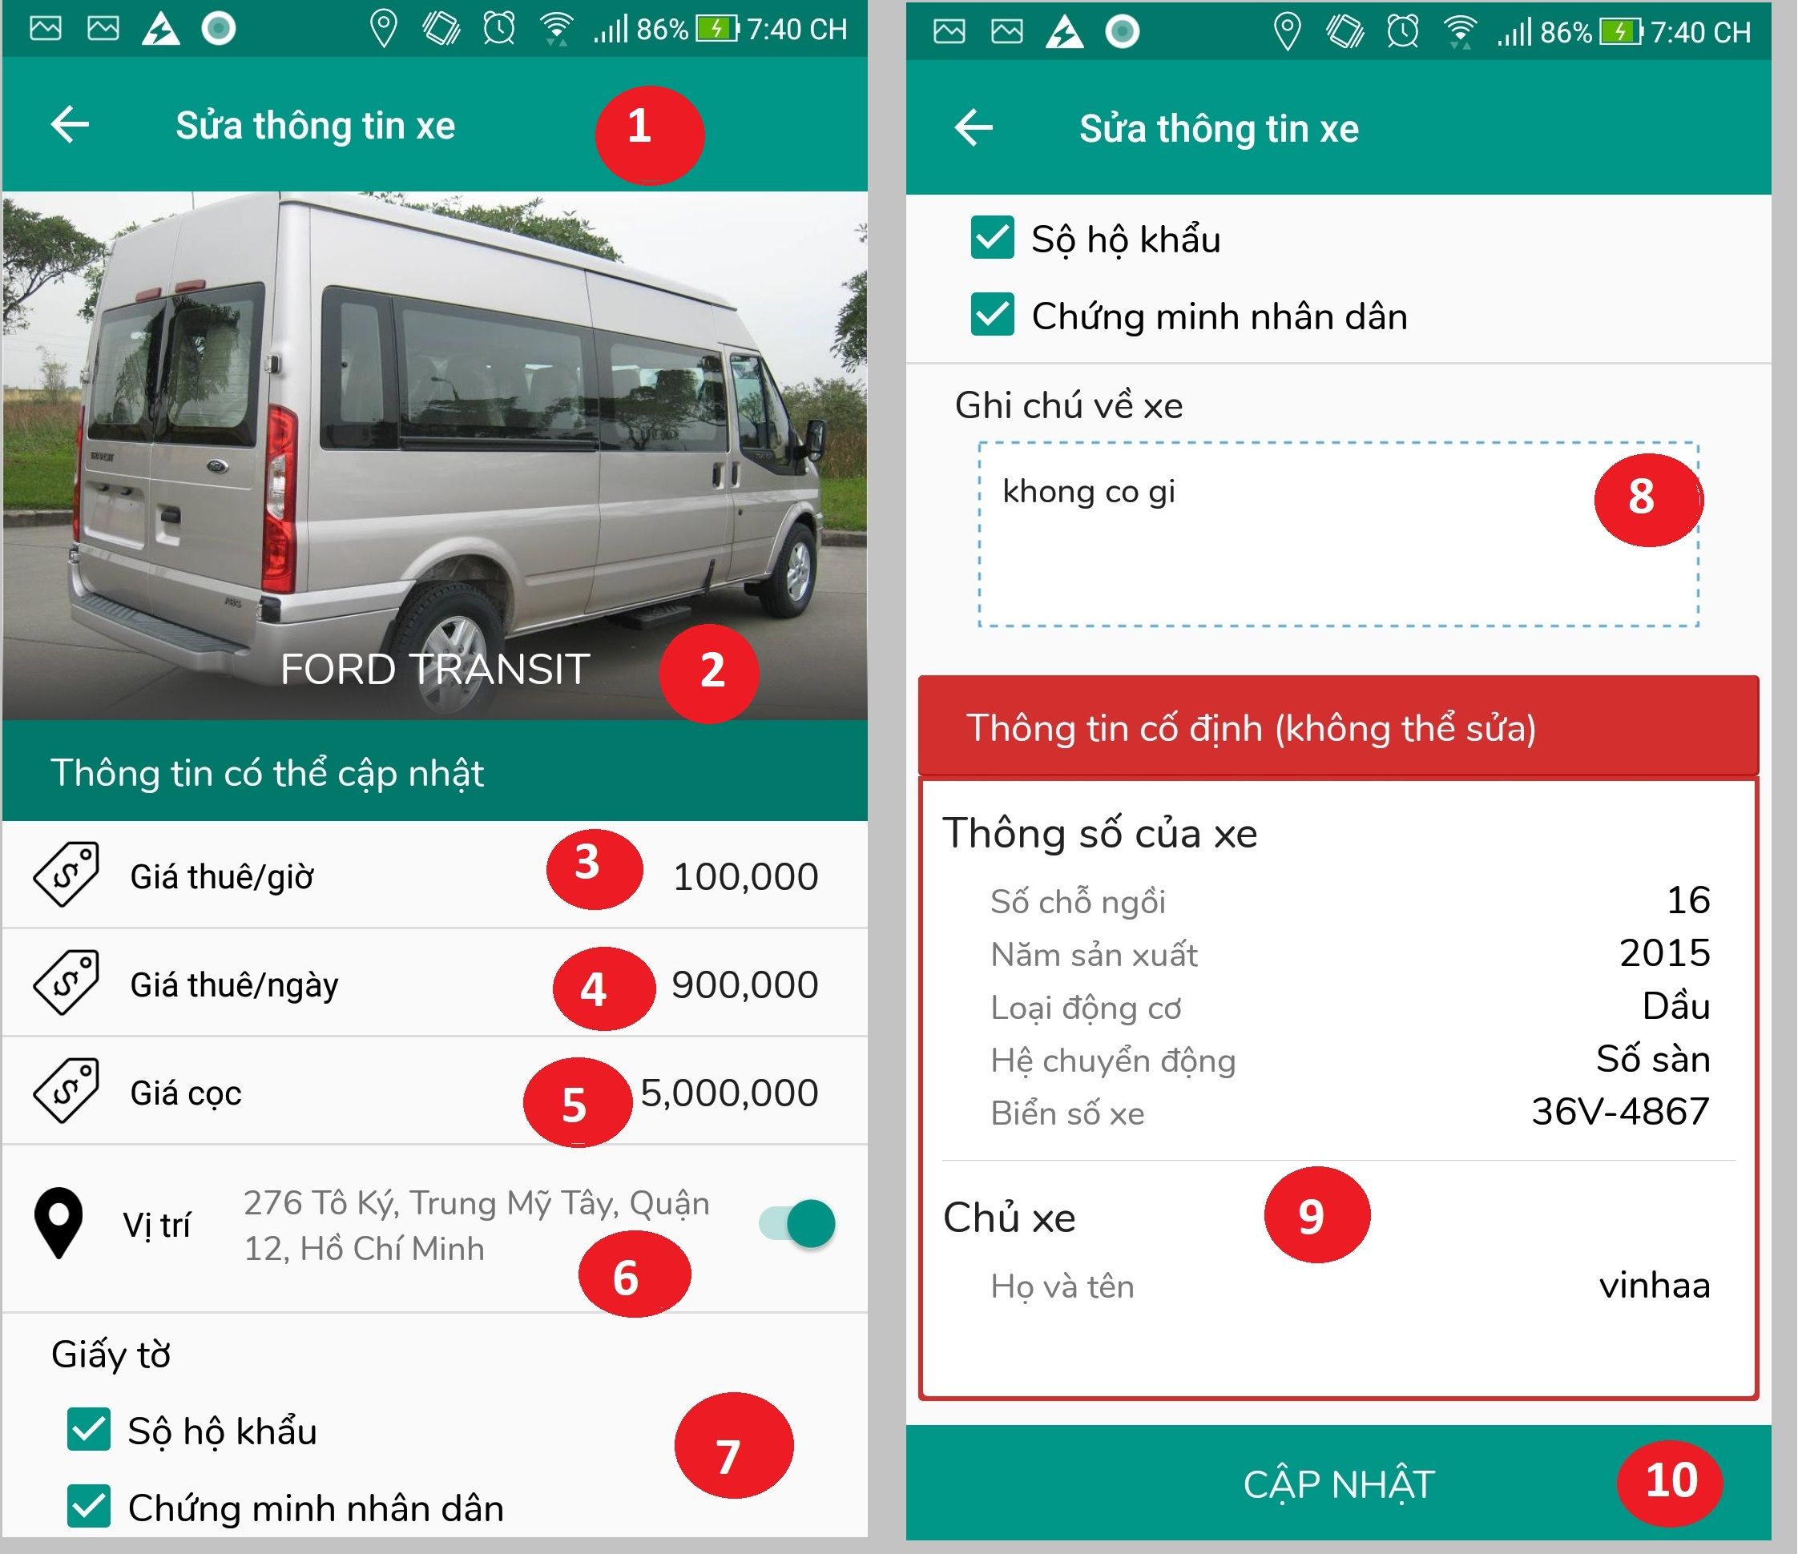

Figure 75 Interface - <Owner> Owner vehicle detail**Select paypment method**

**Fields**

|  |  |  |  |  |  |  |  |
| --- | --- | --- | --- | --- | --- | --- | --- |
| No | Field Name | Description | Read only | Mandatory | Control Type | Data Type | Length |
| 1 | Title | Title of the page | Yes | Yes | Label | N/A | N/A |
| 2 | vehicleName | Name of vehicle | Yes | Yes | Label | N/A | N/A |
| 3 | txtRentFeePerHour | Fill rent fee per hour | No | Yes | Textbox | Int | 8-20 |
| 4 | txtRentFeePerDay | Fill rent fee per day | No | Yes | Textbox | Int | 8-20 |
| 5 | txtDepositFee | Fill deposit fee | No | Yes | Textbox | Int | 8-20 |
| 6 | txtLocation | Fill vehicle current location | No | Yes | Textbox | String | 8-250 |
| 7 | sltPaper | Select paper required to start renting | No | Yes | Checkbox | N/A | N/A |
| 8 | txtDescription | Fill vehicle description | No | Yes | Textbox | String | 8-250 |
| 9 | txtVehicleDetail | Vehicle detail informattion | Yes | Yes | Textview | N/A | N/A |

Table 118 <Owner> Owner vehicle detail fields

**Buttons / Hyperlinks**

|  |  |  |  |  |
| --- | --- | --- | --- | --- |
| No | Function | Description | Validation | Outcome |
| 10 | btnUpdate | Confirm sending updated information | If input is blank, system will send alert | Show sending success message |

Table 119 <Owner> Owner vehicle detail button/hyperlinks

## Database Design

### Entity relationship diagram

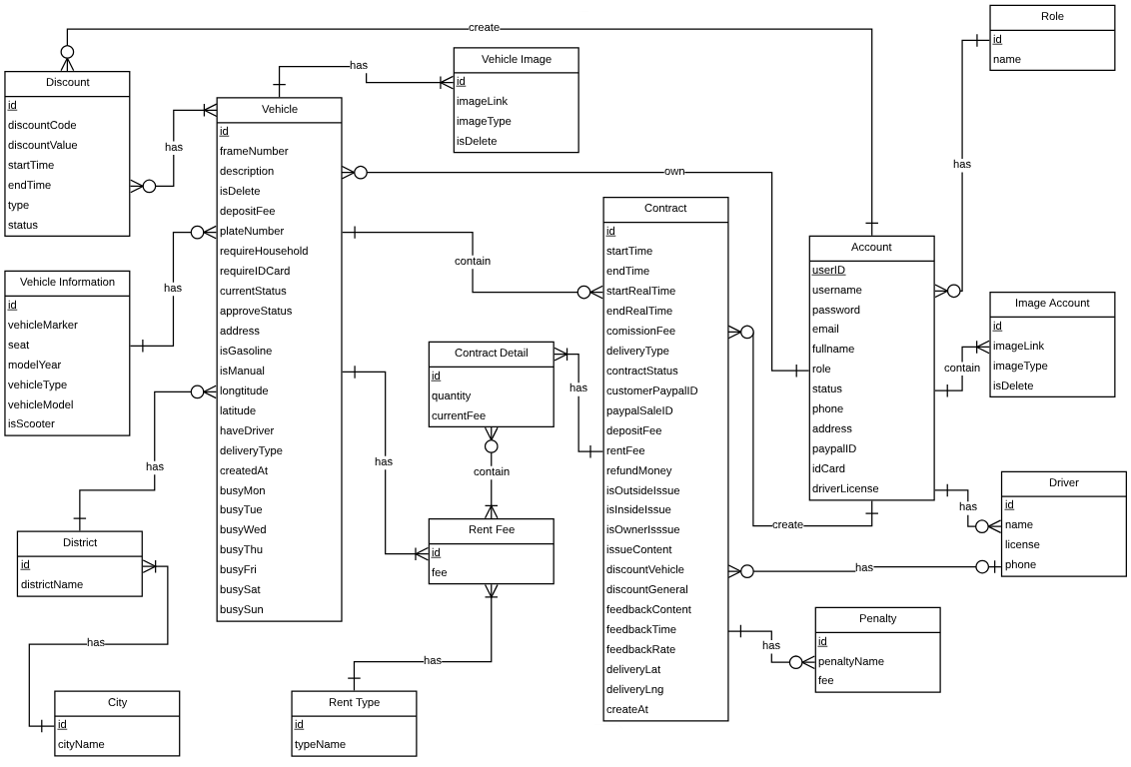

Figure 76 Entity relationship diagram

### Data Dictionary

|  |  |
| --- | --- |
| Entity Data Dictionary: describe content of all entities | |
| Entity name | **Description** |
| Account | Table which contains all user account |
| Image Account | Table which contains image of account |
| Driver | Table which contains driver information |
| Vehicle | Table which contains all vehicle information |
| Vehicle Image | Table which contains image of vehicle |
| Vehicle Information | Table which contains all imformation of vehicle |
| Discount | Table which contains all discount information |
| Contract | Table which contains all contract information |
| Penalty | Table which contains penalty information |
| Contract Detail | Table which contains contract detail information |
| Rent Fee | Table which contains rent fee |
| Rent Types | Table which contains rent type information |
| City | Table which contains city information |
| District | Table which contains district information |
| Role | Table which contains account role information |

Table 120 Entity data dictionary

## Algorithms

### Find nearby vehicle

* + 1. **Definition**

When a user logs in to our system, the application will find vehicles located near the user with a distance between the user's location and the car's location is less than a specific preset distance.

* + 1. **Define problem**

Each vehicle has its own coordinates and distance to the user location differently. However, we need to find all vehicle that near user location to optimizing the time and distance traveled to vehicle of user. The problem is that when a user logs on to the system, in multiple case the available vehicles are not in a predetermined distance zone near the user location, or near to the predetermined zone but not belong to that zone; therefore, we need an algorithm to flexible search for available vehicles that is nearby or convenient for users.

* + 1. **Solution**

To solve this problem, we should follow these steps:

Each time user logs in to application, nearby vehicle list will be found and update through:

1. Get user coordinates.

2. Get all available vehicle coordinates in the system and sort in ascending.

3. Find cross point in vehicle list.

4. Calculate nearest vehicles from user location and add to vehicle list.

5. If vehicle list is not empty, the nearby vehicle list will show.

6. The nearby list structure will be as bellow:

* + Nearby list is not empty, system loads nearby list into home page.
  + Nearby list is empty, predefined list will be display to home page.
    1. **Complexity**

In total, the complexity of this algorithm is **N**

* + 1. **Flow chart**

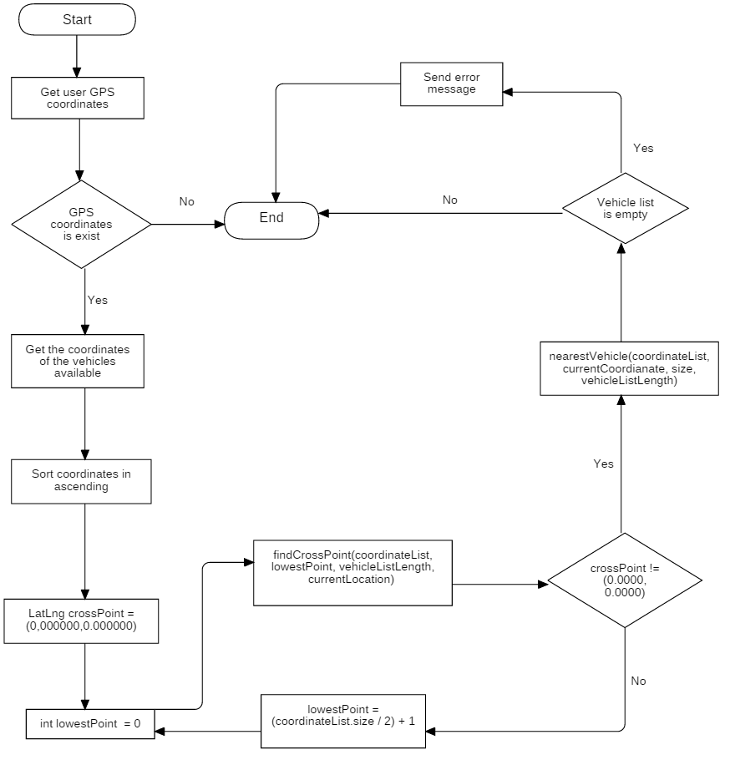

Figure 77: Find nearby vehicle flow chart

### Contract State

The contracts in VRS system is complex and can be managed differently during the operation. The state chart bellow describes all the state of a contract.

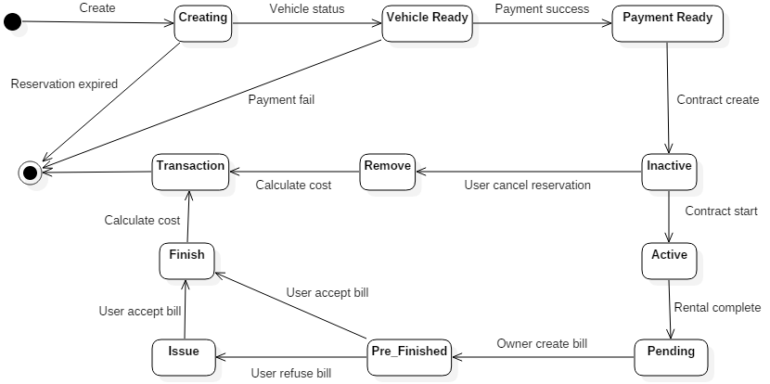

Figure 78 Contract State Chart

|  |  |
| --- | --- |
| SStimulusion  ﷽﷽﷽﷽﷽> ERD  quence numberecution bar em and database.  tate | Description |
| Creating | The contract is created and account is not in ready status or rental vehicle is not available yet |
| Vehicle ready | The contract is assigned with a selected vehicle but have not payment yet |
| Payment ready | The contract is payment |
| Inactive | The contract is created but not start yet |
| Active | The contract is active and vehicle is being used |
| Remove | The contract is cancelled and waiting for calculate cost |
| Pending | The contract is done and waiting for owner created rental bill |
| Pre_Finished | The contract is done and waiting for customer accepted rental bill |
| Issue | Customer refuse rental bill and waiting for new bill |
| Finish | Customer accept bill and waiting for calculate cost |
| Transaction | The contract is finish, waiting for system complete transaction and no longer valuable |

Table 121 Contract State Dictionary

|  |  |  |  |
| --- | --- | --- | --- |
| Stimulus | Description | State before | State after |
| Create | Customer create new contract | N/A | Creating |
| Reservation expired | When the contract session is exceeded, system will change the contract status | Creating | N/A |
| Vehicle status | System checking the vehicle status is ready or not | Creating | Vehicle Ready |
| Payment | System checking payment status via Paypal is success or not | Vehicle Ready | Payment Ready |
| User cancel rental | Customer cancel contract via application while vehicle is already delivered | Ready | Cancelled |
| User returns vehicle | Customers finished using vehicle and return vehicle to owner | Ready | Return |
| Calculate cost | System calculate rental cost used by the user | Return | Refund |
| Calculate cost | System calculate rental cost used by the user | Cancelled | Refund |

Table 122 Contract State Flow

### Notification

#### Definition

Notification is a feature of VRS application to notify customer and owner when important events occurs.

#### Notification Methods

* Send email to receiver
* Show notification icon on web interface

#### Notification use cases

|  |  |  |  |
| --- | --- | --- | --- |
| Type | Trigger | Receiver | Notify method |
| 1 | Customer creates new account | All staff | Web |
| 2 | Customer creates new vehicle | All staff | Web |
| 3 | Customer sends update request | All staff | Web |
| 4 | Employee approve create / update request | Customer | Email |
| 5 | Contract is start created | Owner | Application |
| 6 | Customer is finished renting | Owner | Application |
| 7 | Owner is complete create bill | Customer | Application |
| 8 | Contract is expired | Customer | Application |
| 9 | Contract is cancelled by customer | Owner | Application |
| 10 | Refund request is resolved | Customer | Application |

Table 123 Notification use cases

* For staffs, every notification has "status" to show that if the notification resolved or not.

When a notification is sent to all the staff, every staff has their ability to change the status. That's mean if staff A mark the status as ready, every notification is synchrony.

# System Implementation & Test

## Introduction

### Overview

This section describes the approach and methodologies used by group to plan, organize and manage the testing of VRS system. It provides in the detail all necessary information about the implementation and testing procedure of the system included test plans, test cases, test result, test environments, pass/fail criteria and risks estimations as well as a checklist to cover all possible cases.

### Test Approach

* Goal: Test all features in the whole VRS system based on the core flow.
* Method: black-box testing
* Technique: check list.
* The testing for this project will consists of Integration System test level. Testing the program which was integrated and as a complete system to ensure that the software requirements have been met.
* Integration testing would be performed by all member of team and approved by team leader.
* System testing is focused on assessing the system’s reliability. This process is concerned with finding errors that result from unanticipated interactions between components and component interface problems.

## Database Relationship Diagram

### Physical Diagram

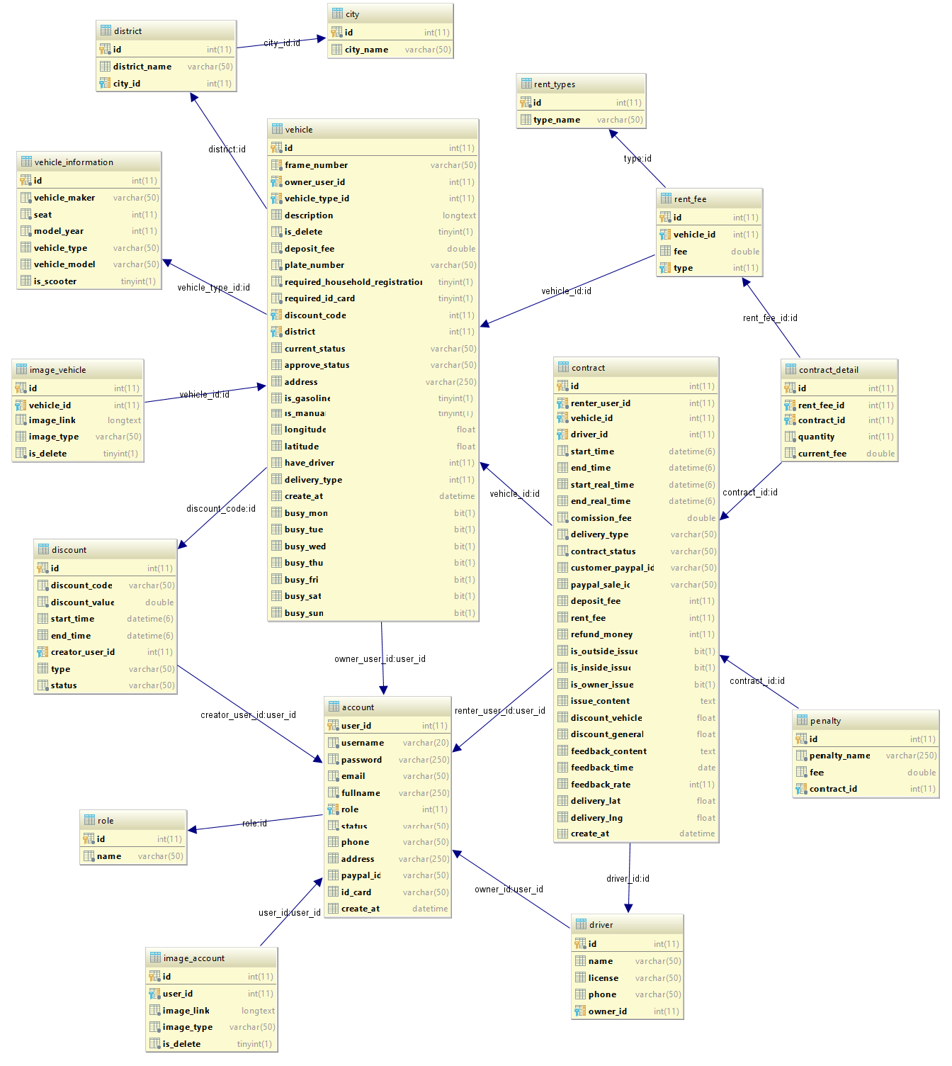

Figure 79 Physical diagram

### Data Dictionary

|  |  |  |
| --- | --- | --- |
| Data dictionary: describe content of all tables | | |
| Table Name | **Mapping with Conceptual diagram** | **Description** |
| Image_vehicle | Vehicle Image | Describe all vehicle image in the system. |
| District | N/A | Describe name of the district |
| City | N/A | Describe name of the city |
| Vehicle | Vehicle | Describe all vehicle in the system. |
| Vehicle Information | VehicleInformation | Describe all vehicle information in the system. |
| Rent fee | N/A | Describe all vehicle rent fee the system. |
| Rent type | N/A | Describe name of the rental fee the system. |
| Account | Account | Describe all account detail information in the system. |
| Discount | N/A | Not exist in conceptual diagram. Needed in physical diagram to describe all discount based on company’s business rules. |
| Penalty | N/A | Not exist in conceptual diagram. Needed in physical diagram to describe all penalty based on company’s business rules. |
| Image Acccount | ImageAccount | Describe all image of account in the system. |
| Driver | N/A | Not exist in conceptual diagram. Needed in physical diagram to describe all driver information in the system. |
| Contract | Contract | Describe all contract information the system. |
| Contract Detail | N/A | Describe all contract detail information the system. |
| Role | N/A | Describe role of account in the system. |

Table 124 Data table dictionary

|  |  |  |  |  |
| --- | --- | --- | --- | --- |
| Table Name | Attributes | Description | Domain | Null |
| Image Vehicle | id {PK} | Unique identifier of vehicle image | int(10) | No |
| Vehicle_id | Id of vehicle that image belong to | varchar(50) | No |
| Image_Link | Link where image is stored | varchar(max) | No |
| Image_type | Type of image | varchar(50) | No |
| Is_delete | Value to check vehicle image is delete or not. | bit | No |
| Vehicle | id {PK} | Unique identifier of vehicle | int(10) | No |
| frameNumber | Frame number of vehicle | varchar(50) | No |
| Owner_user_id | Id of account vehicle belong to | int(10) | No |
| Vehicle_type_id | Id of vehicle information | int(10) | No |
| description | Vehicle description | varchar(max) | Yes |
| Is_delete | Value to check vehicle is delete or not. | bit | No |
| Deposit_fee | Deposit fee of the vehicle | float(10) | No |
| Plate_number | Plate number of the vehicle | int(10) | No |
| Require_household_regis | Value to check renting process is required household registration or not. | bit | No |
| Require_Id_card | Value to check renting process is required ID card or not. | bit | No |
| Discount_code | Discount code of vehicle | varchar(50) | Yes |
| Current_status | Currentt status of the vehicle | varchar(50) | No |
| Approve_status | Approve status of the vehicle | varchar(50) | No |
| address | Address of the vehicle | varchar(50) | No |
| Is_gasoline | Value to check vehicle is run by gasoline or not. | bit | No |
| Is_manual | Value to check vehicle is manual transmission or not. | bit | No |
| longtitude | Vehicle’s longtitude | float | No |
| latitude | Vehicle’s latitude | float | No |
| Have_driver | Vehicle is included driver or not | Int(11) | No |
| Delivery_type | Vehicle delivery type | Int(11) | No |
| Create_at | Vehicle created time | dateTime | No |
| Busy_mon | Vehicle is busy on monday or not | bit | No |
| Busy_tue | Vehicle is busy on tuesday or not | bit | No |
| Busy_wed | Vehicle is busy on wednesday or not | bit | No |
| Busy_thu | Vehicle is busy on thursday or not | bit | No |
| Busy_fri | Vehicle is busy on friday or not | bit | No |
| Busy_sat | Vehicle is busy on saturday or not | bit | No |
| Busy_sun | Vehicle is busy on sunday or not | bit | No |
| Vehicle Information | id {PK} | Unique identifier of vehicle information | int(10) | No |
| Vehicle_maker | Vehicle manufacturer name | varchar(50) | No |
| seat | Number of seat of vehicle | int(10) | No |
| Model_year | Manufacture year of the vehicle | int(10) | No |
| Vehicle_type | Type of vehicle | varchar(50) | No |
| Vehicle_model | Model name of the vehicle | varchar(50) | No |
| Is_scooter | Check if vehicle is scooter or not | bit | No |
| Account | id {PK} | Unique identifier of account. | int(10) | No |
| username | Account’s name | varchar(20) | No |
| password | Account’s password | varchar(250) | No |
| email | Account’s email | varchar(50) | No |
| fullname | Account’s fullname | varchar(250) | No |
| role | Account’s role | Int(11) | No |
| status | Account status | varchar(250) | No |
| phone | Account’s phone | int(12) | No |
| address | Account’s address | varchar(250) | No |
| Payppal_ID | Account’s paypal id | varchar(50) | No |
| Id_ccard | Account’s id card number | varchar(50) | No |
| Driver_license | Account’s driver license number | varchar(255) | Yes |
| Discount | id {PK} | Unique identifier of discount | int(10) | No |
| Discount_code | Discount code | varchar(50) | No |
| Discount_value | Discount value | float | No |
| Start_time | Discount start time | datetime | No |
| End_time | Discount end time | datetime | No |
| type | Discount type | varchar(50) | No |
| status | Discount type | varchar(50) | No |
| Creator_user_id | Id of the account create the discount | int(10) | No |
| Penalty | id {PK} | Unique identifier of penalty | int(10) | No |
| Penalty_name | Penalty’s name | varchar(250) | No |
| fee | Penalty fee | Double | No |
| Contract_id | Id of the contract penalty belong to | int(10) | No |
| Image Account | id {PK} | Unique identifier of vehicle image | int(10) | No |
| User_id | Id of the account that image belong to | int(10) | No |
| Image_link | Link where image is stored | varchar(max) | No |
| Image_type | Type of image | varchar(50) | No |
| Is_delete | Value to check vehicle image is delete or not. | bit | No |
| Driver | id {PK} | Unique identifier of driver | int(10) | No |
| name | Driver’s name | varchar(50) | No |
| license | Driver license number | varchar(50) | No |
| phone | Driver’s phone | int(10) | No |
| Owner_id | Id of the account driver belong to | int(10) | No |
| Contract | id {PK} | Unique identifier of contract | int(10) | No |
| Renter_user_id | Id of the account contract belong to | int(10) | No |
| Vehicle_id | Id of the vehicle contract belong to | int(10) | No |
| Driver_id | Id of the driver contract belong to | int(10) | Yes |
| Start_time | Contract create time | datetime | No |
| End_time | Contract end time | datetime | No |
|  |  |  |  |
| Start_real_time | Contract real start renting time | datetime | No |
| End_real_time | Contract real end renting time | datetime | No |
| Commission_fee | Contract’s comission fee | Double | No |
| Delivery_fee | Vehicle delivery fee | varchar(50) | No |
| Contract_status | Status the contract | varchar(250) | No |
| Customer_paypal_id | Paypal Id of customer | varchar(50) | No |
| Paypal_sale_id | Paypal id of the system | varchar(50) | No |
| Deposit_fee | Contract’s deposit fee | int | No |
| Rent_fee | Rental fee of the vehicle | int(10) | No |
| Refund_money | The refund amount of the contract | int(10) | No |
| Is_outside_issue | Value to check if the exterior is damaged or not. | bit | No |
| Is_inside_issue | Value to check if the interior is damaged or not. | bit | No |
| Is_owner_issue | Value to check if there is some issue about vehicle owner. | bit | No |
| Issue_content | Content of the contract issue | varchar(max) | No |
| Discount_vehicle | The discount amount of the vehicle | float | No |
| Discount_general | The discount amount of the system | float | No |
| Feedback_content | Feedback content | varchar(250) | No |
| Feedback_time | Feedback last modified time | datetime | No |
| Feedback_rate | The number of stars of feedback | int(10) | No |
| Delivery_lat | The latitude of location the vehicle needed to delivery to | float | Yes |
| Delivery_lng | The longitude of location the vehicle needed to delivery to | float | Yes |
| Create_at | Contract’s created time | dateTime | No |
| Contract detail | id {PK} | Unique identifier of contract detail | int(10) | No |
| Rent_fee_id | Id of the rent fee that contract detail belonged to | int(10) | No |
| Contract_id | Id of the contract that contract detail belonged to | int(10) | No |
| Current_fee | Contract current fee type | Double | No |
| Rent fee | id {PK} | Unique identifier of rental fee | int(10) | No |
| Vehicle_id | Id of the vehicle that rent fee belong to | int(10) | No |
| fee | The amount of fee of the contract | Double | No |
| type | Id of rent type that rent fee belong to | int(10) | No |
| Rent type | id {PK} | Unique identifier of rental type | int(10) | No |
| Type_name | Name of the rental type | varchar(250) | No |
| Role | id {PK} | Unique identifier of role | int(10) | No |
| name | Name of the account role | varchar(250) | No |
| District | id {PK} | Unique identifier of district | int(10) | No |
| District_name | Name of the district | varchar(250) | No |
| City_id | Id of the city that district belong to | int(10) | No |
| City | id {PK} | Unique identifier of city | int(10) | No |
| City_name | Name of the city | varchar(250) | No |

Table 125 Data attribute dictionary

## Performance Measures

### Web application page load speed

#### Definition

This section tests the general page load speed from all the page of the web application.

#### Test environment

**Server:**

* **Operating system:** Ubuntu 16.04 Server 32 bit
* **RAM:** 1 GB
* **Storage:** 40 GB
* **Processor:** 2.6 GHz Intel Core i5
* **Network:** 1 Mbps

#### Test cases

Using browser from client side and go to each page of the web application. Record the page load time using Chrome Dev Tools at client side.

**Test pages:**

|  |  |
| --- | --- |
| Public | Register |
| Login |
| Staff | Dashboard |
| Account:   * Approve account * Manage account * Account detail * Edit account information |
| Vehicle:   * Approve vehicle * Manage vehicle * Vehicle detail |
| Report:   * Report chart * Account report tab * Vehicle report tab * Edit vehicle information |
| Feedback:   * Feedback list |
| Driver:   * List driver |
| Customer   * List customer * Customer detail * Create customer * Edit customer information |
| Customer | Home |
| Renting:   * Vehicle rental details * Select rental time * Rental screen * Bill screen |
| Account:   * Account profile * Update account |
| History:   * View rental history |
| Logout |
| Owner | Home |
| Renting:   * Create rental bill |
| Vehicle:   * View vehicle detail * Update vehicle information * Create new vehicle |
| Report:   * Total rental report * Detail rental report |
| Account:   * Account profile * Update account |
| Logout |

#### z

The test is run 10 times, each time we go through all the pages listed above and log down the average page load time.



Figure 80 Web application page load speed test result

|  |  |  |
| --- | --- | --- |
| Test No. | Average page load time (second) | Execute date |
| 1 | 1.67 | 3 August 2018 |
| 2 | 1.35 | 3 August 2018 |
| 3 | 0.94 | 3 August 2018 |
| 4 | 1.44 | 3 August 2018 |
| 5 | 2.01 | 3 August 2018 |
| 6 | 1.35 | 3 August 2018 |
| 7 | 1.59 | 3 August 2018 |
| 8 | 2.12 | 3 August 2018 |
| 9 | 1.11 | 3 August 2018 |
| 10 | 1.29 | 3 August 2018 |
|  | **Average: 1.49 (seconds)** |  |

Table 126 Web application page load speed test result

### Mobile application API load speed

#### Definition

This section tests the load speed of mobile apps when connection to server through API.

#### Test environment

**Server:**

* **Operating system:** Ubuntu 16.04 Server 32 bit
* **RAM:** 1 GB
* **Storage:** 40 GB
* **Processor:** 2.6 GHz Intel Core i5
* **Network:** 1 Mbps

**Client:**

|  |  |  |
| --- | --- | --- |
| Hardware Requirements | Minimum | Recommended |
| Internet Connection | 5 Mbps | 8 Mbps |
| Operating System | Android Phone 6.0 | Android Phone 7.0 |
| Hardware | GPS supported | GPS supported |
| Memory | 150MB | 150MB or more |

Table 127 Mobile app API load speed client specification

#### Test cases

Using mobile application to send the entire API request to web server.

List of APIs:

|  |  |  |
| --- | --- | --- |
| No. | API | Description |
| 1 | getLocation | Get device current location |
| 2 | getAccountInformation | Get account information |
| 3 | getVehicleInformation | Get vehicle information |
| 4 | getRentalHistory | Get rental historyinformation |

Table 128 Mobile app API load speed test cases

#### Test result

The test is run 10 times, each time we run all the test cases listed above and log down the average API response time.



Figure 81 Mobile application API load speed test result

|  |  |  |
| --- | --- | --- |
| Test No. | Average page load time (second) | Execute date |
| 1 | 2.13 | 3 August 2018 |
| 2 | 2.89 | 3 August 2018 |
| 3 | 2.21 | 3 August 2018 |
| 4 | 2.5 | 3 August 2018 |
| 5 | 2.87 | 3 August 2018 |
| 6 | 1.73 | 3 August 2018 |
| 7 | 2.17 | 3 August 2018 |
| 8 | 1.58 | 3 August 2018 |
| 9 | 1.62 | 3 August 2018 |
| 10 | 1.31 | 3 August 2018 |
|  | **Average: 2.10 (seconds)** |  |

Table 129 Mobile application API load speed test result

## Test Plan

The overall purpose of testing is to ensure VRS system meets its entire technical, functional and business requirement. The purpose of this document is to describe the overall test plan and strategy for testing the VRS system. The approach described in this document provides the framework for all testing related to this application. Individual test cases will be written for each version of the application that is released. This document will also be updated as required for each release.

### Features to be tested

* Staff: approve account, approve vehicle, view account detail, update account information, view vehicle detail, update vehicle information, view rental report, view customer feedback, delete customer feedback, view driver information.
* Customer: view rental vehicle detail, renting process, view rental bill, update account information, receive notification.
* Owner: view vehicle information, update vehicle information, view rental report, view rental detail report, create new vehicle, create rental bill.
* Guest: Create new account, create new vehicle.
* System: notify request, send remind notification.

### Features not to be tested

* Admin: add staff, remove staff
* Login, logout, change profile

## System Testing Test Case

### Communication Diagrams

Test cases are created from bellow communication diagram:

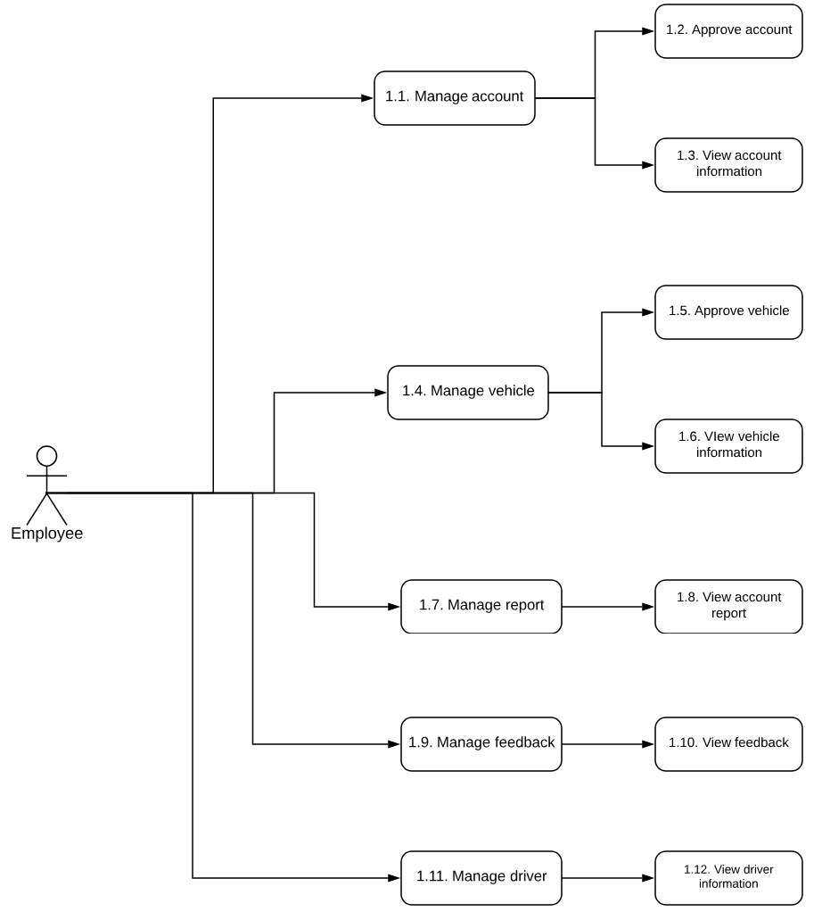

Figure 82 Web Application Communication Diagram

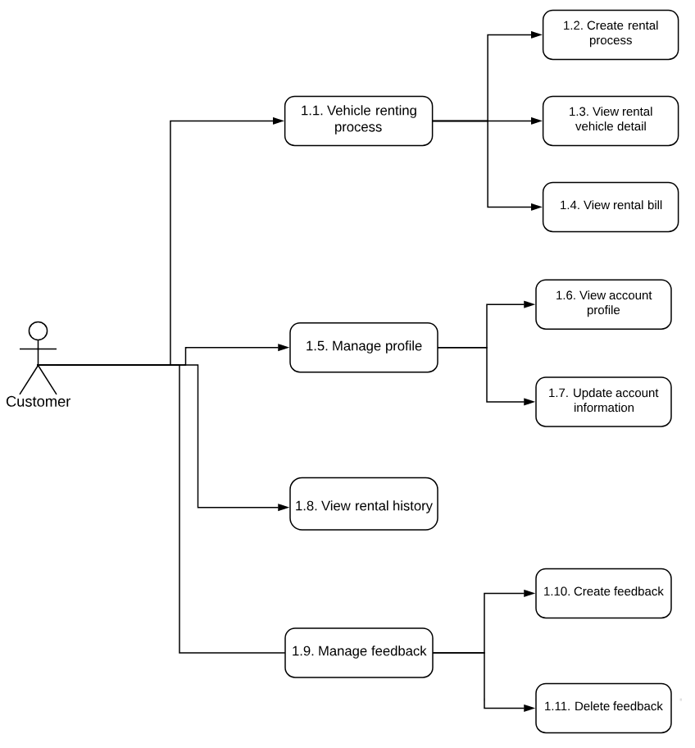 Figure 83 Mobile Applications Communication Diagram - Customer

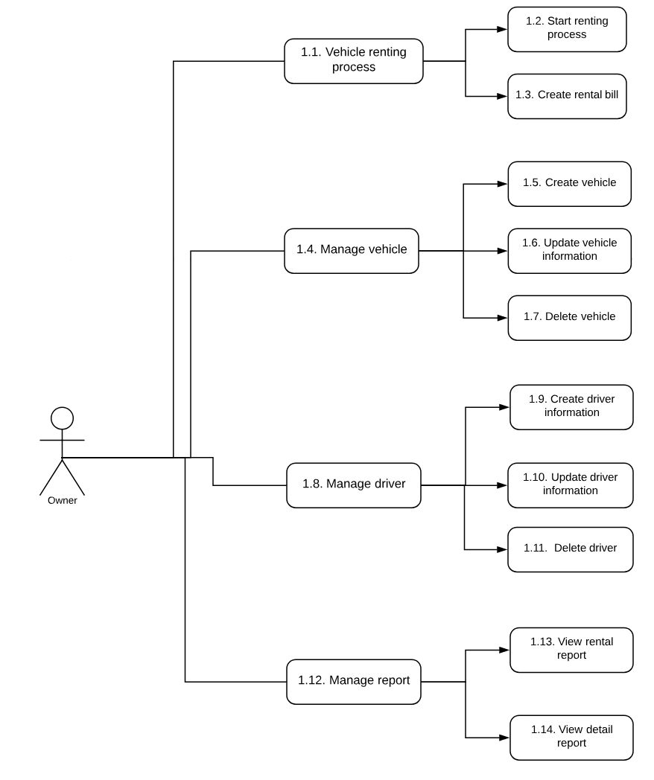

Figure 84 Mobile Applications Communication Diagram - Owner

### Test cases

#### <Guest> Register new account

|  |  |  |  |  |  |  |
| --- | --- | --- | --- | --- | --- | --- |
| ID | Test Case Description | Test case procedure | Expected output | Inter-test case dependence | Result | Test Date |
| VRSGR1 | Test guest register new customer account with valid information | 1. Go to the home page  2. Enter personal information:  - Username: NguyenA  - Password: 123789  - Email: testing@gmail.com  3. Click "Tiếp theo" button.  4. Enter personal information:  - Họ tên: Nguyễn Văn A  - Số điện thoại:0909099099  - Địa chỉ: TP.HCM  5. Chọn hình CMND  6. Click "Tiếp theo" button.  7. Click tab "Người thuê xe".  8. Click “Tôi đồng ý với điều khoản” checkbox  9. Click "HOÀN TẤT" button. | Create customer account request successful, send notification to employee. Message: “Tài khoản được tạo thành công và đang chờ phê duyệt” show |  | Pass | 10/08/18 |
| VRSGR2 | Test guest register new owner account (own motorbike) with valid information | 1. Go to the home page  2. Enter personal information:  - Username: NguyenA, password: 123789  - Email: testing@gmail.com  3. Click "Tiếp theo" button.  4. Enter personal information:  - Họ tên: Nguyễn Văn A  - Số điện thoại:0909099099  - Số CMND/Hộ chiếu: 272185738  - Địa chỉ: TP.HCM  5. Click "Tiếp theo" button.  4. Click tab "Chủ xe".  5.Click “Xe máy” button.  6. Enter vehicle information:  - Tên xe: Honda airblade, năm sản xuất: 2018  7. Select transmission type: “Xe tay ga”, “Xe số”  8. Click "Tiếp theo" button.  9. Enter vehicle detail information:  - Giá thuê xe: 100000, giá cọc: 5000000  10. Chọn ánh giấy đăng kiểm xe  11. Chọn “Sổ hộ khẩu”, “Chứng minh nhân dân” (Optional)  12. Click "Tiếp theo" button.  13. Chọn ảnh phía trước xe  14. Chọn ảnh phía sau xe  15. Click "Tiếp theo" button.  16. Enter vehicle note: “Xe được bảo dưỡng thường xuyên, máy móc tốt” (Optional)  17. Click "Tiếp theo" button.  18. Click “Tôi đồng ý với điều khoản” checkbox  19. Click "HOÀN TẤT" button. | Create owner account request and vehicle request successful, send notification to employee. Message: “Tài khoản được tạo thành công và đang chờ phê duyệt” show |  | Pass | 10/08/18 |
| VRSGR3 | Test guest register new owner account (own personal car) with valid information | 1. Go to the home page  2. Enter personal information:  - Username: NguyenA, password: 123789  - Email: testing@gmail.com  3. Click "Tiếp theo" button.  4. Enter personal information:  - Họ tên: Nguyễn Văn A, Số điện thoại:0909099099  - Số CMND/Hộ chiếu: 272185738, Địa chỉ: TP.HCM  5. Click "Tiếp theo" button.  4. Click tab "Chủ xe".  5.Click “Xe ô tô cá nhân” button.  6. Enter vehicle information:  - Tên xe: Toyota innova, năm sản xuất: 2018  - Số chỗ ngồi: 7  7. Select engine type: “Máy xăng”, “Máy dầu”  8. Select transmission type: “Số sàn”, “Số tự động”  9. Click "Tiếp theo" button.  10. Enter vehicle detail information:  - Giá thuê xe: 1000000, Giá cọc: 20000000  11. Chọn ánh giấy đăng kiểm xe  12. Chọn “Sổ hộ khẩu”, “Chứng minh nhân dân” (Optional)  13. Click "Tiếp theo" button.  14. Chọn ảnh phía trước xe  15. Chọn ảnh phía sau xe  16. Click "Tiếp theo" button.  17. Enter vehicle note: “Xe gia đình, nội thất cao cấp” (Optional)  17. Click "Tiếp theo" button.  18. Click “Tôi đồng ý với điều khoản” checkbox  19. Click "HOÀN TẤT" button. | Create owner account request and vehicle request successful, send notification to employee. Message: “Tài khoản được tạo thành công và đang chờ phê duyệt” show |  | Pass | 10/08/18 |
| VRSGR4 | Test guest register new owner account (own tourism car) with valid information | 1. Go to the home page  2. Enter personal information:  - Username: NguyenA  - Password: 123789  - Email: testing@gmail.com  3. Click "Tiếp theo" button.  4. Enter personal information:  - Họ tên: Nguyễn Văn A  - Số điện thoại:0909099099  - Số CMND/Hộ chiếu: 272185738  - Địa chỉ: TP.HCM  5. Click "Tiếp theo" button.  4. Click tab "Chủ xe".  5.Click “Xe ô tô du lịch” button.  6. Enter vehicle information:  - Tên xe: Ford Transit  - Năm sản xuất: 2015  - Số chỗ ngồi: 16  7. Select engine type: “Máy xăng”, “Máy dầu”  8. Select transmission type: “Số sàn”, “Số tự động”  9. Click "Tiếp theo" button.  10. Enter vehicle detail information:  - Giá thuê xe: 1000000  - Giá cọc: 0  11. Chọn ánh giấy đăng kiểm xe  12. Chọn “Sổ hộ khẩu”, “Chứng minh nhân dân” (Optional)  13. Click "Tiếp theo" button.  14. Chọn ảnh phía trước xe  15. Chọn ảnh phía sau xe  16. Click "Tiếp theo" button.  17. Enter vehicle note: “Xe du lịch chuyên nghiệp, tài xế tận tâm” (Optional)  17. Click "Tiếp theo" button.  18. Enter driver information:  - Tên tài xế: Trần Văn A  - Số bằng lái xe: 053948561184  19. Click "Tiếp theo" button.  20. Click “Tôi đồng ý với điều khoản” checkbox  21. Click "HOÀN TẤT" button. | Create owner account request and vehicle request successful, send notification to employee. Message: “Tài khoản được tạo thành công và đang chờ phê duyệt” show |  | Pass | 10/08/18 |
| VRSGR5 | Test guest register customer account with an exist email | 1. Go to the home page  2. Enter personal information:  - Username: TranA  - Password: 123789  - Email: testing@gmail.com  3. Click "Tiếp theo" button. | Show error message:"Email này đã được sử dụng, vui lòng nhập email khác" |  | Pass | 10/08/18 |
| VRSGR6 | Test guest register customer account with an exist username | 1. Go to the home page  2. Enter personal information:  - Username: NguyenA  - Password: 123789  - Email: testing123@gmail.com  3. Click "Tiếp theo" button. | Show error message:"Tài khoản này đã được sử dụng, vui lòng chọn tên khác" |  | Pass | 10/08/18 |
| VRSGR7 | Test guest register customer account with an exist ID number | 1. Go to the home page  2. Enter personal information:  - Username: NguyenAB  - Password: 123789  - Email: testing1@gmail.com  3. Click "Tiếp theo" button.  4. Enter personal information:  - Họ tên: Nguyễn Văn A  - Số điện thoại:0909099099  - Địa chỉ: TP.HCM  5. Chọn hình CMND  6. Click "Tiếp theo" button. | Show error message:"Số chứng minh này đã được sử dụng, vui lòng nhập lại" |  | Pass | 10/08/18 |
| VRSGR8 | Test owner register contract with an exist frame number | 1. Register new account with information like test case " VRSGR3".  2. Go to the home page  3. Enter vehicle detail information:  - Giá thuê xe: 1000000  - Giá cọc: 0  4. Chọn ánh giấy đăng kiểm xe  5. Chọn “Sổ hộ khẩu”, “Chứng minh nhân dân” (Optional)  6. Click "Tiếp theo" button | Show error message: "Số khung này đã được đăng ký bởi phương tiện khác, vui lòng nhập lại" | VRSGR3 | Pass | 10/08/18 |

Table 130 Test case - <Guest> Register new account

#### <Employee> View Account Request

|  |  |  |  |  |  |  |
| --- | --- | --- | --- | --- | --- | --- |
| ID | Test case description | Test case procedure | Expected output | Inter-test case dependence | Result | Test date |
| VRSEVA1 | View account request | 1. Create an account with username test01  2. Click on account in the grid to view its detail | Display account detailed information page | VRSGR1 – Create account | Pass | 10/08/18 |
| VRSEVA2 | Search request with full name | 1. Create 3 customer with names "Dang Van Ngu", "Duong Tu Ky" and "Nguyen Dinh Bao" with id is HD0001 and HD0002 belongs to "Dang Van Ngu" and " Duong Tu Ky " in turn  3. Input " Duong Tu Ky " to search box  4. Click "Tìm kiếm" button | Display contract HD0002 in the grid view | VRSGR1 – Create account | Pass | 10/08/18 |
| VRSEVA3 | Search request with no keyword | 1. Create 3 request with names "Dang Van Ngu", "Duong Tu Ky" and "Nguyen Dinh Bao" alternatively  2. Create 2 contract HD0001 and HD0002 belongs to "Dang Van Ngu" and "Nguyen Dinh Bao" in turn  3. Click "Tìm kiếm" button | A message notifies there is no value for this search | VRSGR1 – Create account | Pass | 10/08/18 |

Table 131 Test case - <Employee> View account request

#### <Employee> Approve Account Request

|  |  |  |  |  |  |  |
| --- | --- | --- | --- | --- | --- | --- |
| ID | Test case description | Test case procedure | Expected output | Inter-test case dependence | Result | Test date |
| VRSEAA1 | Approve account | 1. Create an account with username test01  2. Click on account in the grid of approve account to view its detail  3. Check on “Đã phê duyệt” checkbox  4. Click “Lưu” button | Account is approved, page reload. | VRSGR1 – Create account | Pass | 10/08/18 |
| VRSEAA2 | Cancel account request | 1. Create an account with username test01  2. Click on account in the grid of approve account to view its detail  3. Check on “Hủy yêu cầu” checkbox  4. Click “Lưu” button | Account is canceled, page reload. | VRSGR1 – Create account | Pass | 10/08/18 |

Table 132 Test case - <Employee> Approve account request

#### <Employee> View Vehicle Request

|  |  |  |  |  |  |  |
| --- | --- | --- | --- | --- | --- | --- |
| ID | Test case description | Test case procedure | Expected output | Inter-test case dependence | Result | Test date |
| VRSEVV1 | View vehicle request | 1. Create a vehicle with frame number 43G1234567  2. Click on vehicle in the grid to view its detail | Display vehicle detailed information page | VRSGR3 – Create vehicle | Pass | 10/08/18 |
| VRSEVV2 | Search request with plate number | 1. Create 3 vehicle with plate number "51A-01234", "52B-00221" and "53B-01121" with id is VH0001 and VH0002 belongs to "51A-01234" and "52B-00221" in turn  3. Input "51A-01234" to search box  4. Click "Tìm kiếm" button | Display vehicle id VH0001 in the grid view | VRSGR3 – Create vehicle | Pass | 10/08/18 |
| VRSEVV3 | Search request with no keyword | 1. Create 3 vehicle with plate number "51A-01234", "52B-00221" and "53B-01121" with id is VH0001 and VH0002 belongs to "51A-01234" and "52B-00221" in turn  2. Click "Tìm kiếm" button | A message notifies there is no value for this search | VRSGR3 – Create vehicle | Pass | 10/08/18 |

Table 133 Test case - <Employee> View vehicle request

#### <Employee> Approve Vehicle Request

|  |  |  |  |  |  |  |
| --- | --- | --- | --- | --- | --- | --- |
| ID | Test case description | Test case procedure | Expected output | Inter-test case dependence | Result | Test date |
| VRSEAV1 | Approve vehicle | 1. Create a vehicle with frame number 43G1234567  2. Click on vehicle in the grid to view its detail  3. Check on “Đã phê duyệt” checkbox  4. Click “Lưu” button | Vehicle is approved, page reload. | VRSGR3 – Create vehicle | Pass | 10/08/18 |
| VRSEAV2 | Cancel account request | 1. Create a vehicle with frame number 43G1234567  2. Click on vehicle in the grid to view its detail  3. Check on “Hủy yêu cầu” checkbox  4. Click “Lưu” button | Vehicle is canceled, page reload. | VRSGR3 – Create vehicle | Pass | 10/08/18 |

Table 134 Test case - <Employee> Approve vehicle request

#### <Employee> View Account Detail

|  |  |  |  |  |  |  |
| --- | --- | --- | --- | --- | --- | --- |
| ID | Test case description | Test case procedure | Expected output | Inter-test case dependence | Result | Test date |
| VRSEVA1 | View account detail | 1. Register new account with information like test case " VRSGR1" and approve account like test case “VRSEAA1”  2. Click on account in the Manage account grid to view its detail | Display account detailed information page | VRSGR1 – Create account, VRSEAA1– Approve account | Pass | 10/08/18 |
| VRSEVA2 | Search request with full name | 1. Create 3 request with names "Dang Van Ngu", "Duong Tu Ky" and "Nguyen Dinh Bao" with id is HD0001 and HD0002 belongs to "Dang Van Ngu" and "Nguyen Dinh Bao" in turn  2. Approve those account.  3. Input " Nguyen Dinh Bao" to search box  4. Click "Tìm kiếm" button | Display vehicle id HD0002 in the grid view | VRSGR1 – Create account, VRSEAA1– Approve account | Pass | 10/08/18 |
| VRSEVA3 | Search request with no keyword | 1. Create 3 request with names "Dang Van Ngu", "Duong Tu Ky" and "Nguyen Dinh Bao" with id is HD0001 and HD0002 belongs to "Dang Van Ngu" and "Nguyen Dinh Bao" in turn  2. Approve those account.  3. Click "Tìm kiếm" button | A message notifies that there is no value for this search | VRSGR1 – Create account, VRSEAA1– Approve account | Pass | 10/08/18 |

Table 135 Test case - <Employee> View account detail

#### <Employee> View Vehicle Detail

|  |  |  |  |  |  |  |
| --- | --- | --- | --- | --- | --- | --- |
| ID | Test case description | Test case procedure | Expected output | Inter-test case dependence | Result | Test date |
| VRSEVV1 | View vehicle detail | 1. Register new vehicle with information like test case " VRSGR3" and approve vehicle like test case “VRSAV1”  2. Click on vehicle in the Manage vehicle grid to view its detail | Display vehicle detailed information page | VRSGR3 – Create vehicle, VRSAV1 – Approve vehicle | Pass | 10/08/18 |
| VRSEVV2 | Search request with plate number | 1. Create 3 vehicle with plate number "51A-01234", "52B-00221" and "53B-01121" with id is VH0001 and VH0002 belongs to "51A-01234" and "52B-00221" in turn  2. Approve those vehicles.  3. Input "51A-01234" to search box  4. Click "Tìm kiếm" button | Display vehicle id VH0001 in the grid view | VRSGR3 – Create vehicle, VRSAV1 – Approve vehicle | Pass | 10/08/18 |
| VRSEVV3 | Search request with no keyword | 1. Create 3 vehicle with plate number "51A-01234", "52B-00221" and "53B-01121" with id is VH0001 and VH0002 belongs to "51A-01234" and "52B-00221" in turn  2. Approve those vehicles.  3. Click "Tìm kiếm" button | A message notifies there is no value for this search | VRSGR3 – Create vehicle, VRSAV1 – Approve vehicle | Pass | 10/08/18 |

Table 136 Test case - <Employee> View vehicle detail

#### <Employee> View Report Chart

|  |  |  |  |  |  |  |
| --- | --- | --- | --- | --- | --- | --- |
| ID | Test case description | Test case procedure | Expected output | Inter-test case dependence | Result | Test date |
| VRSEVR1 | View rented vehicle report | 1. Login with employee account  2. Go to the manage report | Display rented vehicle report chart |  | Pass | 10/08/18 |
| VRSEVR2 | View vehicle distribution report | 1. Login with employee account  2. Go to the manage report | Display vehicle distribution report chart |  | Pass | 10/08/18 |

Table 137 Test case - <Employee> View report chart

#### <Customer> Manage profile

|  |  |  |  |  |  |  |
| --- | --- | --- | --- | --- | --- | --- |
| ID | Test Case Description | Test case procedure | Expected output | Inter-test case dependence | Result | Test Date |
| VRSCMP1 | View account profile | 1. Login in with approved account  2. Click “Quản lý tài khoản” button in menu | Account information saved in the system will be display in account detail page as textview |  | Pass | 10/08/18 |
| VRSCMP2 | Update account profile | 1. Login in with approved account  2. Click “Quản lý tài khoản” button in menu  3. Click “Chỉnh sửa” button  4. Enter new account information  5. Click “Cập nhật” button | System show message “Tài khoản của bạn đang chờ được duyệt. Vui lòng chờ” |  |  |  |

Table 138 Test case - <Customer> Manage profile

#### <Customer> Create New Rental Request

|  |  |  |  |  |  |  |
| --- | --- | --- | --- | --- | --- | --- |
| ID | Test Case Description | Test case procedure | Expected output | Inter-test case dependence | Result | Test Date |
| VRSCC1 | Create new rental request success with pickup method is “Nhận xe tại chỗ” | 1. Login in with customer account  2. Select vehicle  3. Click “Thuê” button  4. Select renting time is 1 day  5. Click “Tiếp theo” button  6. Complete payment process via paypal successfully  7. Select “Nhận xe tại chỗ” | Rental request is sent to vehicle owner. System show message “Yêu cầu thuê của bạn đã được gửi, vui lòng chờ chủ xe liên hệ”. |  | Pass | 10/08/18 |
| VRSCC2 | Create new rental request success with pickup method is “Tự đến lấy xe” | 1. Login in with customer account  2. Select vehicle  3. Click “Thuê” button  4. Select renting time is 1 hour  5. Click “Tiếp theo” button  6. Complete payment process via paypal successfully  7. Select “Tự đến lấy xe” | Rental request is sent to vehicle owner. System show message “Yêu cầu thuê của bạn đã được gửi, vui lòng chờ chủ xe phản hồi”. |  |  |  |
| VRSCC3 | Create new rental request with fail payment | 1. Login in with customer account  2. Select vehicle  3. Click “Thuê” button  4. Select renting time is 1 hour  5. Click “Tiếp theo” button  6. Payment via paypal fail | System show message error and require customer to re-payment |  |  |  |

Table 139 Test case - <Customer> Create new rental request

#### <Customer> Execute Vehicle Rental Process

|  |  |  |  |  |  |  |
| --- | --- | --- | --- | --- | --- | --- |
| ID | Test Case Description | Test case procedure | Expected output | Inter-test case dependence | Result | Test Date |
| VRSCE1 | Execute rental process with pickup method is “Nhận xe tại chỗ” | 1. Create rental request in 1-day same as test case “VRSCC1”  2. Receive accept rental request from system  3. Click “Chi tiết hợp đồng” button  4. Receive start renting time notify from system  5. Click “Tiến trình hợp đồng” button  6. Contract information and rental information show  7. Click “Trả xe” button | Return vehicle notify is send to vehicle owner. System show message “Yêu cầu kết thúc hợp đồng của bạn đã được gửi, vui lòng chờ trong giây lát để chủ xe tiến hành tính toán hợp đồng”. | VRSCC1 | Pass | 10/08/18 |
| VRSCE2 | Execute rental process with pickup method is “Tự đến lấy xe” | 1. Create rental request in 1-day same as test case “VRSCC2”  2. Receive accept rental request from system  3. Click “Chi tiết hợp đồng” button  4. Show route from customer current location to vehicle location  5. Receive start renting time notify from system  6. Contract information and rental information show  7. Click “Trả xe” button | Return vehicle notify is send to vehicle owner. System show message “Yêu cầu kết thúc hợp đồng của bạn đã được gửi, vui lòng chờ trong giây lát để chủ xe tiến hành tính toán hợp đồng”. | VRSCC1 | Pass | 10/08/18 |

Table 140 Test case - <Customer> Execute vehicle rental process

#### <Customer> Cancel Vehicle Rental Process

|  |  |  |  |  |  |  |
| --- | --- | --- | --- | --- | --- | --- |
| ID | Test Case Description | Test case procedure | Expected output | Inter-test case dependence | Result | Test Date |
| VRSCCV1 | Cancel rental request while rental request is accepted by owner | 1. Create rental request in 1-day same as test case “VRSCC1”  2. Receive accept rental request from system  3. Click “Chi tiết hợp đồng” button  4. Click “Hủy yêu cầu” button  5. Click “Chấp nhận” button in confirm dialog | Vehicle rental request canceled, system show message “Yêu cầu hủy hợp đồng của bạn đã được gửi, vui lòng chờ trong giây lát để hệ thống xử lý và hoàn tiền”. | VRSCC1 | Pass | 10/08/18 |
| VRSCCV2 | Cancel rental request while rental request is not yet accepted by owner | 1. Create rental request in 1-day same as test case “VRSCC1”  2. Click “Hủy” button | Vehicle rental request canceled, system show message “Hợp đồng của bạn đã bị hủy, vui lòng chờ trong giây lát để hệ thống xử lý và hoàn tiền”. | VRSCC1 | Pass | 10/08/18 |

Table 141 Test case - <Customer> Cancel vehicle rental process

#### <Customer> View renting history

|  |  |  |  |  |  |  |
| --- | --- | --- | --- | --- | --- | --- |
| ID | Test Case Description | Test case procedure | Expected output | Inter-test case dependence | Result | Test Date |
| VRSCV1 | View vehicle renting history of customer has renting vehicle | 1. Login with customer account has already renting at least one vehicle  2. Click on “Lịch sử thuê xe” button in menu | Renting history of account has saved in the system will show in renting history page |  | Pass | 10/08/18 |

Table 142 Test case - <Customer> View renting history

#### <Owner> Accept Rental Request

|  |  |  |  |  |  |  |
| --- | --- | --- | --- | --- | --- | --- |
| ID | Test Case Description | Test case procedure | Expected output | Inter-test case dependence | Result | Test Date |
| VRSOAR1 | Accept rental request | 1. Login with owner account  2. Receive renting request from system  3. Click on notification – renter information show  4. Click “Chấp nhận” button | Rental contract is created. Forward to contract detail page |  | Pass | 10/08/18 |
| VRSOAR2 | Cancel rental request | 1. Login with owner account  2. Receive renting request from system  3. Click on notification – renter information show  4. Click “Hủy yêu cầu” button  5. Click confirm button on alert dialog | Rental request is deleted. System send notify to customer notify that rental request is canceled |  | Pass | 10/08/18 |

Table 143 Test case - <Owner> Accept rental request

#### <Owner> Update Penalty Bill

|  |  |  |  |  |  |  |
| --- | --- | --- | --- | --- | --- | --- |
| ID | Test Case Description | Test case procedure | Expected output | Inter-test case dependence | Result | Test Date |
| VRSOCR1 | Create rental bill | 1. Login with owner account  2. Receive return vehicle request from system  3. Click on notification – forward to create rental bill page  4. Input rental details  5. Click “Gửi” button | Rental bill is sent to renter. |  | Pass | 10/08/18 |
| VRSOCR2 | Re-create rental bill | 1. Create rental bill same as test case VRSOC1  2. Input different data in rental details field  3. Click “Gửi” button | Rental bill is update to renter. Rental bill page is reloaded. |  | Pass | 10/08/18 |

Table 144 Test case - <Owner> Update penalty bill

#### <Owner> Manage vehicle

|  |  |  |  |  |  |  |
| --- | --- | --- | --- | --- | --- | --- |
| ID | Test Case Description | Test case procedure | Expected output | Inter-test case dependence | Result | Test Date |
| VRSOMV1 | Create vehicle | 1. Login with owner account  2. Click “Manage vehicle” button on menu  3. Click “Add vehicle” button  4. Input vehicle details same as test case VRSG3  5. Click “Hoàn tất” button | System show message “Yêu cầu tạo xe của bạn đã gửi, vui lòng chờ nhân viên phê duyệt” | VRSG3 | Pass | 10/08/18 |
| VRSOMV2 | Update vehicle | 1. Login with owner account  2. Click “Manage vehicle” button on menu  3. Click on vehicle want to update  4. Click “Chỉnh sửa” button  5. Input new vehicle information  5. Click “Chấp nhận” button | System show message “Yêu cầu cập nhật xe của bạn đã gửi, vui lòng chờ nhân viên phê duyệt” |  | Pass | 10/08/18 |
| VRSOMV3 | Delete vehicle | 1. Login with owner account  2. Click “Manage vehicle” button on menu  3. Click delete icon next to vehicle want to delete | System show message “Xe của bạn đã được xóa khỏi hệ thống, xe sẽ không thể được sử dụng nữa. Để yêu cầu tạo lại phương tiện vui lòng liên hệ nhân viên để được hỗ trợ” |  | Pass | 10/08/18 |

Table 145 Test case - <Owner> Manage vehicle

#### <Owner> Manage rental report

|  |  |  |  |  |  |  |
| --- | --- | --- | --- | --- | --- | --- |
| ID | Test Case Description | Test case procedure | Expected output | Inter-test case dependence | Result | Test Date |
| VRSOMR1 | View total rental report | 1. Login with owner account own at least one vehicle and vehicle has been approved  2. Click on “Xem báo cáo” button in menu | All owners' vehicles approved and saved in the system will be displayed in the rental report page along with the total earnings calculated by the system. |  | Pass | 10/08/18 |
| VRSOMR2 | View detail rental report | 1. Login with owner account own at least one vehicle and vehicle has been approved  2. Click on “Xem báo cáo” button in menu  3. Click on random vehicle | All rental history of selected vehicle will be displayed in the rental details page and arranged by rental date |  | Pass | 10/08/18 |
| VRSOMR3 | View rental report while no vehicle approved yet | 1. Login with owner account own at least one vehicle and vehicle has been approved  2. Click on “Xem báo cáo” button in menu | Blank rental details page show with a message “Xe của bạn hiện chưa được phê duyệt hoặc đã bị xóa. Vui lòng kiểm tra lại sau”. |  | Pass | 10/08/18 |
| VRSOMR4 | View rental report while vehicle is not yet being rented | 1. Login with owner account own at least one vehicle and vehicle has been approved  2. Click on “Xem báo cáo” button in menu | All owners' vehicles approved and saved in the system will be displayed in the rental report page with income is 0 and total revenue is 0 |  | Pass | 10/08/18 |

Table 146 Test case - <Owner> Manage rental report

#### <Owner> Manage driver

|  |  |  |  |  |  |  |
| --- | --- | --- | --- | --- | --- | --- |
| ID | Test Case Description | Test case procedure | Expected output | Inter-test case dependence | Result | Test Date |
| VRSOMD1 | View driver information (for owner of passenger car) | 1. Login with passenger car  owner account  2. Click on “Quản lý tài xế” button in menu  3. Click on random driver | Driver information saved in the system will be displayed in driver detail page |  | Pass | 10/08/18 |
| VRSOMD2 | Update driver information (for owner of passenger car) | 1. Login with passenger car  owner account  2. Click on “Quản lý tài xế” button in menu  3. Click on random driver  4. Enter update data  5. Click on “Cập nhật” button | Driver information saved in the system will be displayed in update driver detail page as textbox |  | Pass | 10/08/18 |
| VRSOMD3 | Delete driver information (for owner of passenger car) | 1. Login with passenger car  owner account  2. Click on “Quản lý tài xế” button in menu  3. Click on driver  4. Click delete icon next to driver  4. Click on “Chấp nhận” button in confirm dialog | Driver information is deleted from the system, redirect to manage driver page |  | Pass | 10/08/18 |
| VRSOMD4 | View driver information (for owner not own passenger car) | 1. Login with  owner account not own passenger car  2. Click on menu button | “Quản lý tài khoản” tab will not exist |  | Pass | 10/08/18 |

Table 147 Test case - <Owner> Manage driver

#### <Owner> Create discount

|  |  |  |  |  |  |  |
| --- | --- | --- | --- | --- | --- | --- |
| ID | Test Case Description | Test case procedure | Expected output | Inter-test case dependence | Result | Test Date |
| VRSOCD1 | Create renting vehicle discount with valid value | 1. Login with owner  2. Click on “Thêm mã giảm giá”  3. Enter required fields  4. Select vehicle want to add discount  5. Click “Chấp nhận” button | Discount information saved to system. System automatic apply discount to selected vehicle |  | Pass | 10/08/18 |
| VRSOCD2 | Create renting vehicle discount with invalid value | 1. Login with owner  2. Click on “Thêm mã giảm giá”  3. Enter invalid data  4. Select vehicle want to add discount  5. Click “Chấp nhận” button | System show error message “Thông tin giảm giá bạn nhập không hợp lệ. Vui lòng nhập lại”. |  | Pass | 10/08/18 |

Table 148 Test case - <Owner> Create discount

**F. Software User’s Manual**

**1. Installation Guide**

**1.1 Setting up environment at server side**

The specifications are based on the dependencies requirements and performance test result from previous section of this document.

#### 1.1.1 Hardware requirement

**For server:**

|  |  |
| --- | --- |
| Criteria | Minimum Requirements |
| Internet Connection | Cable (4 Mbps) |
| Computer Processor | 64-bit CPU 1.4GHz with 2 cores |
| Computer Memory | 4 GB RAM |

Table 149: Hardware requirement for server

**For client:**

|  |  |
| --- | --- |
| Criteria | Minimum Requirements |
| Internet Connection | Cable (1 Mbps or higher) |
| Computer Processor | Intel® Core i3 1.4GHz |
| Computer Memory | 1GB RAM |

Table 150: Hardware requirement for client

#### 1.1.2 Software requirement

**For server:**

|  |  |
| --- | --- |
| Name | Name/Version |
| Operating System | *Windows 7 /Linux Ubuntu 16.04* |
| Environment | *Java Runtime Environment 1.8* |
| Web Server | Apache Tomcat 8.5.31 |
| Database Systems | *MySQL 5.7* |

Table 151: Software requirement for server

**For client:**

|  |  |
| --- | --- |
| Name | Name/Version |
| Operating System | *Windows 7 or higher* |
| Web browser | Firefox (v52 or higher), Chromes (v28 or higher) |

Table 152: Software requirement for client

**For android:**

|  |  |
| --- | --- |
| Name | Name/Version |
| Operating System | *Android 4.4 or above* |

Table 152: Software requirement for mobile

**1.2 Back-end Deployment Process**

**1.2.1 Check environment**

Check Java Runtime Environment version by following these steps:

**Step 1**: Open the Command Prompt

**Step 2**: Check Java Runtime Environment version by running this command: java -version

The result should be same as the example below. If the java version is not 1.8, please download & install this Java Runtime Environment version.

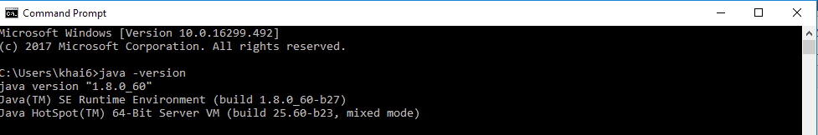

Figure 85: Check Java Runtime Environment Version

Make sure that MySQL has been install and running as Windows services.

**Step 1**: open run windows, type "services.msc” and click ok.

**Step 2**: In the Services Window, check if MySQL is running.

This picture below is the correct state for MySQL.



Figure 86: Check MySQL57 status

If MySQL is not running, turn on the service following these steps:



Figure 87: Start MySQL57

**1.2.2 Import database**

Open Jetbrain Datagrip and follow the following steps to import database:

Step1: Connect to database using existed username/password

Step2: Create new Schema name “VRC_DB”

Step3: Right-click on “VRC_DB” schema and select “restore with mysql”

Step4: Choose the path to mysql.exe that installed in your computer and path to “vrc_db.sql” which was provided in Deployment folder.

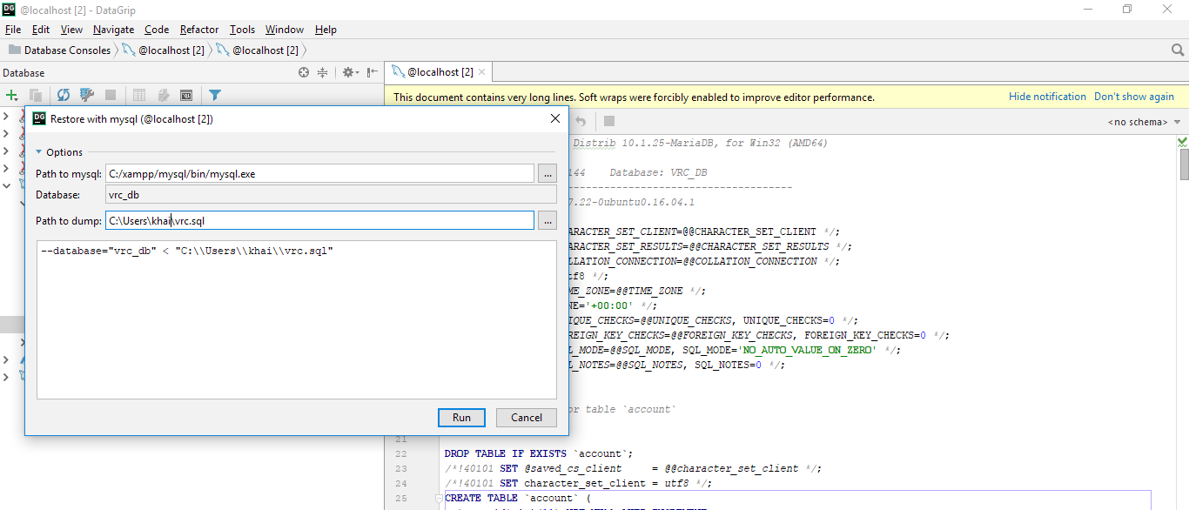

Figure 88: Import Database

**1.2.3 Build project**

**Step 1**: Download and install maven for build dependency at: https://maven.apache.org/download.cgi

**Step 2**: Create Web Application deployment package by open the Command Prompt at the project folder and do following steps:

**Step 3**: Clean and install dependency in the project

Mvn install

**Step 4**: Go to path: /src/main/resources/application.properties and change username/password of database

**Step 5**: Run this comment to create target package:

Mvn clean package

**Step 6**: Now get the package which jar extension at path: [project folder path]/target/

**Step 7**: Run project back-end:

java-jar {packagename}.jar

**Step 8**: The back-end now will run on port 8080. Check at 127.0.0.1:8080/swagger-ui.html for list of API available.

**1.2.4 Deploy project**

**Step 1**: Run project back-end:

Java-jar {packagename}.jar

**Step 2**: The back-end now will run on port 8080. Check at 127.0.0.1:8080/swagger-ui.html for list of API available.

**1.3 Web application deployment process**

**1.3.1 Check environment**

Check NodeJS version and node package management (npm) by following these steps:

**Step 1**: Open the Command Prompt

**Step 2**: Check NodeJS version by running this command: node -v

The result should be same as the example below. If the nodejs version is not v8.6.0, please download & install this NodeJS version.

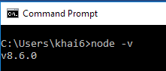

**Step 3**: Check Npm version by running this command: npm -v

The result should be same as the example below. If the npm version is not v6.1.0 or above, please download & install this npm version.

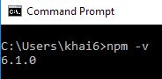

**1.3.2 Build project**

**Step 1:** Access to source folder

**Step 2:** Open command prompt

**Step 3:** Type `npm install` to install necessary package. This action may take around 4-5 minutes depend on network speed and performance of machine.

**Step 4:** Type `npm run build` to create production package.

**Step 5:** Access to build folder and open index.html file. The application is now already to serve.

**1.3.3 Deploy project**

**Step 1**: Access to source folder

**Step 2**: Open command prompt

**Step 3**: Type `npm run start` to run project. Now the application will run on port 3000 by default

**2. User Manual**

### 2.1 Employee

#### 2.1.1 View contract detail

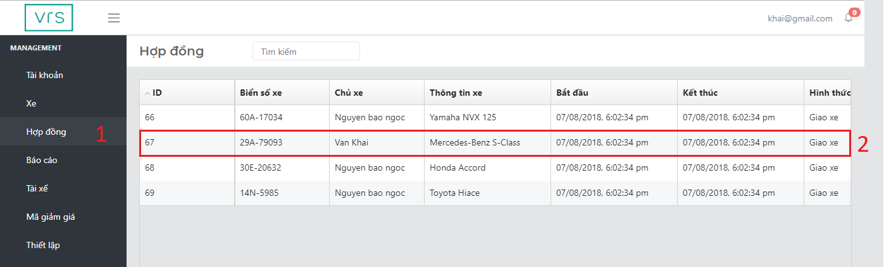

Figure 89: View contract detail (1)

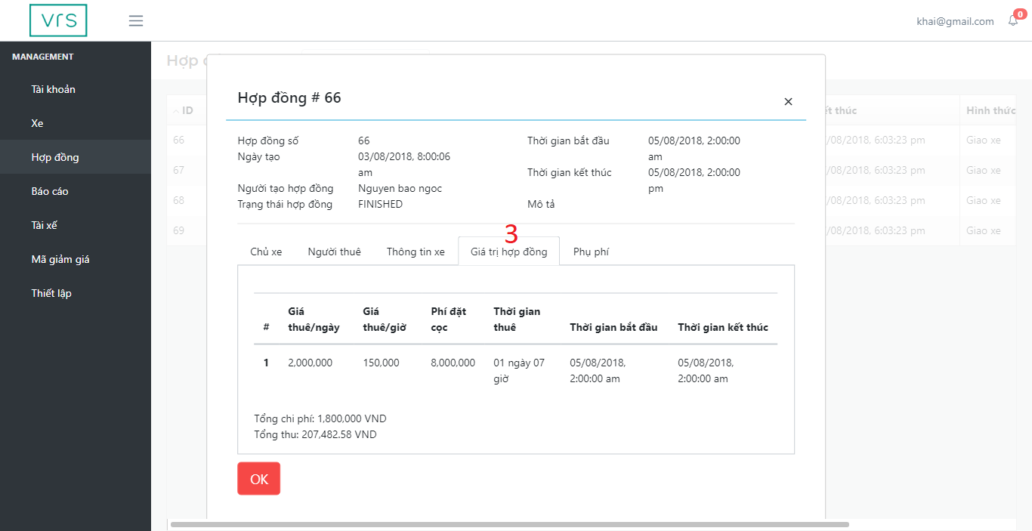

Figure 90: View contract detail (2)

|  |  |
| --- | --- |
| Step | Description |
| 1 | Click on menu tab “Hợp đồng” |
| 2 | Click on menu item |
| 3 | Click on navbar “Giá trị hợp đồng” |

Table 153: User manual – View contract detail

#### 2.2.2 Approve account

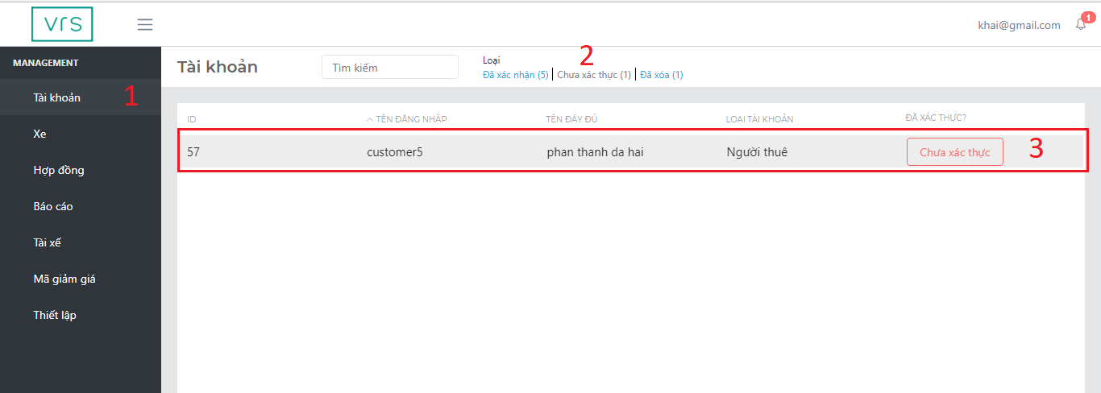

Figure 91: Approve account (1)

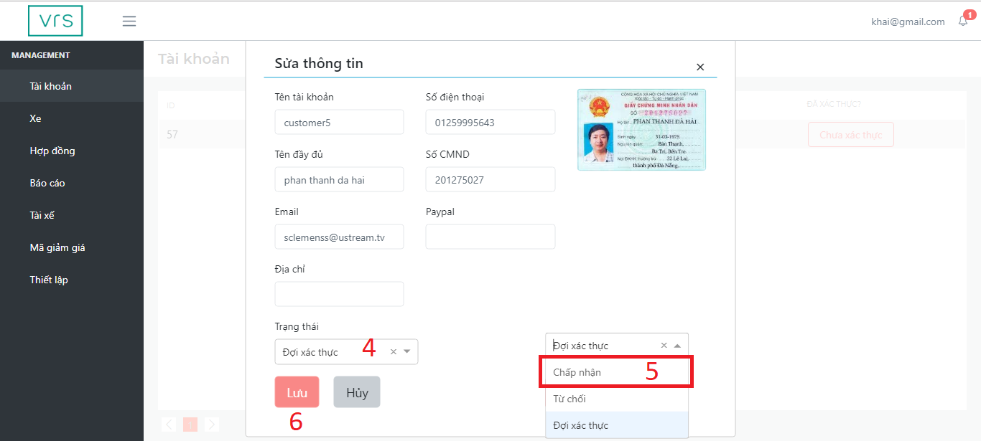

Figure 92: Approve account (2)

|  |  |
| --- | --- |
| Step | Description |
| 1 | Click on menu tab “Tài khoản” |
| 2 | Click on navbar “Chưa xác thực” |
| 3 | Click on table row |
| 4 | Click on dropdown “Đã xác thực?” |
| 5 | Select on “Chấp nhận” item |
| 6 | Click on “Lưu” button |

Table 154: User manual – Approve account

#### 2.2.3 Approve vehicle

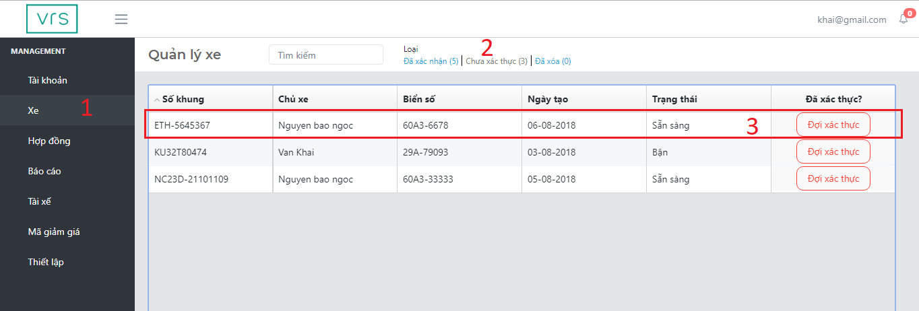

Figure 93: Approve vehicle (1)

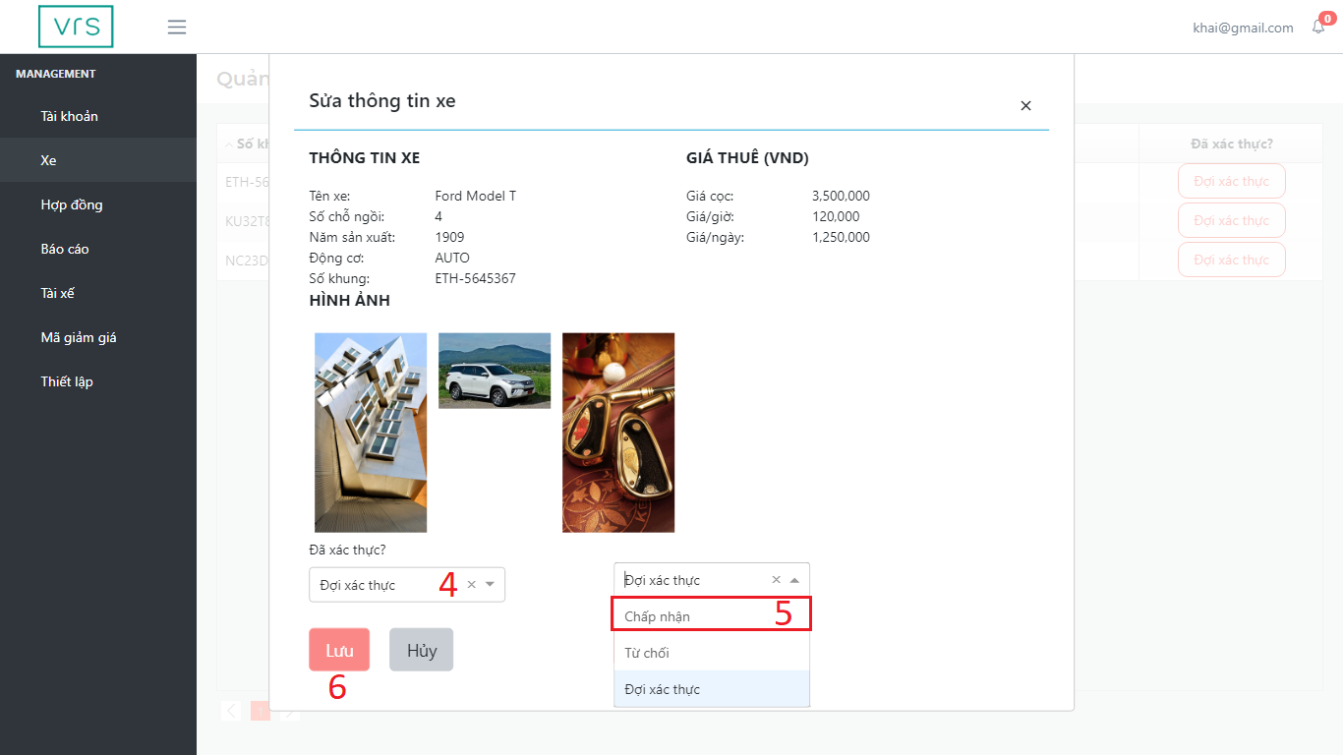

Figure 94: Aprrove vehicle (2)

|  |  |
| --- | --- |
| Step | Description |
| 1 | Click on menu tab “Xe” |
| 2 | Click on navbar “Chưa xác thực” |
| 3 | Click on table row |
| 4 | Click on dropdown “Đã xác thực?” |
| 5 | Select on “Chấp nhận” item |
| 6 | Click on “Lưu” button |

Table 155: User manual – Approve vehicle

### 2.2 Customer

#### 2.2.1 Create rental request

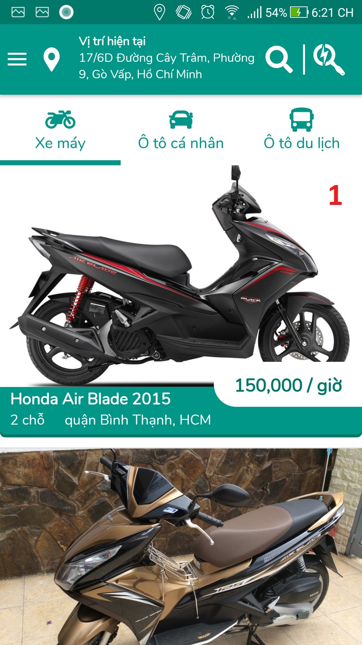

Figure 95: Create rental request (1)

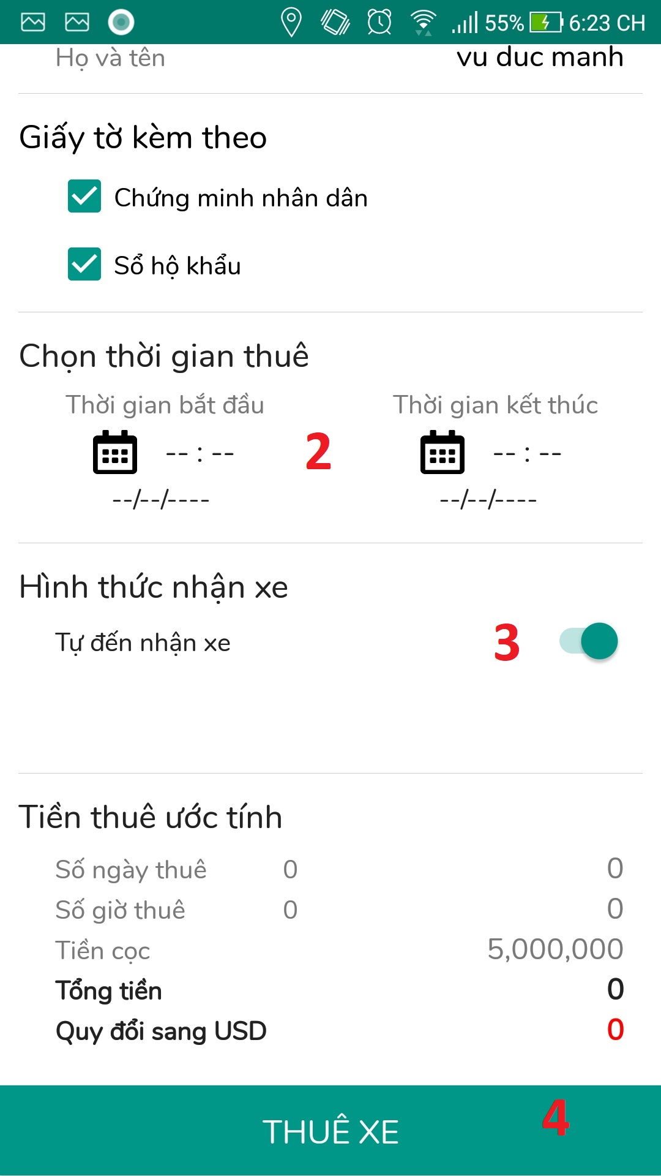

Figure 96: Create rental request (2)

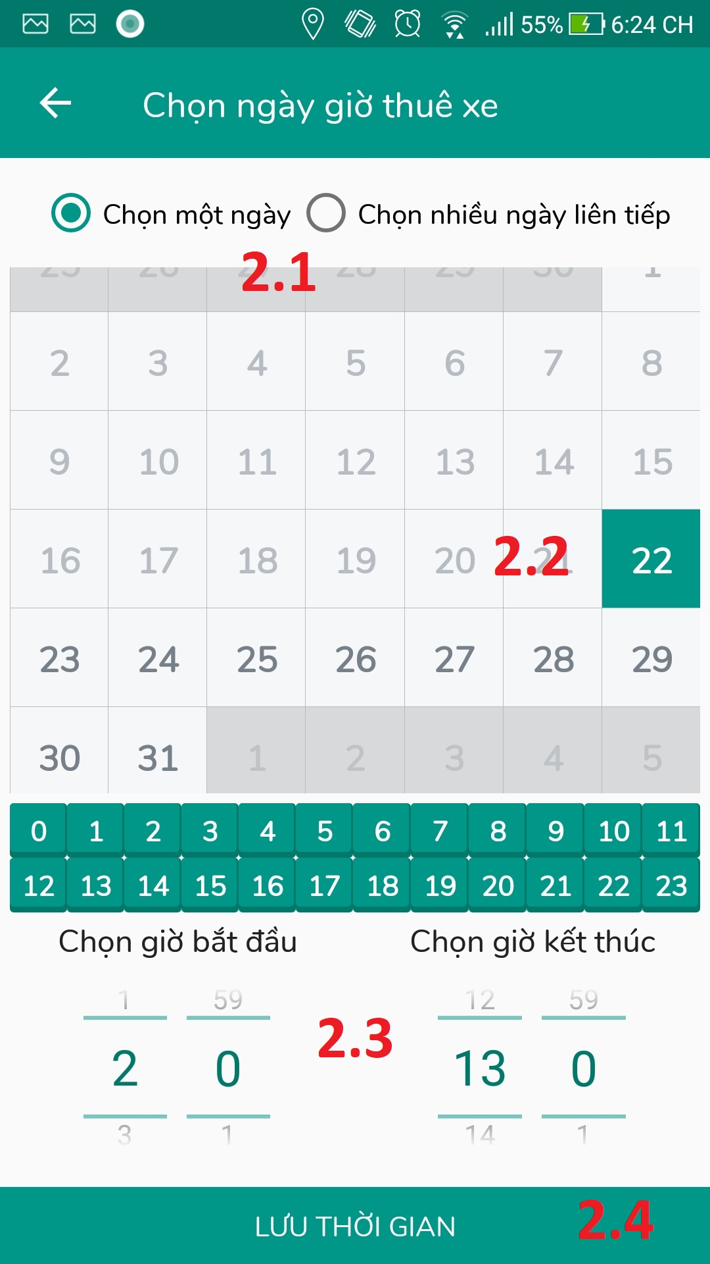

Figure 97: Create rental request (3)

|  |  |
| --- | --- |
| Step | Description |
| 1 | Click on selected vehicle image |
| 2 | Click on “Chọn thời gian thuê” button |
| 2.1 | Click on “Loại thuê” radio button |
| 2.2 | Click on wanted date |
| 2.3 | Select rent time |
| 2.4 | Click on “Lưu thời gian” button |
| 3 | Click on “Tự đến nhận xe” switch button |
| 4 | Click on “Thuê xe” button |

Table 156: User manual - Create rental request

#### 2.2.2 View rental history

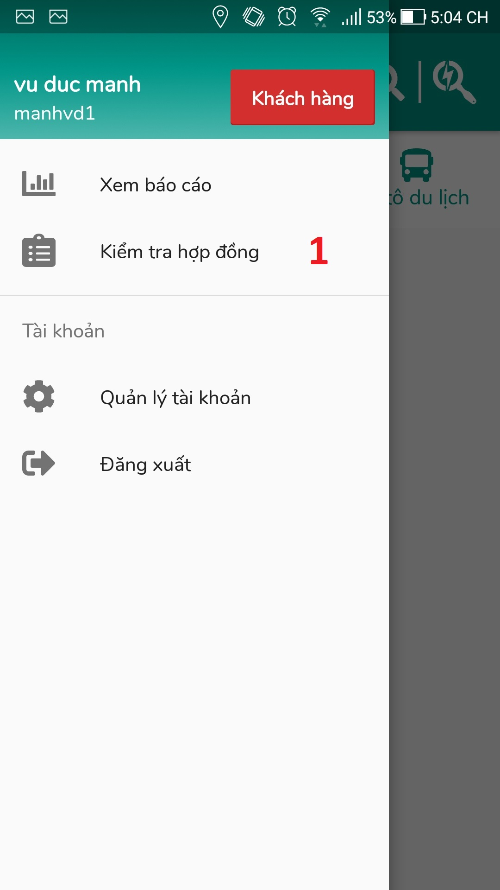

Figure 98: View rental history (1)

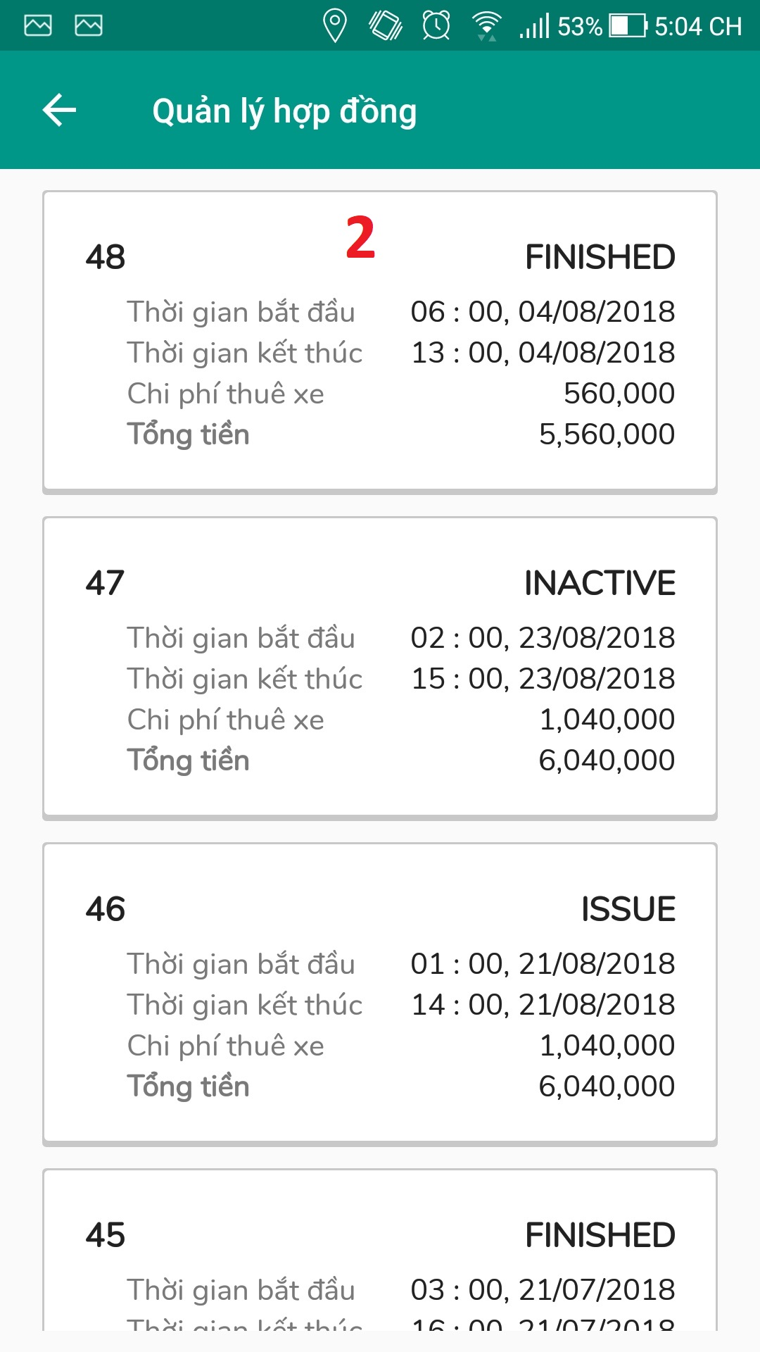

Figure 99: View rental history (2)

|  |  |
| --- | --- |
| Step | Description |
| 1 | Click on tab “Kiểm tra hợp đồng” |
| 2 | Click on rental contract want to see detail |

Table 157: User manual – View rental history

#### 2.2.3 Update profile

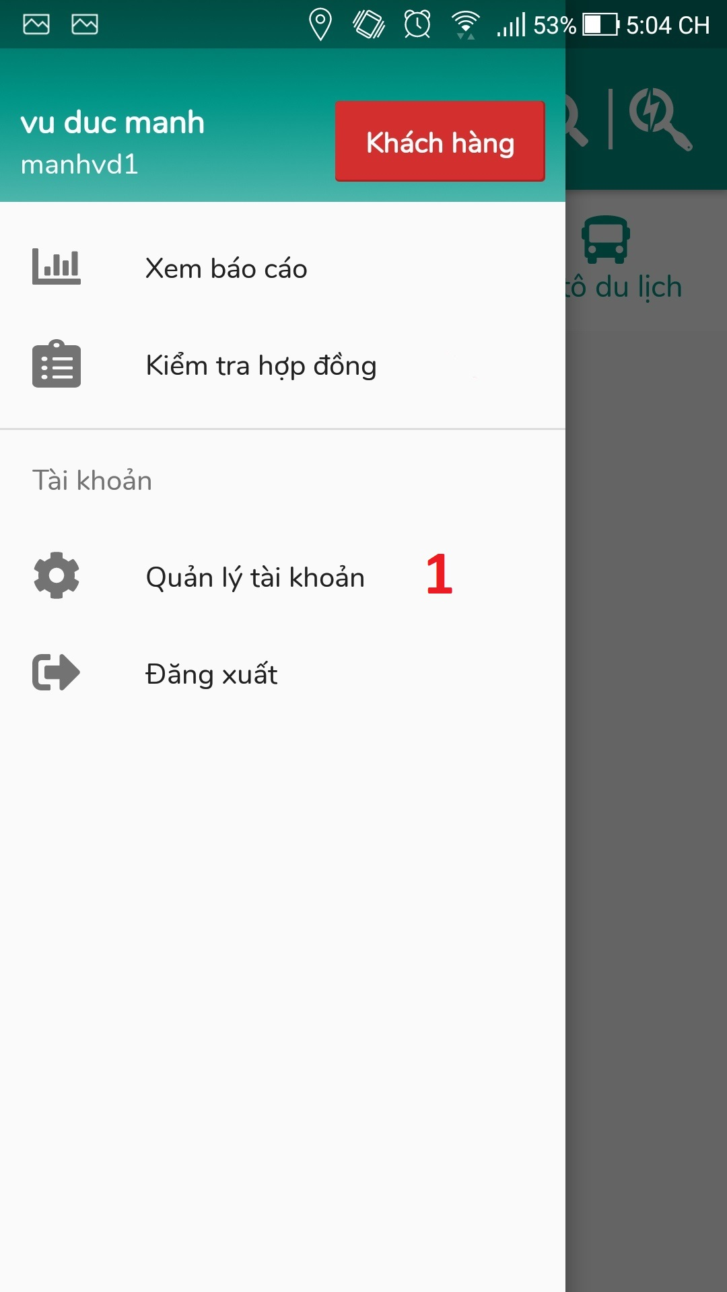

Figure 100: Update profile (1)

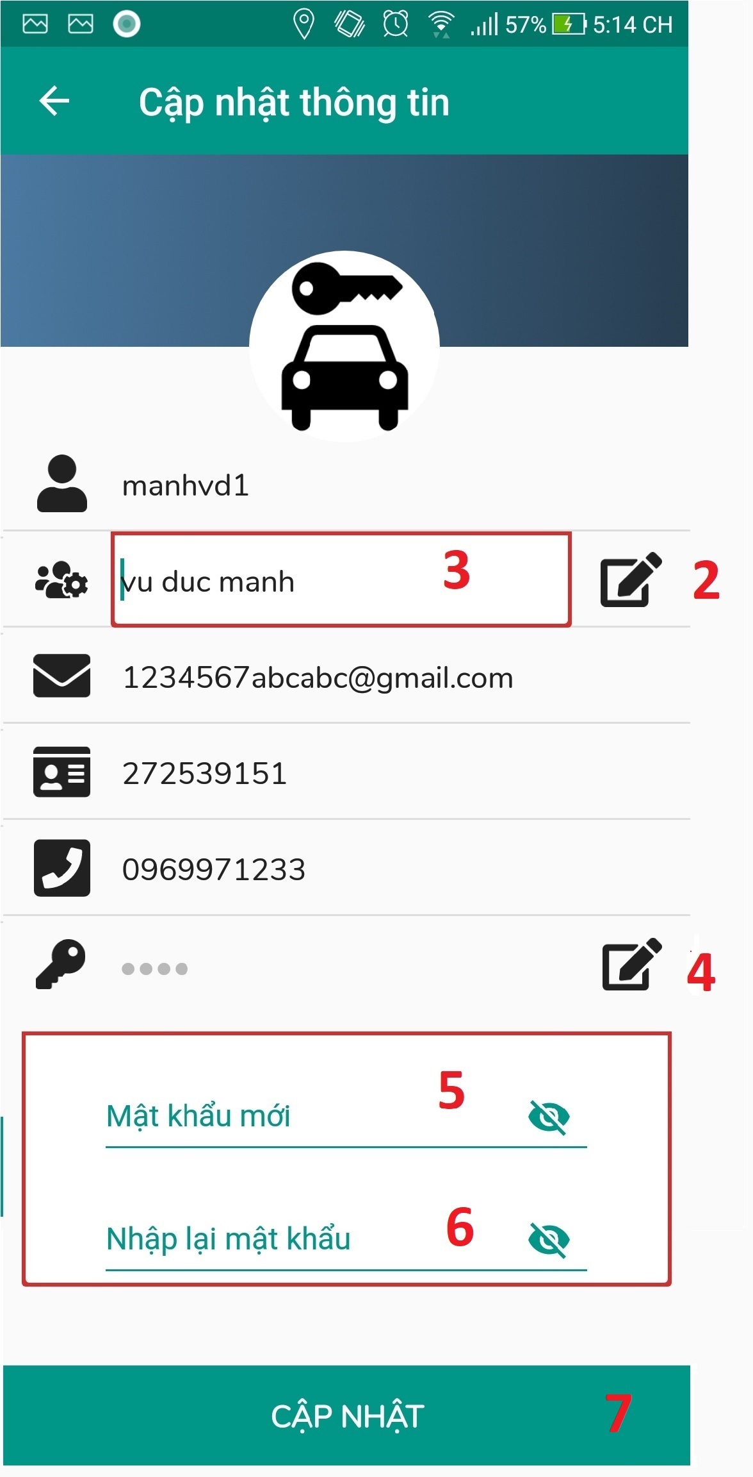

Figure 101: Update profile (2)

|  |  |
| --- | --- |
| Step | Description |
| 1 | Click on “Quản lý tài khoản” tab |
| 2 | Click on “Thay đổi” icon to change full name |
| 3 | Fill in field “Họ tên” |
| 4 | Click on “Thay đổi” icon to change password |
| 5 | Fill in field “Mật khẩu mới” if you want to update password |
| 6 | Fill in field “Xác nhận mật khẩu” to update password |
| 7 | Click on “Cập nhật” button |

Table 158: User manual - Update profile

### 2.3 Owner

#### 2.3.1 Update vehicle

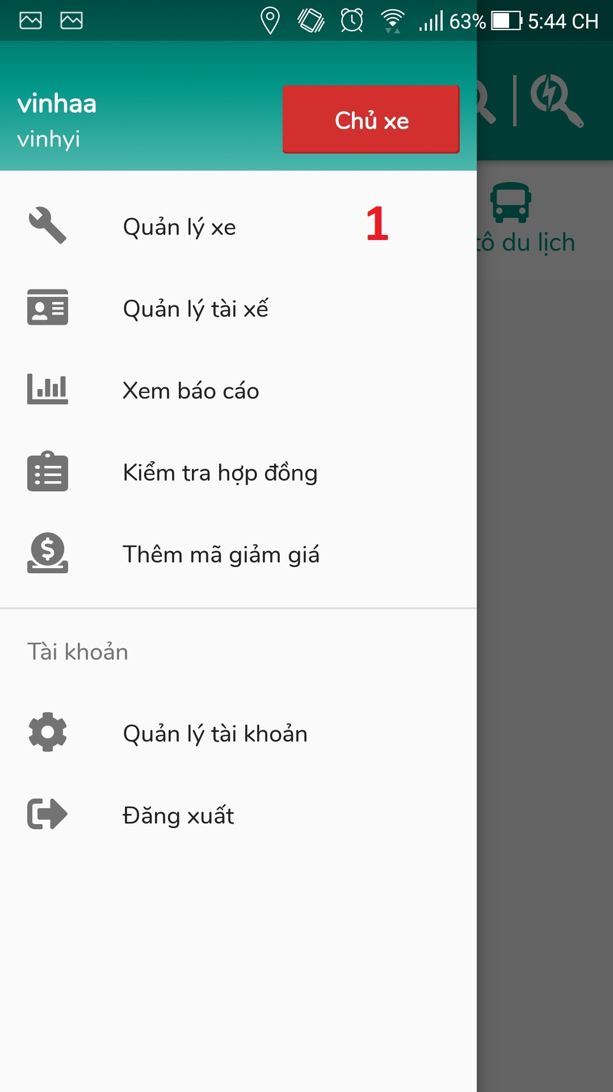

Figure 102: Update vehicle (1)

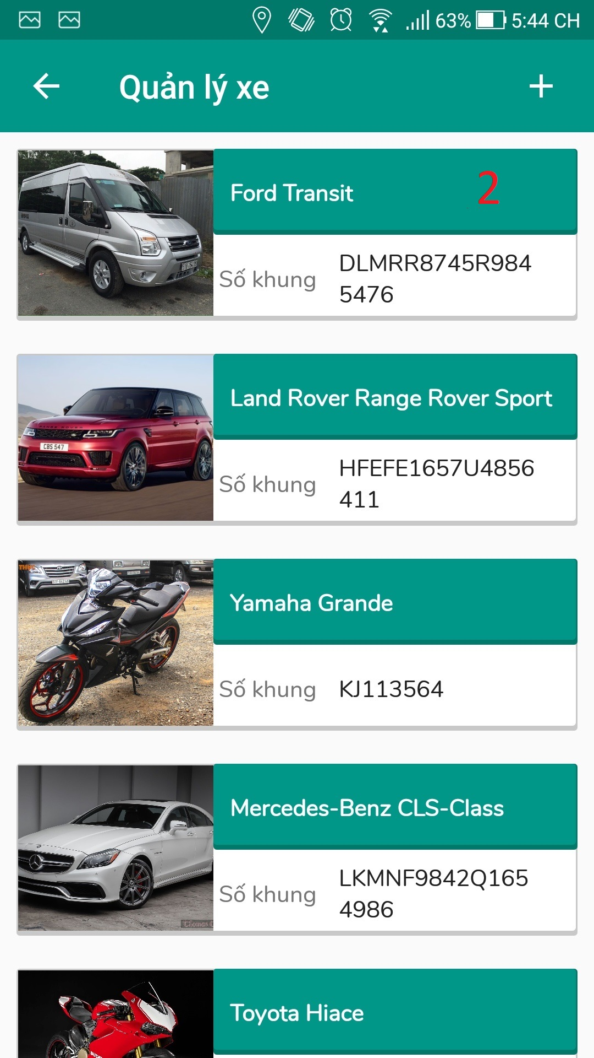

Figure 103: Update vehicle (2)

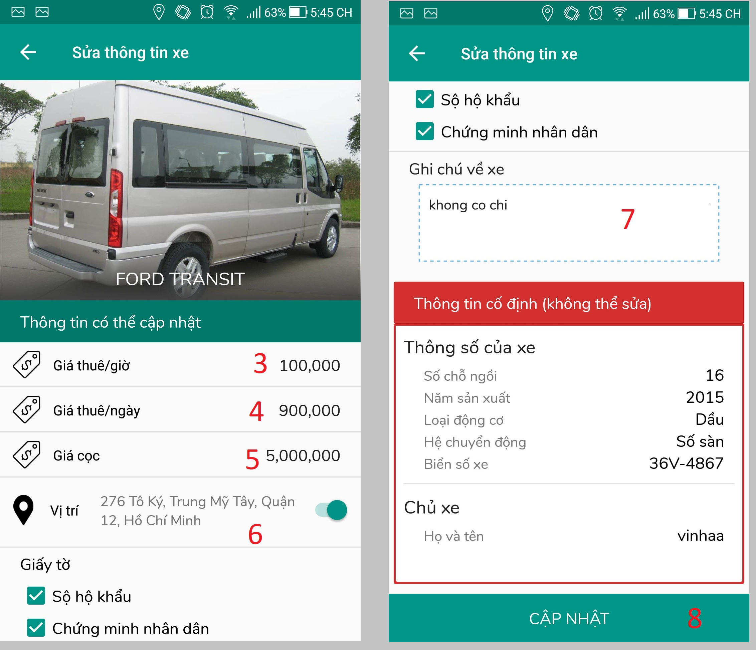

Figure 104: Update vehicle (3)

|  |  |
| --- | --- |
| Step | Description |
| 1 | Click on “Quản lý xe” tab |
| 2 | Click on vehicle want to update |
| 3 | Fill in field “Giá thuê theo giờ” if you want to update |
| 4 | Fill in field “Giá thuê theo ngày” if you want to update |
| 5 | Fill in field “Giá cọc” if you want to update |
| 6 | Fill in field “Vị trí” if you want to update vehicle location |
| 7 | Fill in field “Ghi chú” if you want to update data |
| 8 | Click on “Cập nhật” button |

Table 159: User manual - Update vehicle

#### 2.3.2 Create discount

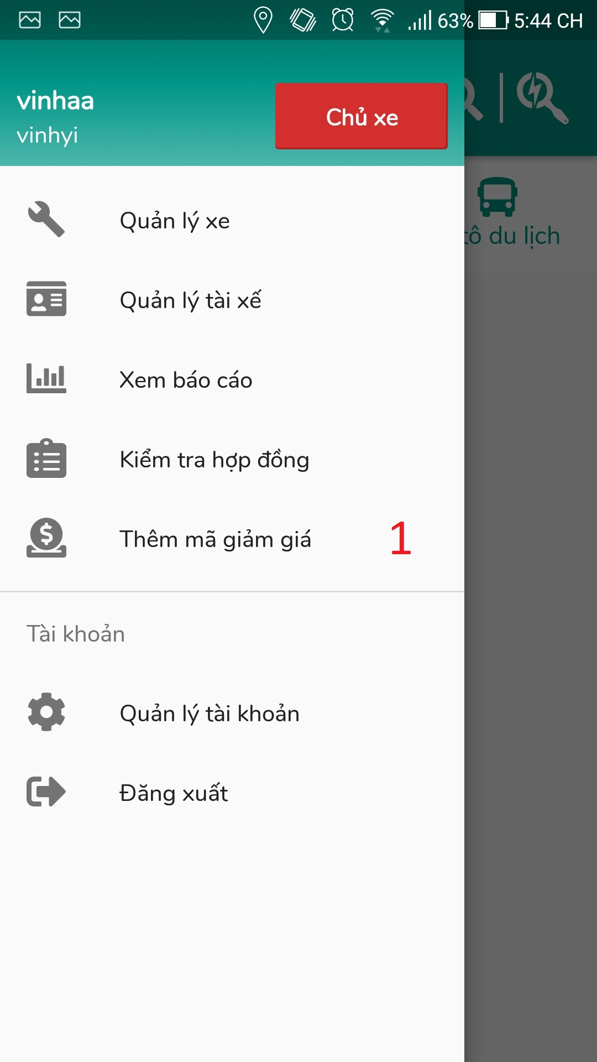

Figure 105: Create discount (1)

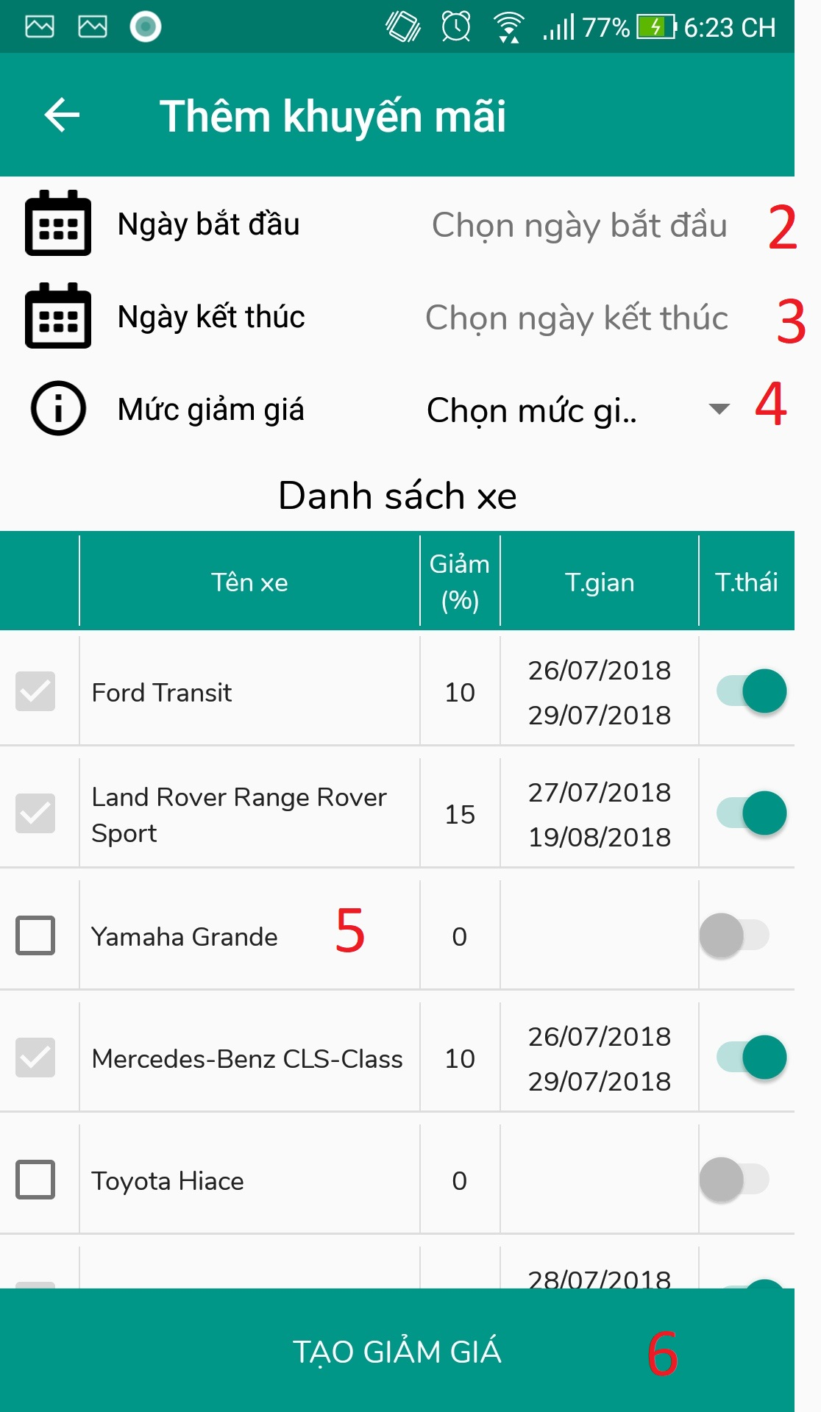

Figure 106: Create discount (2)

|  |  |
| --- | --- |
| Step | Description |
| 1 | Click on “Thêm mã giảm giá” tab |
| 2 | Select date in “Ngày bắt đầu” field |
| 3 | Select date in “Ngày kết thúc” field |
| 4 | Select “Mức giảm giá” in dropdown |
| 5 | Click on checkbox vehicle you want to take create discount |
| 6 | Click on “Tạo giảm giá” button |

Table 160: User manual – Create discount

**G. Appendix**

1. **Spring Framework 5.0** *[Online.].* Available: https://spring.io/.

Accessed on: May. 2018.

1. **The Unified Modeling Language** *[Online.].* Available: http://www.uml-diagrams.org/.

Accessed on: May. 2018.

1. **MySQL** *[Online]*. Available: <https://dev.mysql.com/doc/>

Accessed on: May. 2018.

1. **Paypal Payment Engine** *[Online.]*. Available: https://developer.paypal.com/ Accessed on: June. 2018.
2. **Spring Framework Deployment** *[Online.]* Available:

https://spring.io/blog/2014/03/07/deploying-spring-boot-applications. Accessed on: May. 2018.

https://spring.io/projects/spring-framework. Accessed on: May. 2018.

1. **2018 Global Self-drive Car Rental Market Industry Research Report** *[Online.]* Available: https://declara.com/content/VaoJkV95.

Accessed on: Jan. 2018.

